Nanda Country Bush Blitz
Hymenoptera (wasps only)
21–31 October
Submitted: 14 March 2025
Ben Parslow and Erinn Fagan-Jeffries

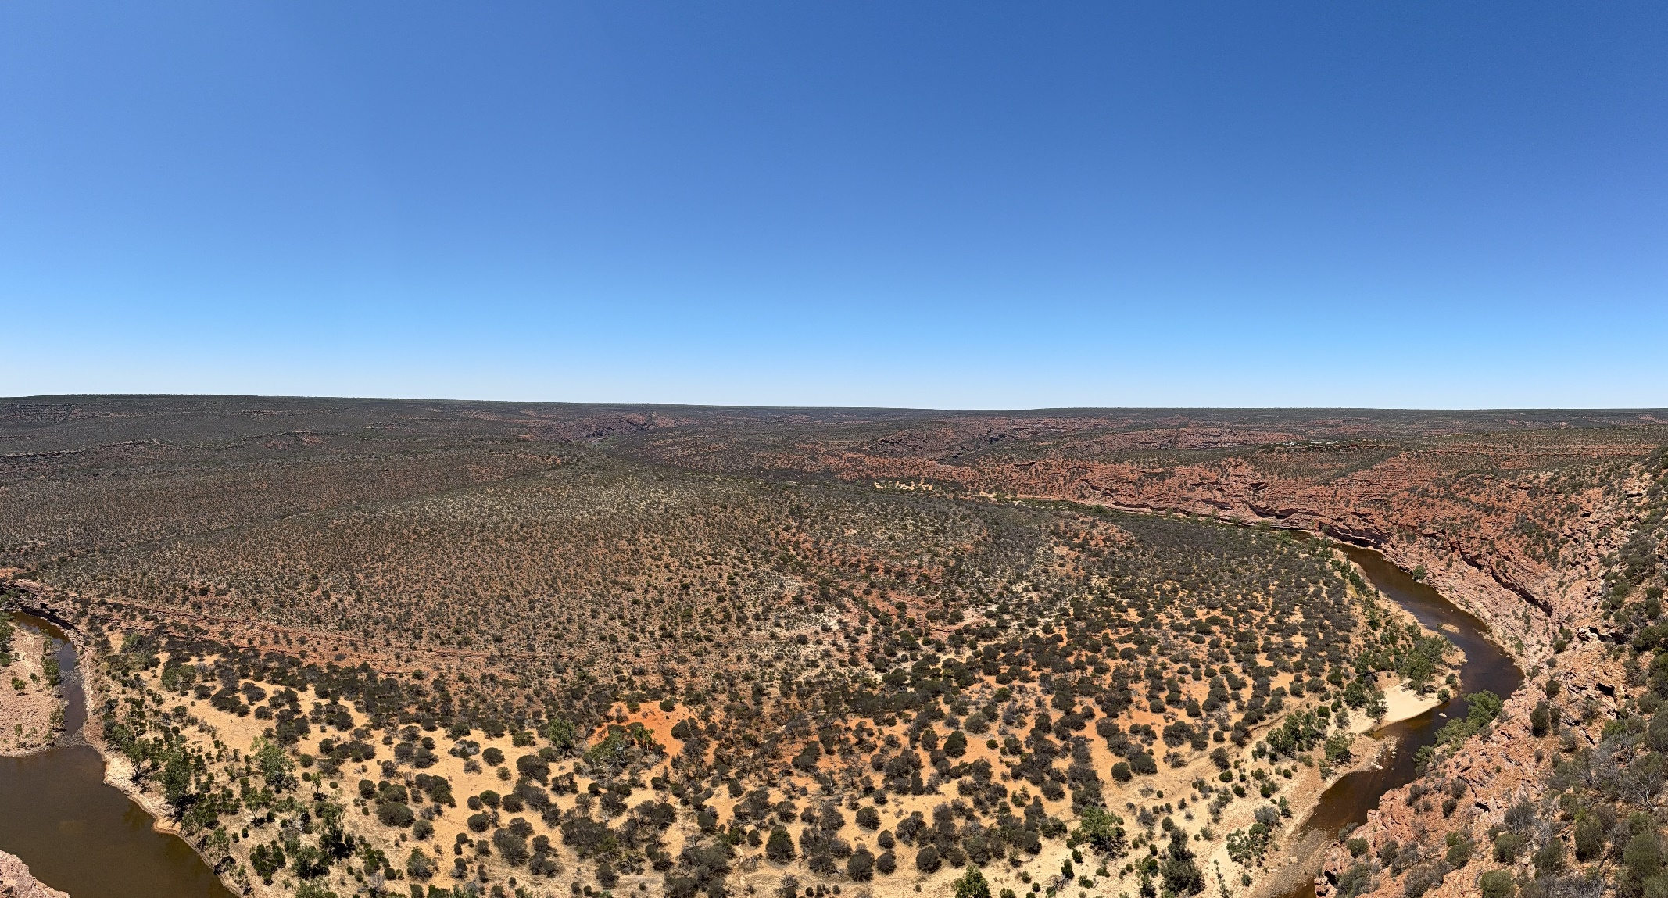

Nomenclature and taxonomy used in this report is consistent with:
Australian Faunal Directory (AFD)
(except for some recent updates to Chalcidoidea which follow
Burks et al. 2022: https://doi.org/10.3897/jhr.94.94263)

Contents
Contents 2
List of contributors 3
Abstract 4
1. Introduction 4
2. Methods 5
2.1 Site selection 5
2.2 Survey techniques 6
2.2.1 Methods used at standard survey sites 7
2.3 Identifying the collections 7
3. Results and Discussion 8
3.1 Un-named or not formalised taxa 8
3.2 Species new to science 19
3.3 Introduced species 19
3.4 Threatened species 20
3.5 Range extensions 20
3.6 Genetic information 21
4. Information on species lists 22
5. Information for land managers 22
6. Other significant findings 22
7. Conclusions 22
Acknowledgements 23
References 24
Appendices 25
Appendix 1. List of Hymenoptera (excluding bees and ants) recorded during the Nanda Country Bush Blitz 25

List of contributors
List of contributors to this report.
Name | Institution/affiliation | Qualifications/area of expertise | Level/form of contribution
Ben Parslow | South Australian Museum | Evanioidea, Hymenoptera | Survey participant and report author
Erinn Fagan-Jeffries | The University of Adelaide | Ichneumonoidea | Survey participant and report author
Tareva-Chine Atkin-Zaldivar | The University of Adelaide | Tanaostigmatidae | Identification of Tanaostigmatidae specimens
Tiahni Bament | The University of Adelaide | DNA sequencing | DNA barcoding of specimens
Emily Davies | The University of Adelaide | DNA sequencing | DNA barcoding of specimens
Olivia Portmann | The University of Adelaide | Ichneumonidae | Identification of Paraphylax
Keith Bayless | Australian National Insect Collection | Diptera | Survey participant, pro wasp collector

Abstract
The Nanda Country Bush Blitz was highly successful for the Hymenoptera team, and will lead to a substantial increase in wasp biodiversity data available for land managers and researchers.
Before the expedition, there were only 231 records of wasps on the Atlas of Living Australia in the survey area, representing only 15 different families and 11 named species.
During the two-week expedition, hymenopterans were surveyed using a variety of methods including sweep netting, vehicle nets, Malaise traps, and light sheets.
There were 508 different putative species identified from 37 different families. Using either morphological or molecular methods, 44 taxa were able to be identified as a named species, only three of which were previously recorded on The Atlas of Living Australia in the survey area bounds. The remaining 465 species were identified to morphospecies or molecular operational taxonomic units at various taxonomic levels. A large proportion of these taxa likely represent undescribed species; however, this will take dedicated systematic studies to determine.

1. Introduction
The order Hymenoptera contains the ants, bees, wasps and sawflies. Despite being essential for ecosystem functioning as pollinators, parasitoids, and predators, many groups are vastly understudied in Australia. It is estimated that less than 30% of Australia’s estimated 44,000 species of Hymenoptera are described.
The bees (clade Anthophila) collected on the Nanda Country Bush Blitz are covered in a separate report. Ants (family Formicidae) generally require quite different collecting methods than the rest of the Hymenoptera, and were not a target group of this survey. The remaining ~68 families of wasp and sawfly are covered in this report, with particular emphasis on the groups for which with report authors have expertise.
The Atlas of Living Australia currently lists 231 records of Hymenoptera (excluding bees and ants) within the bounding box shown in Figure 1. These records include members of 15 families, with only 11 different species-level identifications. Approximately half (n=130) of the records are from a preserved specimen in a collection, a few are a DNA barcode record (n=14) and 87 are human observations from iNaturalist and Questagame.
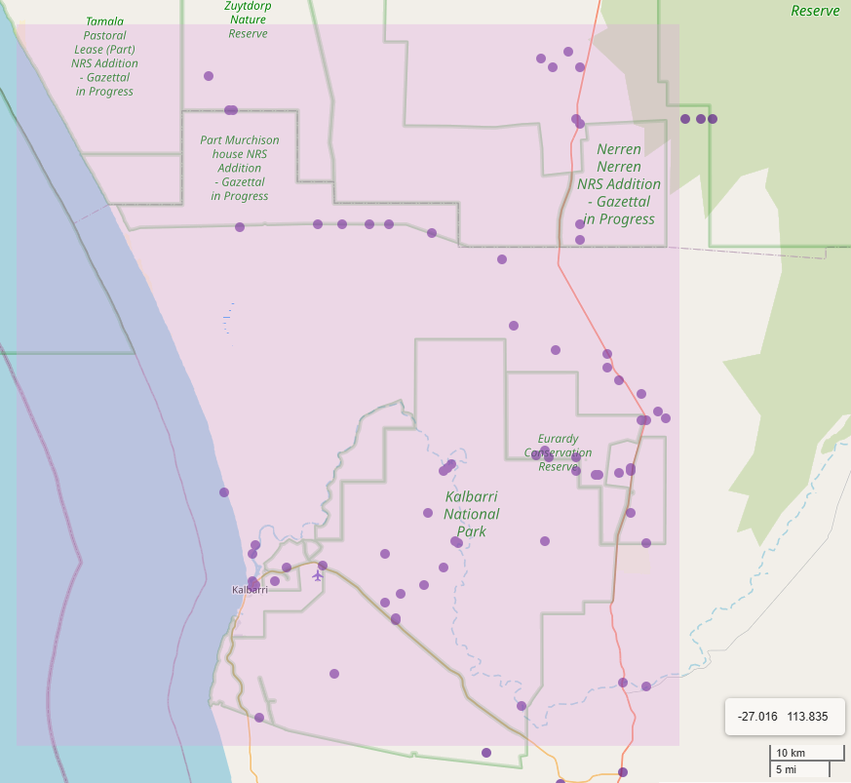
Fig 1. Current records (as of 24.2.2025) of Hymenoptera (excluding bees and ants) in and around the survey area on the Atlas of Living Australia.

2. Methods

2.1 Site selection
Sites were selected to try to cover a broad range of habitats and geographic spread, although sites with flowering plants were prioritised due to the likelihood of increasing the amount collected if sweep netting is done at floral resources vs non-flowering vegetation. The 67 different sites at which Hymenoptera were collected is shown in Figure 2 (note that 10 of these points actually represent vehicle net samples that range from 4 km to 35 km in sampled distances).

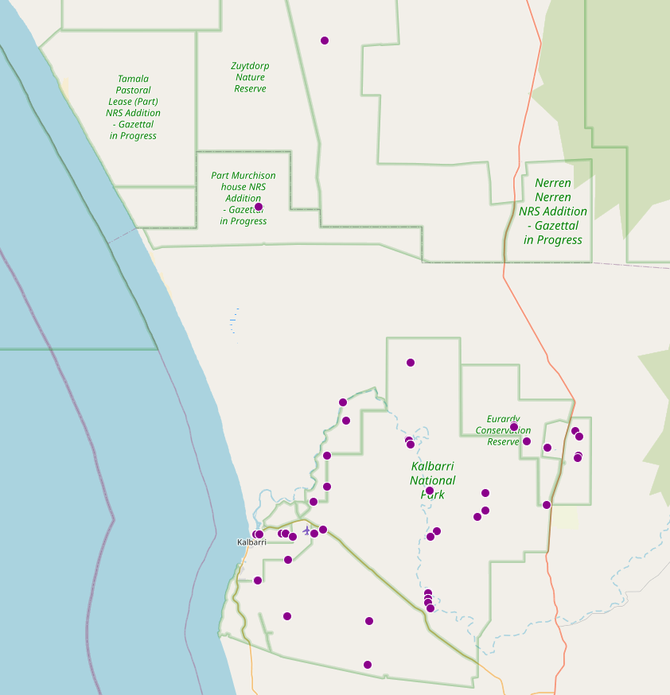
Fig. 2. Sites at which wasps (Hymenoptera excluding bees and ants) were collected from during the Bush Blitz survey.

2.2 Survey techniques
Various survey techniques were used to try to sample as much diversity as possible, and included:
- Contact sweep netting of vegetation, particularly flowering plants (Fig. 3).
- Active collection of wasps on the ground or trunk/branches of trees (Fig. 3).
- Active collecting at a Lepi-LED light in front of a white sheet or tent.
- Five standard Townes style Malaise traps (e.g. Fig. 4), and four 6 m Malaise traps.
- Vehicle nets mounted on top of cars travelling along tracks within the park.
Samples were collected into 70-100% ethanol and kept cold in a fridge or freezer for the duration of the expedition.
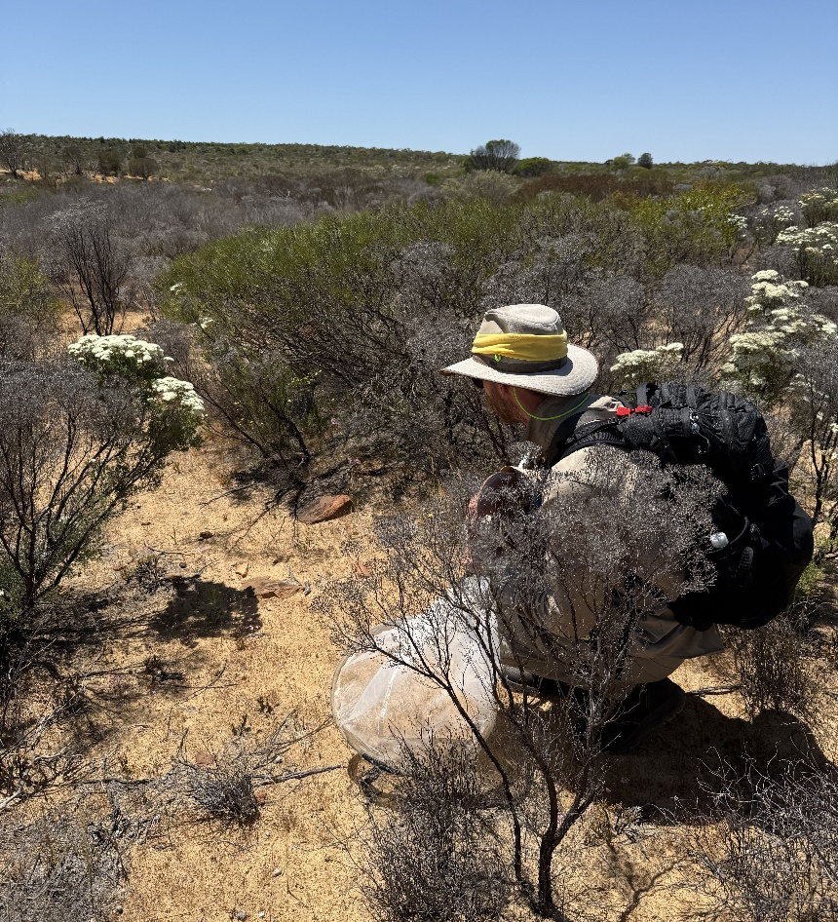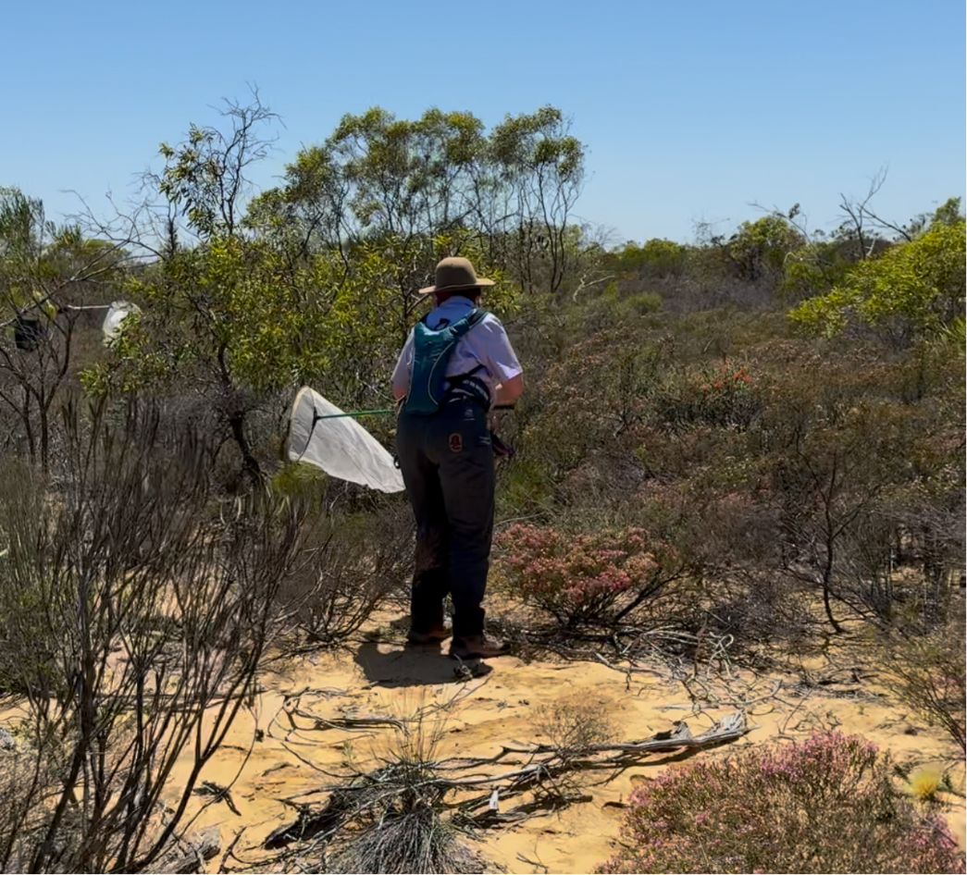
Fig. 3. Examples of ground collecting (stalking wasps hovering above the sand) and sweep netting on the expedition.

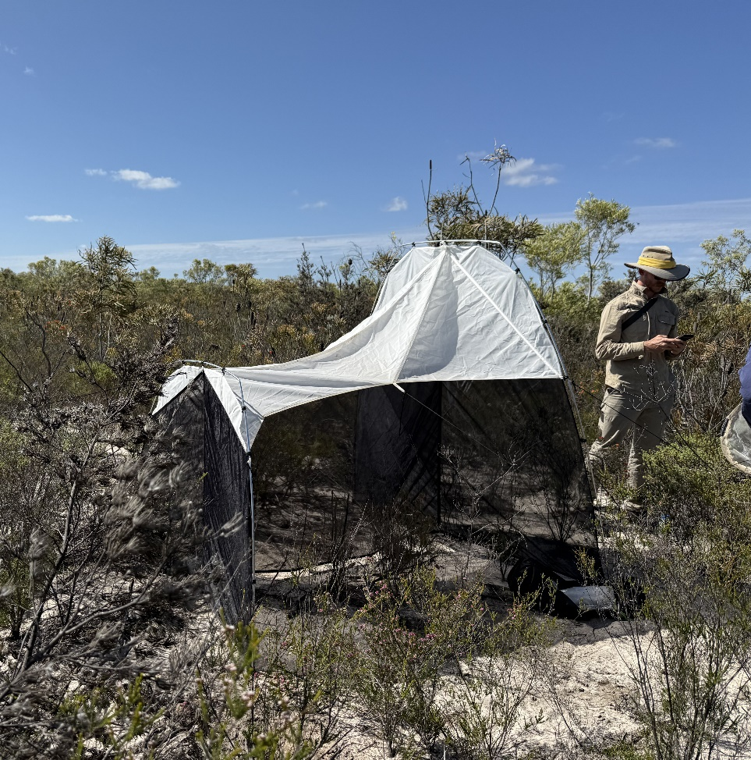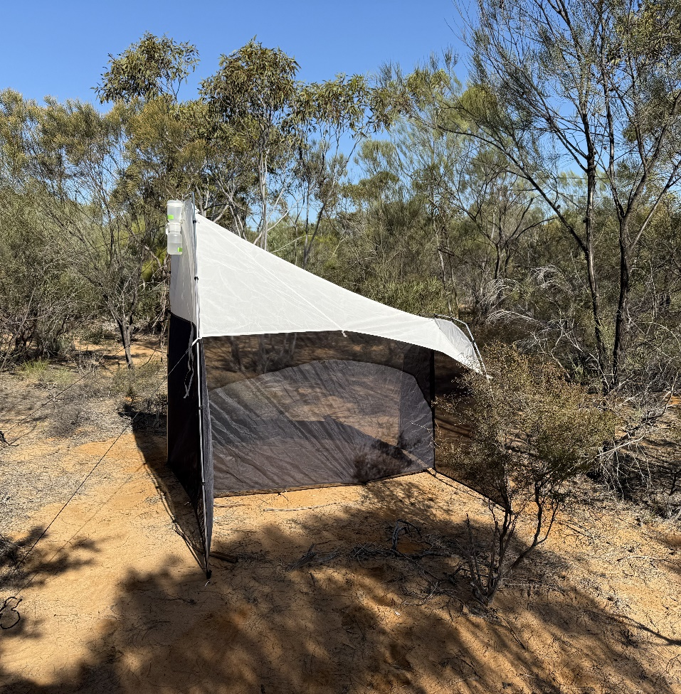
Fig. 4. Two of the Townes-style Malaise traps used on the Nanda Country Bush Blitz.

2.2.1 Methods used at standard survey sites
Both standard survey sites were visited by the survey authors or other expedition members with a team of people (either Nanda rangers, DBCA rangers, BHP staff or teachers). A Townes-style Malaise trap was placed at each site for as long as possible during the expedition. At each site, sweep-netting of vegetation and direct searching was conducted for at least half an hour.

2.3 Identifying the collections
Bulk samples were firstly sorted to order level, and then to superfamily or family level. Many specimens of the superfamilies Chalcidoidea, Platygastroidea and Ichneumonoidea (n=2280) underwent rapid-DNA barcoding of the COI gene using the pipeline developed in the SARFMEE labs at The University of Adelaide. Sequences were sorted into Molecular Operational Taxonomic Units (MOTUs) using the RESL algorithm on BOLD. Sequences were compared against references databases (Gebank or BOLD) using BLAST (Genbank) or the BOLD identification portal. Identifications and MOTU delimitation was confirmed or supported using coarse morphology.
For all other superfamilies, specimens were identified as far as reasonably possible in the timeframe (e.g. subfamily, genus, or species level) using a variety of resources (listed below) and comparison to the collection at The South Australian Museum (SAMA).
The following resources were used to identify survey material (Azevedo et. al. 2018; Bohart, 1985; Bohart & Menke, 1976; Carpenter & Brown, 2021; Evans & Matthews, 1973; Gauld, 1984; Naumann, 1991; Jennings & Austin, 2002; Pasteels, 1957; Parslow, 2020).

3. Results and Discussion
Appendix 1 lists all Hymenoptera (excluding ants and bees) recorded during the Bush Blitz. Collections made during this Bush Blitz will result in at least 3000 specimens being added to public collections. Due to the timeframe of the survey report, the authors were unable to identify all individuals, and prioritised identifying species across the diversity of Hymenoptera, and groups in which they had expertise.
In total, 1678 individual specimens were identified to a putative species level, either to a named species, or an operational taxonomic unit (either a morphospecies or molecular OTU). There were 508 different putative species identified amongst those 1678 individuals, in 37 different families, 44 which were able to be identified as a named species using either morphology or a match of the COI barcode to BOLD or Genbank (subsequently confirmed by coarse morphological examination). These records are all available to be added to public databases. Only three of the taxa identified to species level were previously recorded on the Atlas of Living Australia within the survey area: Bothriomutilla rugicollis, Radumeris tasmaniensis and Podalonia tydei. The remaining 41 taxa represent new records for the survey area (according to ALA data).
Given that only 15 families and 11 species (231 records total) were listed on ALA in the survey area before the expedition, this represents a very large increase in the available biodiversity data, including a doubling of the number of hymenopteran families formally recorded.

3.1 Un-named or not formalised taxa
As most of Australia’s wasp diversity is undescribed, and identifying all of the 37 different families to species level using traditional (often non-existent or outdated keys) is beyond the scope of this report, most of the species fall under the ‘un-named or not formalised’ definition. It is likely a few of these are named taxa, but will require significant time and expertise in the different groups to determine. The survey authors made an effort to sort as many specimens as possible to morphospecies or molecular OTU (MOTUs) to allow the collections to be as accessible for future research as possible.
Table 1. Putatively un-named or not formalised taxa
Taxon | Comment
Acanthostethus BBKB-1 | Identified to genus and morphospecies
Agathidinae sp. BBKB-1 | identified to subfamily and MOTU
Agathidinae sp. BBKB-2 | identified to subfamily and MOTU
Agathidinae sp. BBKB-3 | identified to subfamily and MOTU
Agathidinae sp. BBKB-4 | identified to subfamily and MOTU
Agathidinae sp. BBKB-5 | identified to subfamily and MOTU
Aleiodes sp. BBKB-1 | identified to genus and MOTU
Allophatnus sp. BBKB-1 | identified to genus and MOTU
Anacis sp. BBKB-1 | identified to genus and MOTU
Anacis sp. BBKB-2 | identified to genus and MOTU
Anoplius BBKB-1 | Identified to genus and morphospecies
Argogorytes BBKB-1 | Identified to genus and morphospecies
Austrogorytes BBKB-1 | Identified to genus and morphospecies
Austrogorytes BBKB-2 | Identified to genus and morphospecies
Bembecinus BBKB-1 | Identified to genus and morphospecies
Bembecinus BBKB-2 | Identified to genus and morphospecies
Bembix BBKB-1 | Identified to genus and morphospecies
Bembix BBKB-2 | Identified to genus and morphospecies
Brachistinae sp. BBKB-1 | identified to subfamily and MOTU
Brachycyrtus sp. BBKB-1 | identified to genus and MOTU
Brachymeria sp. BBKB-1 | identified to genus and MOTU
Brachymeria sp. BBKB-2 | identified to genus and MOTU
Brachymeria sp. BBKB-3 | identified to genus and MOTU
Brachymeria sp. BBKB-4 | identified to genus and MOTU
Brachymeria sp. BBKB-5 | identified to genus and MOTU
Brachymeria sp. BBKB-6 | identified to genus and MOTU
Braconidae sp. BBKB-1 | identified to family and MOTU
Braconidae sp. BBKB-2 | identified to family and MOTU
Braconidae sp. BBKB-3 | identified to family and MOTU
Braconidae sp. BBKB-4 | identified to family and MOTU
Braconidae sp. BBKB-5 | identified to family and MOTU
Braconinae sp. BBKB-1 | identified to subfamily and MOTU
Braconinae sp. BBKB-10 | identified to subfamily and MOTU
Braconinae sp. BBKB-11 | identified to subfamily and MOTU
Braconinae sp. BBKB-12 | identified to subfamily and MOTU
Braconinae sp. BBKB-13 | identified to subfamily and MOTU
Braconinae sp. BBKB-2 | identified to subfamily and MOTU
Braconinae sp. BBKB-3 | identified to subfamily and MOTU
Braconinae sp. BBKB-4 | identified to subfamily and MOTU
Braconinae sp. BBKB-5 | identified to subfamily and MOTU
Braconinae sp. BBKB-6 | identified to subfamily and MOTU
Braconinae sp. BBKB-7 | identified to subfamily and MOTU
Braconinae sp. BBKB-8 | identified to subfamily and MOTU
Braconinae sp. BBKB-9 | identified to subfamily and MOTU
Campopleginae sp. BBKB-1 | identified to subfamily and MOTU
Cardiochilinae sp. BBKB-1 | identified to subfamily and MOTU
Ceraphronidae sp. BBKB-1 | identified to family and MOTU
Ceraphronidae sp. BBKB-2 | identified to family and MOTU
Chalcididae sp. BBKB-1 | identified to family and MOTU
Chalcididae sp. BBKB-10 | identified to family and MOTU
Chalcididae sp. BBKB-2 | identified to family and MOTU
Chalcididae sp. BBKB-3 | identified to family and MOTU
Chalcididae sp. BBKB-4 | identified to family and MOTU
Chalcididae sp. BBKB-5 | identified to family and MOTU
Chalcididae sp. BBKB-6 | identified to family and MOTU
Chalcididae sp. BBKB-7 | identified to family and MOTU
Chalcididae sp. BBKB-8 | identified to family and MOTU
Chalcididae sp. BBKB-9 | identified to family and MOTU
Chalcidoidea sp. BBKB-1 | identified to superfamily and MOTU
Chalcidoidea sp. BBKB-10 | identified to superfamily and MOTU
Chalcidoidea sp. BBKB-11 | identified to superfamily and MOTU
Chalcidoidea sp. BBKB-12 | identified to superfamily and MOTU
Chalcidoidea sp. BBKB-13 | identified to superfamily and MOTU
Chalcidoidea sp. BBKB-14 | identified to superfamily and MOTU
Chalcidoidea sp. BBKB-15 | identified to superfamily and MOTU
Chalcidoidea sp. BBKB-16 | identified to superfamily and MOTU
Chalcidoidea sp. BBKB-17 | identified to superfamily and MOTU
Chalcidoidea sp. BBKB-18 | identified to superfamily and MOTU
Chalcidoidea sp. BBKB-19 | identified to superfamily and MOTU
Chalcidoidea sp. BBKB-2 | identified to superfamily and MOTU
Chalcidoidea sp. BBKB-20 | identified to superfamily and MOTU
Chalcidoidea sp. BBKB-21 | identified to superfamily and MOTU
Chalcidoidea sp. BBKB-22 | identified to superfamily and MOTU
Chalcidoidea sp. BBKB-23 | identified to superfamily and MOTU
Chalcidoidea sp. BBKB-24 | identified to superfamily and MOTU
Chalcidoidea sp. BBKB-25 | identified to superfamily and MOTU
Chalcidoidea sp. BBKB-26 | identified to superfamily and MOTU
Chalcidoidea sp. BBKB-3 | identified to superfamily and MOTU
Chalcidoidea sp. BBKB-4 | identified to superfamily and MOTU
Chalcidoidea sp. BBKB-5 | identified to superfamily and MOTU
Chalcidoidea sp. BBKB-6 | identified to superfamily and MOTU
Chalcidoidea sp. BBKB-7 | identified to superfamily and MOTU
Chalcidoidea sp. BBKB-8 | identified to superfamily and MOTU
Chalcidoidea sp. BBKB-9 | identified to superfamily and MOTU
Cheloninae sp. BBKB-1 | identified to subfamily and MOTU
Cheloninae sp. BBKB-2 | identified to subfamily and MOTU
Cheloninae sp. BBKB-3 | identified to subfamily and MOTU
Cheloninae sp. BBKB-4 | identified to subfamily and MOTU
Chrysolampidae sp. BBKB-1 | identified to family and MOTU
Chrysolampidae sp. BBKB-2 | identified to family and MOTU
Clitemnestra BBKB-1 | Identified to genus and morphospecies
Coelocybidae sp. BBKB-1 | identified to family and MOTU
Coelocybidae sp. BBKB-2 | identified to family and MOTU
Colotrechninae sp. BBKB-1 | identified to subfamily and MOTU
Colotrechninae sp. BBKB-2 | identified to subfamily and MOTU
Colotrechninae sp. BBKB-3 | identified to subfamily and MOTU
Colotrechninae sp. BBKB-4 | identified to subfamily and MOTU
Colotrechninae sp. BBKB-5 | identified to subfamily and MOTU
Colotrechninae sp. BBKB-6 | identified to subfamily and MOTU
Colotrechninae sp. BBKB-7 | identified to subfamily and MOTU
Cotesia nr radiantis' cf Fagan-Jeffries & Austin 2019 | identified to genus and MOTU, match to published MOTU
Cotesia sp. BBKB-1 | identified to genus and MOTU
Ctenostegus BBKB-1 | Identified to genus and morphospecies
Ctenostegus BBKB-2 | Identified to genus and morphospecies
Ctenostegus BBKB-3 | Identified to genus and morphospecies
Dinotrema sp. BBKB-1 | identified to genus and MOTU
Diolcogaster sp. BBKB-1 | identified to genus and MOTU
Diolcogaster sp. BBKB-2 | identified to genus and MOTU
Dolichogenidea sp. BBKB-1 | identified to genus and MOTU
Dolichogenidea sp. BBKB-2 | identified to genus and MOTU
Dolichogenidea sp. BBKB-3 | identified to genus and MOTU
Dolichogenidea sp. BBKB-4 | identified to genus and MOTU
Dryinus BBKB-1 | Identified to genus and morphospecies
Encyrtidae sp. BBKB-1 | identified to family and MOTU
Encyrtidae sp. BBKB-10 | identified to family and MOTU
Encyrtidae sp. BBKB-11 | identified to family and MOTU
Encyrtidae sp. BBKB-12 | identified to family and MOTU
Encyrtidae sp. BBKB-13 | identified to family and MOTU
Encyrtidae sp. BBKB-14 | identified to family and MOTU
Encyrtidae sp. BBKB-15 | identified to family and MOTU
Encyrtidae sp. BBKB-16 | identified to family and MOTU
Encyrtidae sp. BBKB-2 | identified to family and MOTU
Encyrtidae sp. BBKB-3 | identified to family and MOTU
Encyrtidae sp. BBKB-4 | identified to family and MOTU
Encyrtidae sp. BBKB-5 | identified to family and MOTU
Encyrtidae sp. BBKB-6 | identified to family and MOTU
Encyrtidae sp. BBKB-7 | identified to family and MOTU
Encyrtidae sp. BBKB-8 | identified to family and MOTU
Encyrtidae sp. BBKB-9 | identified to family and MOTU
Enicospilus sp. BBKB-1 | identified to genus and MOTU
Entedoninae sp. BBKB-1 | identified to subfamily and MOTU
Entedoninae sp. BBKB-2 | identified to subfamily and MOTU
Entedoninae sp. BBKB-5 | identified to subfamily and MOTU
Entedoninae sp. BBKB-6 | identified to subfamily and MOTU
Entedoninae sp. BBKB-7 | identified to subfamily and MOTU
Entedoninae sp. BBKB-8 | identified to subfamily and MOTU
Epyrinae BBKB-1 | identified to subfamily and morphospecies
Epyrinae BBKB-2 | identified to subfamily and morphospecies
Eucaphila sp. BBKB-1 | identified to genus and MOTU
Eulophidae sp. BBKB-1 | identified to family and MOTU
Eulophidae sp. BBKB-10 | identified to family and MOTU
Eulophidae sp. BBKB-11 | identified to family and MOTU
Eulophidae sp. BBKB-12 | identified to family and MOTU
Eulophidae sp. BBKB-13 | identified to family and MOTU
Eulophidae sp. BBKB-14 | identified to family and MOTU
Eulophidae sp. BBKB-15 | identified to family and MOTU
Eulophidae sp. BBKB-16 | identified to family and MOTU
Eulophidae sp. BBKB-2 | identified to family and MOTU
Eulophidae sp. BBKB-3 | identified to family and MOTU
Eulophidae sp. BBKB-4 | identified to family and MOTU
Eulophidae sp. BBKB-5 | identified to family and MOTU
Eulophidae sp. BBKB-6 | identified to family and MOTU
Eulophidae sp. BBKB-7 | identified to family and MOTU
Eulophidae sp. BBKB-8 | identified to family and MOTU
Eulophidae sp. BBKB-9 | identified to family and MOTU
Eulophinae sp. BBKB-1 | identified to subfamily and MOTU
Eulophinae sp. BBKB-10 | identified to subfamily and MOTU
Eulophinae sp. BBKB-11 | identified to subfamily and MOTU
Eulophinae sp. BBKB-12 | identified to subfamily and MOTU
Eulophinae sp. BBKB-13 | identified to subfamily and MOTU
Eulophinae sp. BBKB-14 | identified to subfamily and MOTU
Eulophinae sp. BBKB-15 | identified to subfamily and MOTU
Eulophinae sp. BBKB-16 | identified to subfamily and MOTU
Eulophinae sp. BBKB-2 | identified to subfamily and MOTU
Eulophinae sp. BBKB-3 | identified to subfamily and MOTU
Eulophinae sp. BBKB-4 | identified to subfamily and MOTU
Eulophinae sp. BBKB-6 | identified to subfamily and MOTU
Eulophinae sp. BBKB-7 | identified to subfamily and MOTU
Eulophinae sp. BBKB-8 | identified to subfamily and MOTU
Eulophinae sp. BBKB-9 | identified to subfamily and MOTU
Eumeninae BBKB-1 | identified to subfamily and morphospecies
Eumeninae BBKB-2 | identified to subfamily and morphospecies
Eumeninae BBKB-3 | identified to subfamily and morphospecies
Eupelmidae sp. BBKB-1 | identified to family and MOTU
Eupelmidae sp. BBKB-10 | identified to family and MOTU
Eupelmidae sp. BBKB-11 | identified to family and MOTU
Eupelmidae sp. BBKB-2 | identified to family and MOTU
Eupelmidae sp. BBKB-3 | identified to family and MOTU
Eupelmidae sp. BBKB-4 | identified to family and MOTU
Eupelmidae sp. BBKB-5 | identified to family and MOTU
Eupelmidae sp. BBKB-6 | identified to family and MOTU
Eupelmidae sp. BBKB-7 | identified to family and MOTU
Eupelmidae sp. BBKB-8 | identified to family and MOTU
Eupelmidae sp. BBKB-9 | identified to family and MOTU
Euphorinae sp. BBKB-1 | identified to subfamily and MOTU
Eupsenella BBKB-1 | Identified to genus and morphospecies
Euryischiinae sp. BBKB-1 | identified to subfamily and MOTU
Euryischiinae sp. BBKB-2 | identified to subfamily and MOTU
Euryischiinae sp. BBKB-3 | identified to subfamily and MOTU
Eurytomidae sp. BBKB-1 | identified to family and MOTU
Eurytomidae sp. BBKB-10 | identified to family and MOTU
Eurytomidae sp. BBKB-11 | identified to family and MOTU
Eurytomidae sp. BBKB-12 | identified to family and MOTU
Eurytomidae sp. BBKB-13 | identified to family and MOTU
Eurytomidae sp. BBKB-14 | identified to family and MOTU
Eurytomidae sp. BBKB-15 | identified to family and MOTU
Eurytomidae sp. BBKB-16 | identified to family and MOTU
Eurytomidae sp. BBKB-17 | identified to family and MOTU
Eurytomidae sp. BBKB-18 | identified to family and MOTU
Eurytomidae sp. BBKB-19 | identified to family and MOTU
Eurytomidae sp. BBKB-2 | identified to family and MOTU
Eurytomidae sp. BBKB-20 | identified to family and MOTU
Eurytomidae sp. BBKB-21 | identified to family and MOTU
Eurytomidae sp. BBKB-22 | identified to family and MOTU
Eurytomidae sp. BBKB-23 | identified to family and MOTU
Eurytomidae sp. BBKB-24 | identified to family and MOTU
Eurytomidae sp. BBKB-25 | identified to family and MOTU
Eurytomidae sp. BBKB-26 | identified to family and MOTU
Eurytomidae sp. BBKB-27 | identified to family and MOTU
Eurytomidae sp. BBKB-28 | identified to family and MOTU
Eurytomidae sp. BBKB-29 | identified to family and MOTU
Eurytomidae sp. BBKB-3 | identified to family and MOTU
Eurytomidae sp. BBKB-30 | identified to family and MOTU
Eurytomidae sp. BBKB-31 | identified to family and MOTU
Eurytomidae sp. BBKB-32 | identified to family and MOTU
Eurytomidae sp. BBKB-33 | identified to family and MOTU
Eurytomidae sp. BBKB-34 | identified to family and MOTU
Eurytomidae sp. BBKB-35 | identified to family and MOTU
Eurytomidae sp. BBKB-4 | identified to family and MOTU
Eurytomidae sp. BBKB-5 | identified to family and MOTU
Eurytomidae sp. BBKB-6 | identified to family and MOTU
Eurytomidae sp. BBKB-7 | identified to family and MOTU
Eurytomidae sp. BBKB-8 | identified to family and MOTU
Eurytomidae sp. BBKB-9 | identified to family and MOTU
Gasteruption BBKB-1 | Identified to genus and morphospecies
Gasteruption BBKB-2 | Identified to genus and morphospecies
Goniozus BBKB-1 | Identified to genus and morphospecies
Gryon sp. M427_cf Murphy et al 2007_saxatile_group | identified to genus and MOTU, match to published MOTU
Gryon sp. M430 cf Murphy et al 2007 | identified to genus and MOTU, match to published MOTU
Gryon sp. BBKB-1 | identified to genus and MOTU
Homolobinae sp. BBKB-1 | identified to subfamily and MOTU
Homolobinae sp. BBKB-2 | identified to subfamily and MOTU
Ichneumonidae sp. BBKB-1 | identified to family and MOTU
Ichneumonidae sp. BBKB-2 | identified to family and MOTU
Ichneumonidae sp. BBKB-3 | identified to family and MOTU
Iconella sp. BBKB-1 | identified to genus and MOTU
Labium sp. BBKB-1 | identified to genus and MOTU
Labium sp. BBKB-2 | identified to genus and MOTU
Larrisson BBKB-1 | Identified to genus and morphospecies
Megastigmidae sp. BBKB-1 | identified to family and MOTU
Megastigmidae sp. BBKB-2 | identified to family and MOTU
Megastigmidae sp. BBKB-3 | identified to family and MOTU
Megastigmidae sp. BBKB-4 | identified to family and MOTU
Megastigmidae sp. BBKB-5 | identified to family and MOTU
Megastigmus sp. BBKB-1 | identified to genus and MOTU
Mesochorus sp. BBKB-1 | identified to genus and MOTU
Mesochorus sp. BBKB-2 | identified to genus and MOTU
Microchelonus sp. BBKB-1 | identified to genus and MOTU
Microctonus sp. BBKB-1 | identified to genus and MOTU
Microctonus sp. BBKB-2 | identified to genus and MOTU
Microctonus sp. BBKB-3 | identified to genus and MOTU
Microgastrinae sp. BBKB-1 | identified to subfamily and MOTU
Microgastrinae sp. BBKB-2 | identified to subfamily and MOTU
Microgastrinae sp. BBKB-3 | identified to subfamily and MOTU
Microplitis sp. BBKB-1 | identified to genus and MOTU
Microplitis sp. BBKB-2 | identified to genus and MOTU
Mutilidae BBKB-1 | identified to family and morphospecies
Mutilidae BBKB-2 | identified to family and morphospecies
Mutilidae BBKB-3 | identified to family and morphospecies
Mutilidae BBKB-4 | identified to family and morphospecies
Mutilidae BBKB-5 | identified to family and morphospecies
Mutilidae BBKB-6 | identified to family and morphospecies
Mutilidae BBKB-7 | identified to family and morphospecies
Mymaridae sp. BBKB-1 | identified to family and MOTU
Mymaridae sp. BBKB-10 | identified to family and MOTU
Mymaridae sp. BBKB-11 | identified to family and MOTU
Mymaridae sp. BBKB-12 | identified to family and MOTU
Mymaridae sp. BBKB-2 | identified to family and MOTU
Mymaridae sp. BBKB-3 | identified to family and MOTU
Mymaridae sp. BBKB-4 | identified to family and MOTU
Mymaridae sp. BBKB-5 | identified to family and MOTU
Mymaridae sp. BBKB-6 | identified to family and MOTU
Mymaridae sp. BBKB-7 | identified to family and MOTU
Mymaridae sp. BBKB-8 | identified to family and MOTU
Mymaridae sp. BBKB-9 | identified to family and MOTU
Netelia sp. BBKB-1 | identified to genus and MOTU
Netelia sp. BBKB-2 | identified to genus and MOTU
Netelia sp. BBKB-3 | identified to genus and MOTU
Netelia sp. BBKB-4 | identified to genus and MOTU
Opiinae sp. BBKB-1 | identified to subfamily and MOTU
Opiinae sp. BBKB-2 | identified to subfamily and MOTU
Opius sp. BBKB-1 | identified to genus and MOTU
Opius sp. BBKB-2 | identified to genus and MOTU
Opius sp. BBKB-3 | identified to genus and MOTU
Orgilinae sp. BBKB-1 | identified to subfamily and MOTU
Orthocentrinae sp. BBKB-2 | identified to subfamily and MOTU
Orthocentrus sp. BBKB-1 | identified to genus and MOTU
Oxyserphus BBKB-1 | Identified to genus and morphospecies
Paraphylax BBKB-1 | identified to genus and MOTU
Paraphylax sp. BBKB-1 | identified to genus and MOTU
Paraphylax sp. BBKB-2 | identified to genus and MOTU
Paraphylax sp. BBKB-3 | identified to genus and MOTU
Perilampidae sp. BBKB-1 | identified to family and MOTU
Perilampidae sp. BBKB-2 | identified to family and MOTU
Perilampidae sp. BBKB-3 | identified to family and MOTU
Perilampidae sp. BBKB-4 | identified to family and MOTU
Perilampidae sp. BBKB-5 | identified to family and MOTU
Perilampidae sp. BBKB-6 | identified to family and MOTU
Phanerotoma sp. BBKB-1 | identified to genus and MOTU
Phanerotoma sp. BBKB-2 | identified to genus and MOTU
Phanerotoma sp. BBKB-3 | identified to genus and MOTU
Phanerotoma sp. BBKB-4 | identified to genus and MOTU
Platygastridae sp. BBKB-10 | identified to family and MOTU
Platygastridae sp. BBKB-1 | identified to family and MOTU
Platygastridae sp. BBKB-2 | identified to family and MOTU
Platygastridae sp. BBKB-3 | identified to family and MOTU
Platygastridae sp. BBKB-4 | identified to family and MOTU
Platygastridae sp. BBKB-6 | identified to family and MOTU
Platygastridae sp. BBKB-7 | identified to family and MOTU
Platygastridae sp. BBKB-8 | identified to family and MOTU
Platygastridae sp. BBKB-9 | identified to family and MOTU
Platygastroidea sp. BBKB-1 | identified to superfamily and MOTU
Platygastroidea sp. BBKB-2 | identified to superfamily and MOTU
Platygastroidea sp. BBKB-3 | identified to superfamily and MOTU
Podagritus BBKB-1 | Identified to genus and morphospecies
Podagritus BBKB-2 | Identified to genus and morphospecies
Pristaulacus BBKB-1 | Identified to genus and morphospecies
Pseudofoenus BBKB-1 | Identified to genus and morphospecies
Pseudofoenus BBKB-2 | Identified to genus and morphospecies
Psyllaephagus sp. BBKB-1 | identified to genus and MOTU
Psyllaephagus sp. BBKB-2 | identified to genus and MOTU
Psyllaephagus sp. BBKB-3 | identified to genus and MOTU
Pteromalidae sp. BBKB-1 | identified to family and MOTU
Pteromalidae sp. BBKB-10 | identified to family and MOTU
Pteromalidae sp. BBKB-11 | identified to family and MOTU
Pteromalidae sp. BBKB-2 | identified to family and MOTU
Pteromalidae sp. BBKB-3 | identified to family and MOTU
Pteromalidae sp. BBKB-4 | identified to family and MOTU
Pteromalidae sp. BBKB-5 | identified to family and MOTU
Pteromalidae sp. BBKB-6 | identified to family and MOTU
Pteromalidae sp. BBKB-7 | identified to family and MOTU
Pteromalidae sp. BBKB-8 | identified to family and MOTU
Pteromalidae sp. BBKB-9 | identified to family and MOTU
Pteromalidae? sp. BBKB-1 | identified to family and MOTU
Scelionidae sp. BBKB-1 | identified to family and MOTU
Scelionidae sp. BBKB-10 | identified to family and MOTU
Scelionidae sp. BBKB-11 | identified to family and MOTU
Scelionidae sp. BBKB-12 | identified to family and MOTU
Scelionidae sp. BBKB-13 | identified to family and MOTU
Scelionidae sp. BBKB-14 | identified to family and MOTU
Scelionidae sp. BBKB-15 | identified to family and MOTU
Scelionidae sp. BBKB-16 | identified to family and MOTU
Scelionidae sp. BBKB-17 | identified to family and MOTU
Scelionidae sp. BBKB-18 | identified to family and MOTU
Scelionidae sp. BBKB-19 | identified to family and MOTU
Scelionidae sp. BBKB-2 | identified to family and MOTU
Scelionidae sp. BBKB-3 | identified to family and MOTU
Scelionidae sp. BBKB-4 | identified to family and MOTU
Scelionidae sp. BBKB-5 | identified to family and MOTU
Scelionidae sp. BBKB-6 | identified to family and MOTU
Scelionidae sp. BBKB-7 | identified to family and MOTU
Scelionidae sp. BBKB-8 | identified to family and MOTU
Scelionidae sp. BBKB-9 | identified to family and MOTU
Scelioninae sp. BBKB-1 | identified to subfamily and MOTU
Scolia BBKB-1 | Identified to genus and morphospecies
Sericophorus BBKB-1 | Identified to genus and morphospecies
Sericophorus BBKB-2 | Identified to genus and morphospecies
Spex BBKB-1 | Identified to genus and morphospecies
Spex BBKB-2 | Identified to genus and morphospecies
Spex BBKB-3 | Identified to genus and morphospecies
Spilomena BBKB-1 | Identified to genus and morphospecies
Synopeas sp. BBKB-1 | identified to genus and MOTU
Systasidae sp. BBKB-1 | identified to family and MOTU
Systasidae sp. BBKB-2 | identified to family and MOTU
Systasidae sp. BBKB-3 | identified to family and MOTU
Systasidae sp. BBKB-4 | identified to family and MOTU
Systasidae sp. BBKB-5 | identified to family and MOTU
Systasidae sp. BBKB-6 | identified to family and MOTU
Systasidae sp. BBKB-7 | identified to family and MOTU
Systasidae sp. BBKB-8 | identified to family and MOTU
Systasidae sp. BBKB-9 | identified to family and MOTU
Szepligetiella BBKB-1 | Identified to genus and morphospecies
Szepligetiella BBKB-2 | Identified to genus and morphospecies
Tachytes BBKB-1 | Identified to genus and morphospecies
Tachytes BBKB-2 | Identified to genus and morphospecies
Tachytes BBKB-3 | Identified to genus and morphospecies
Tanaostigmatidae sp. BBKB-1 | identified to family and MOTU
Tanaostigmodes BBKB-1 | identified to genus and MOTU
Telengaiinae sp. BBKB-1 | identified to subfamily and MOTU
Telenomus sp. M432 cf Murphy et al 2007 | Identified to genus and MOTU
Telenominae sp. BBKB-1 | identified to subfamily and MOTU
Telenominae sp. BBKB-2 | identified to subfamily and MOTU
Telenominae sp. BBKB-3 | identified to subfamily and MOTU
Telenominae sp. BBKB-4 | identified to subfamily and MOTU
Telenominae sp. BBKB-5 | identified to subfamily and MOTU
Telenominae sp. BBKB-6 | identified to subfamily and MOTU
Telostegus BBKB-1 | Identified to genus and morphospecies
Temelucha sp. BBKB-1 | identified to genus and MOTU
Tetrastichinae sp. BBKB-1 | identified to subfamily and MOTU
Tetrastichinae sp. BBKB-10 | identified to subfamily and MOTU
Tetrastichinae sp. BBKB-11 | identified to subfamily and MOTU
Tetrastichinae sp. BBKB-12 | identified to subfamily and MOTU
Tetrastichinae sp. BBKB-13 | identified to subfamily and MOTU
Tetrastichinae sp. BBKB-14 | identified to subfamily and MOTU
Tetrastichinae sp. BBKB-15 | identified to subfamily and MOTU
Tetrastichinae sp. BBKB-16 | identified to subfamily and MOTU
Tetrastichinae sp. BBKB-17 | identified to subfamily and MOTU
Tetrastichinae sp. BBKB-18 | identified to subfamily and MOTU
Tetrastichinae sp. BBKB-19 | identified to subfamily and MOTU
Tetrastichinae sp. BBKB-2 | identified to subfamily and MOTU
Tetrastichinae sp. BBKB-20 | identified to subfamily and MOTU
Tetrastichinae sp. BBKB-21 | identified to subfamily and MOTU
Tetrastichinae sp. BBKB-22 | identified to subfamily and MOTU
Tetrastichinae sp. BBKB-23 | identified to subfamily and MOTU
Tetrastichinae sp. BBKB-24 | identified to subfamily and MOTU
Tetrastichinae sp. BBKB-25 | identified to subfamily and MOTU
Tetrastichinae sp. BBKB-26 | identified to subfamily and MOTU
Tetrastichinae sp. BBKB-27 | identified to subfamily and MOTU
Tetrastichinae sp. BBKB-3 | identified to subfamily and MOTU
Tetrastichinae sp. BBKB-4 | identified to subfamily and MOTU
Tetrastichinae sp. BBKB-5 | identified to subfamily and MOTU
Tetrastichinae sp. BBKB-6 | identified to subfamily and MOTU
Tetrastichinae sp. BBKB-7 | identified to subfamily and MOTU
Tetrastichinae sp. BBKB-8 | identified to subfamily and MOTU
Tetrastichinae sp. BBKB-9 | identified to subfamily and MOTU
Thynnidae BBKB-1 | identified to family and morphospecies
Thynnidae BBKB-10 | identified to family and morphospecies
Thynnidae BBKB-11 | identified to family and morphospecies
Thynnidae BBKB-12 | identified to family and morphospecies
Thynnidae BBKB-13 | identified to family and morphospecies
Thynnidae BBKB-14 | identified to family and morphospecies
Thynnidae BBKB-15 | identified to family and morphospecies
Thynnidae BBKB-16 | identified to family and morphospecies
Thynnidae BBKB-17 | identified to family and morphospecies
Thynnidae BBKB-18 | identified to family and morphospecies
Thynnidae BBKB-19 | identified to family and morphospecies
Thynnidae BBKB-2 | identified to family and morphospecies
Thynnidae BBKB-20 | identified to family and morphospecies
Thynnidae BBKB-21 | identified to family and morphospecies
Thynnidae BBKB-22 | identified to family and morphospecies
Thynnidae BBKB-23 | identified to family and morphospecies
Thynnidae BBKB-3 | identified to family and morphospecies
Thynnidae BBKB-4 | identified to family and morphospecies
Thynnidae BBKB-5 | identified to family and morphospecies
Thynnidae BBKB-6 | identified to family and morphospecies
Thynnidae BBKB-7 | identified to family and morphospecies
Thynnidae BBKB-8 | identified to family and morphospecies
Thynnidae BBKB-9 | identified to family and morphospecies
Toryminae sp. BBKB-1 | identified to subfamily and MOTU
Toryminae sp. BBKB-2 | identified to subfamily and MOTU
Toryminae sp. BBKB-3 | identified to subfamily and MOTU
Toryminae sp. BBKB-4 | identified to subfamily and MOTU
Toryminae sp. BBKB-5 | identified to subfamily and MOTU
Toryminae sp. BBKB-6 | identified to subfamily and MOTU
Toryminae sp. BBKB-7 | identified to subfamily and MOTU
Torymoides sp. BBKB-1 | identified to genus and MOTU
Trichogramma sp. BBKB-1 | identified to genus and MOTU
Trichogrammatidae sp. BBKB-1 | identified to family and MOTU
Trichogrammatidae sp. BBKB-10 | identified to family and MOTU
Trichogrammatidae sp. BBKB-11 | identified to family and MOTU
Trichogrammatidae sp. BBKB-12 | identified to family and MOTU
Trichogrammatidae sp. BBKB-13 | identified to family and MOTU
Trichogrammatidae sp. BBKB-14 | identified to family and MOTU
Trichogrammatidae sp. BBKB-15 | identified to family and MOTU
Trichogrammatidae sp. BBKB-2 | identified to family and MOTU
Trichogrammatidae sp. BBKB-3 | identified to family and MOTU
Trichogrammatidae sp. BBKB-4 | identified to family and MOTU
Trichogrammatidae sp. BBKB-5 | identified to family and MOTU
Trichogrammatidae sp. BBKB-6 | identified to family and MOTU
Trichogrammatidae sp. BBKB-7 | identified to family and MOTU
Trichogrammatidae sp. BBKB-8 | identified to family and MOTU
Trichogrammatidae sp. BBKB-9 | identified to family and MOTU
Turneromyia BBKB-1 | Identified to genus and morphospecies
Vipiellus sp. BBKB-1 | identified to genus and MOTU
Zagrammosoma nr. latilineatum | identified to genus and MOTU, very close match to described species

3.2 Species new to science
In this report, ‘species new to science’ means species that were not recognised by Western science before this Bush Blitz.
As mentioned above, it is highly likely many of the informal species in section 3.1 are new species, but this will require significant work and expertise in different taxa to determine definitely. The list below are species that the report contributors have expertise in and are reasonably sure represent undescribed species not collected before. However, several other specimens will feed immediately into active systematics projects that the report authors are involved in, including those of Szepligetiella, Paraphylax, Tanaostigmatidae, Microgastrinae, and Rogadinae. Confirmation of new species in those groups is therefore likely to occur within the next 12 months.
Table 2. Species new to science
Species | Comment
Gasteruption BBKB-sp1 | Putative new species, only known from specimens collected on 2021 Bush Blitz Yalata/ Fowlers Bay
Gasteruption BBKB-2 | Putative new species, represented by single male specimen
Pristaulacus BBKB-sp.1 | Distinctive male specimen, different to all described Australian species
Tanaostigmodes BBKB-1 | Extremely rare in collections, only one species known from WA with a lost holotype and vague description.

3.3 Introduced species
There were no introduced species of Hymenoptera (excluding bees, which are not reported here) identified in the material collected. Notably, there were no specimens of the invasive European wasp (Vespula germanica) collected during the survey.

3.4 Threatened species
None of the Hymenoptera species collected during the survey were listed as critically endangered, endangered, vulnerable or conservation dependent under the Australian Environment Protection and Biodiversity Conservation Act 1999. It should be noted that this is more to do with so few invertebrates being listed as threatened, rather than none of the species actually being of conservation concern.

3.5 Range extensions
Detailed information on Hymenoptera distributions is generally only available for well-studied groups. For the range extensions below, unless otherwise noted, we use only the data on the Atlas of Living Australia. We acknowledge there may be additional specimens in collections that are not digitised and available on the ALA.
Of the wasp specimens identified to species level, nearly all of them represent range extensions or infill in distribution (Table 5), due to the limited records for the survey area. Many of the specimens identified to genus, subfamily or family level also represent significant range extensions compared to the data on ALA, but it would be impractical to list them all here.
Table 5. Range extensions or significant infill in distribution records for species
Species | Location sighted/observed | Distance from nearest known record (km) | Comments
Diadegma semiclausum | Kalbarri NP | ~480 km | Nearest record on ALA is near Perth
Diplazon laetatorius | Eurardy station; Kalbarri NP | ~295 km | Records on ALA in Carnarvon and near Guilderton
Ichneumon promissorius | Kalbarri NP | ~480 km | Nearest record on ALA is near Perth
Echthromorpha intricatoria | Kalbarri NP | ~460 km | Nearest record on ALA is near Perth
Lissopimpla excelsa | Kalbarri NP, multiple sites | ~100 km | Records on ALA near Geraldton and Denham
Aphidius colemani | Eurardy Station and Kalbarri NP, multiple sites | ~500 km | Nearest record on ALA is near Perth. Used in biological control of common aphid pests.
Habrobracon hebetor | Kalbarri rd. -27.6989123, 114.1766402 |  | No records on ALA (listed on ALA as Bracon hebetor, may be issue with record sync). Used commercially as a parasitoid for moths. ID needs confirmation.
Myiocnema comperei | Kalbarri NP | ~3000 km | Only records on ALA are in Melbourne, Brisbane, and north QLD.
Aphidius ervi | SSS2 | ~3100 km | No records on ALA in WA – NSW, QLD, TAS. Known and commercially used parasitoid of aphid pests in Australia.
Apanteles brockhedgesi | Kalbarri NP, multiple sites | ~570 km | Most southern record in WA, other record in WA further north (From Slater-Baker et al. 2025)
Apanteles ippeus | Eurardy station; Kalbarri NP, multiple sites | ~570 km | Most southern record in WA, other records for WA further north (From Slater-Baker et al. 2025)
Apanteles magicus | Kalbarri NP | ~480 km | Records in WA near Perth and further north (From Slater-Baker et al. 2025)
Apanteles oenone | Kalbarri NP | ~570 km | Most southern record in WA, two other records for WA further north (From Slater-Baker et al. 2025)
Apanteles rufiterra | Kalbarri NP | ~270 km | Records in WA both north and south of Kalbarri (From Slater-Baker et al. 2025)
Dolichogenidea bonbonensis | Kalbarri NP | ~500 km | Other record in WA is further north (from Fagan-Jeffries et al. 2019)
Glytpanateles kingae | Eurady station, Kalbarri NP, multiple sites | ~500 km | Other record in WA is further north (from Fagan-Jeffries et al. 2022)
Glytpanateles kittelae | Kalbarri NP, multiple sites | ~2,200 km | First record for WA (from Fagan-Jeffries et al. 2022)
Gasteruption raphidioides | Kalbarri NP, Four ways access track | ~540 km | Broadly distributed species, other records from WA are south closer to Perth
Gasteruption zebra | Kalbarri NP, multiple sites | ~2,300 km | Recorded from SA, ACT and NSW
Szepligetiella perfida | Kalbarri NP, Hawks head road | ~1700 km | The species was described from material collected in Tasmania (Westwood, 1851), it has been recorded in SA and likely has a broader distribution across Australia.

3.6 Genetic information
Of the 2280 specimens which underwent COI barcoding, 1794 produced a usable COI barcode (79% sequencing success rate). All available sequences of Ichneumonoidea were included in the dataset used for this report, but there were ~200 barcodes of Platygastroidea and Chalcidoidea that were not included due to time constraints. However, these are still available for future research. This process allowed a much clearer identification of OTUs than morphology would have provided within the timeframe, and also assisted in identifying and delimiting groups in which the report authors are not specialists. We believe the addition of the large number of DNA barcodes in this report allowed for the substantially higher number of families and OTUs to be recorded compared to previous expeditions on which wasps were surveyed. These barcode data will be made public if permission is granted from the Nanda Traditional Owners and land managers, which will also allow the tracking of OTUs across different Bush Blitz surveys if a similar process is followed in future. This is extremely useful given that most of Australia’s hymenopterans are undescribed, there is limited taxonomic expertise, and different researchers attend different Bush Blitz surveys. We believe the addition of the large number of DNA barcodes in this report allowed for the substantially higher number of families and OTUs to be recorded compared to previous expeditions on which wasps were surveyed.

4. Information on species lists
The hymenopteran fauna of Australia is extremely diverse, and highly understudied. The Australian faunal directory lists 74 families and over 12,000 described species (only a third of the estimated species-level diversity). The high diversity and lack of suitable identification resources for many groups makes identifying specimens beyond family or generic level time-consuming and often impossible. Therefore, the main focus of this report was on groups in which the survey participants had expertise and where suitable resources were available. It should also be noted that there is a portion of material that is not included in this report at all and is still in bulk vials sorted to either order or family level, that will be deposited in WAM. However, effort was made to try and include a large spectrum of diversity in the species list.

5. Information for land managers
The sampled habitat across Kalbarri National Park was found to be of high quality and, based on collections, supported diverse communities of Hymenoptera. Sites sampled across the Eurardy Nature Reserve were also found to be of high quality, even in areas with historic evidence of previous grazing. It is recommended continued efforts are maintained to manage pest plant and animal species, and to limit land clearing. This will support the high diversity of Hymenoptera across the parks and reserves.

6. Other significant findings
In terms of the number and diversity of hymenopterans collected on the Nanda Country Bush Blitz, the survey was one of the most successful that either of the report authors have attended. This is likely due to:
- Having a two-person team allowed for more in-depth sampling at sites.
- The “Bee team” (Remko Leijs and Katja Hogendoorn) running vehicle nets provided many specimens not collected with other methods.
- The large number of Malaise traps, including the 6 m traps run by Keith Bayless, provided a diversity of material.
- The collaboration with other survey members, particularly Keith Bayless (Diptera), Nik Tatarnic (Hemiptera), Katja Hogendoorn and Remko Leijs (bees) allowed all entomology participants to collect specimens for other teams at different sites, expanding the diversity of material available to everyone.
The ideal weather (warm, not too windy, allowing high insect activity) and presence of many flowering plants from recent rain, also likely contributed to the high number of different species recorded during the survey.

7. Conclusions
Kalbarri National Park, Eurardy station and surrounding reserves contain a highly diverse hymenopteran fauna. This report touches on just a small subset of the species that are most likely present in the area, and has substantially increased the publicly available biodiversity data for the region.

Acknowledgements
We would like to thank the Nanda Aboriginal Corporation, Nanda Traditional Owners, Nanda Rangers, Department of Biodiversity, Conservation and Attractions (DBCA) rangers, BHP staff, and the Eurardy Nature reserve (Bush Heritage) managers for facilitating access to sites and assisting with collections and knowledge on Country. We are grateful to the other Bush Blitz participants, Earthwatch staff, and the amazing Bush Blitz expedition leaders (Helen and Kate) who assisted with collections, morale, safety and logistics in the field.

References
Azevedo, C. O., Alencar, I. D., Ramos, M. S., Barbosa, D. N., Colombo, W. D., Vargas, J. M., & Lim, J. (2018). Global guide of the flat wasps (Hymenoptera, Bethylidae). Zootaxa, 4489(1), 1-294.
Bohart, R. M. (1985). A key to the Australian Chrysis with description of new species (Hymenoptera: Chrysididae). Insecta Mundi, 47-52.
Bohart, R. M. & Menke, A. S. (1976). Sphecid wasps of the world: A generic revision. University of California Press, London
Burks R, Mitroiu M-D, Fusu L, Heraty JM, Janšta P, Heydon S, Papilloud ND-S, Peters RS, Tselikh EV, Woolley JB, van Noort S, Baur H, Cruaud A, Darling C, Haas M, Hanson P, Krogmann L, Rasplus J-Y (2022) From hell’s heart I stab at thee! A determined approach towards a monophyletic Pteromalidae and reclassification of Chalcidoidea (Hymenoptera). Journal of Hymenoptera Research 94: 13-88. https://doi.org/10.3897/jhr.94.94263
Carpenter, J. M., & Brown, G. R. (2021). A key to the Australian genera of Eumeninae (Hymenoptera: Vespidae). Records of the Australian Museum, 73(3), 87-101.
Evans, H. E., & Matthews, R. W. (1973). Systematics and nesting behavior of Australian Bembix Sand Wasps (Hymenoptera, Sphecidae). American Entomological Institute. https://cir.nii.ac.jp/crid/1130282269543656448
Fagan-Jeffries, E. P., McClelland, A. R., Bird, A. J., Giannotta, M. M., Bradford, T. M., & Austin, A. D. (2022). Systematic revision of the parasitoid wasp genus Glyptapanteles Ashmead (Hymenoptera: Braconidae: Microgastrinae) for Australia results in a ten-fold increase in species. European Journal of Taxonomy, 792(1), 1–116. https://doi.org/10.5852/ejt.2022.792.1647
Fagan-Jeffries, Erinn P., Cooper, Steven J. B. & Austin, Andrew D., 2019, New species of Australian microgastrine parasitoid wasps (Hymenoptera: Braconidae: Microgastrinae) documented through the ‘ Bush Blitz’ surveys of national reserves, Zootaxa 4560 (3), pp. 401-440
Gauld, I. D. (1984). An introduction to the Ichneumonidae of Australia. British Museum (Natural History).
Naumann, I. D., (1991). Hymenoptera (Wasps, bees, ants, sawflies). In The insects of Australia: A textbook for students and research workers (Vol. 2). Cornell University Press.
Jennings, J. T., & Austin, A. D. (2002). Systematics and distribution of world hyptiogastrine wasps (Hymenoptera: Gasteruptiidae). Invertebrate Systematics, 16(5), 735. https://doi.org/10.1071/IT01048
Parslow, B. (2020). Systematics and Host Associations of the Australian Gasteruption (Gasteruptiidae: Evanioidea) (Doctoral dissertation, Flinders University, College of Science and Engineering.).
Pasteels, J. J. (1957). Revision du genre Gasteruption (Hymenoptera, Evanoidea, Gasteruptionidae),[pt. 3.]: Especes australiennes. Memoires Insitut Royal Des Sciences Naturelles de Belgique, 56, 1–125.
Slater-Baker M-R, Fagan-Jeffries EP, Oestmann KJ, Portmann OG, Bament TM, Howe AG, Guzik MT, Bradford TM, McClelland AR, Woodward A, Clarke S, Ducker N, Fernández-Triana J (2025) DNA barcoding, integrative taxonomy, citizen science, and Bush Blitz surveys combine to reveal 34 new species of Apanteles (Hymenoptera, Braconidae, Microgastrinae) in Australia. ZooKeys 1227: 1-128. https://doi.org/10.3897/zookeys.1227.130467

Appendices

Appendix 1. List of Hymenoptera (excluding bees and ants) recorded during the Nanda Country Bush Blitz
Family | Species | Common name | Species new to science | Threatened species (EPBC Act) | Threatened species (Biodiversity Conservation Act 2016) | Introduced species
[Superfamily] Chalcidoidea | Chalcidoidea sp. BBKB-1 | na | unknown | no | no | no
[Superfamily] Chalcidoidea | Chalcidoidea sp. BBKB-2 | na | unknown | no | no | no
[Superfamily] Chalcidoidea | Chalcidoidea sp. BBKB-3 | na | unknown | no | no | no
[Superfamily] Chalcidoidea | Chalcidoidea sp. BBKB-4 | na | unknown | no | no | no
[Superfamily] Chalcidoidea | Chalcidoidea sp. BBKB-5 | na | unknown | no | no | no
[Superfamily] Chalcidoidea | Chalcidoidea sp. BBKB-6 | na | unknown | no | no | no
[Superfamily] Chalcidoidea | Chalcidoidea sp. BBKB-7 | na | unknown | no | no | no
[Superfamily] Chalcidoidea | Chalcidoidea sp. BBKB-8 | na | unknown | no | no | no
[Superfamily] Chalcidoidea | Chalcidoidea sp. BBKB-9 | na | unknown | no | no | no
[Superfamily] Chalcidoidea | Chalcidoidea sp. BBKB-10 | na | unknown | no | no | no
[Superfamily] Chalcidoidea | Chalcidoidea sp. BBKB-11 | na | unknown | no | no | no
[Superfamily] Chalcidoidea | Chalcidoidea sp. BBKB-12 | na | unknown | no | no | no
[Superfamily] Chalcidoidea | Chalcidoidea sp. BBKB-13 | na | unknown | no | no | no
[Superfamily] Chalcidoidea | Chalcidoidea sp. BBKB-14 | na | unknown | no | no | no
[Superfamily] Chalcidoidea | Chalcidoidea sp. BBKB-15 | na | unknown | no | no | no
[Superfamily] Chalcidoidea | Chalcidoidea sp. BBKB-16 | na | unknown | no | no | no
[Superfamily] Chalcidoidea | Chalcidoidea sp. BBKB-17 | na | unknown | no | no | no
[Superfamily] Chalcidoidea | Chalcidoidea sp. BBKB-18 | na | unknown | no | no | no
[Superfamily] Chalcidoidea | Chalcidoidea sp. BBKB-19 | na | unknown | no | no | no
[Superfamily] Chalcidoidea | Chalcidoidea sp. BBKB-20 | na | unknown | no | no | no
[Superfamily] Chalcidoidea | Chalcidoidea sp. BBKB-21 | na | unknown | no | no | no
[Superfamily] Chalcidoidea | Chalcidoidea sp. BBKB-22 | na | unknown | no | no | no
[Superfamily] Chalcidoidea | Chalcidoidea sp. BBKB-23 | na | unknown | no | no | no
[Superfamily] Chalcidoidea | Chalcidoidea sp. BBKB-24 | na | unknown | no | no | no
[Superfamily] Chalcidoidea | Chalcidoidea sp. BBKB-25 | na | unknown | no | no | no
[Superfamily] Chalcidoidea | Chalcidoidea sp. BBKB-26 | na | unknown | no | no | no
[Superfamily] Platygastroidea | Platygastroidea sp. BBKB-1 | na | unknown | no | no | no
[Superfamily] Platygastroidea | Platygastroidea sp. BBKB-2 | na | unknown | no | no | no
[Superfamily] Platygastroidea | Platygastroidea sp. BBKB-3 | na | unknown | no | no | no
Aulacidae | Aulacus aquilus | na | no | no | no | no
Aulacidae | Pristaulacus BBKB-1 | na | yes | no | no | no
Bethylidae | Epyrinae BBKB-1 | na | unknown | no | no | no
Bethylidae | Epyrinae BBKB-2 | na | unknown | no | no | no
Bethylidae | Eupsenella BBKB-1 | na | unknown | no | no | no
Bethylidae | Goniozus BBKB-1 | na | unknown | no | no | no
Braconidae | Agathidinae sp. BBKB-1 | na | unknown | no | no | no
Braconidae | Agathidinae sp. BBKB-2 | na | unknown | no | no | no
Braconidae | Agathidinae sp. BBKB-3 | na | unknown | no | no | no
Braconidae | Agathidinae sp. BBKB-4 | na | unknown | no | no | no
Braconidae | Agathidinae sp. BBKB-5 | na | unknown | no | no | no
Braconidae | Aleiodes sp. BBKB-1 | na | unknown | no | no | no
Braconidae | Apanteles brockhedgesi | na | no | no | no | no
Braconidae | Apanteles ippeus | na | no | no | no | no
Braconidae | Apanteles magicus | na | no | no | no | no
Braconidae | Apanteles oenone | na | no | no | no | no
Braconidae | Apanteles rufiterra | na | no | no | no | no
Braconidae | Aphidius colemani | na | no | no | no | no
Braconidae | Aphidius ervi | na | no | no | no | no
Braconidae | Brachistinae sp. BBKB-1 | na | unknown | no | no | no
Braconidae | Braconidae sp. BBKB-1 | na | unknown | no | no | no
Braconidae | Braconidae sp. BBKB-2 | na | unknown | no | no | no
Braconidae | Braconidae sp. BBKB-3 | na | unknown | no | no | no
Braconidae | Braconidae sp. BBKB-4 | na | unknown | no | no | no
Braconidae | Braconidae sp. BBKB-5 | na | unknown | no | no | no
Braconidae | Braconinae sp. BBKB-1 | na | unknown | no | no | no
Braconidae | Braconinae sp. BBKB-2 | na | unknown | no | no | no
Braconidae | Braconinae sp. BBKB-3 | na | unknown | no | no | no
Braconidae | Braconinae sp. BBKB-5 | na | unknown | no | no | no
Braconidae | Braconinae sp. BBKB-6 | na | unknown | no | no | no
Braconidae | Braconinae sp. BBKB-7 | na | unknown | no | no | no
Braconidae | Braconinae sp. BBKB-8 | na | unknown | no | no | no
Braconidae | Braconinae sp. BBKB-9 | na | unknown | no | no | no
Braconidae | Braconinae sp. BBKB-10 | na | unknown | no | no | no
Braconidae | Braconinae sp. BBKB-11 | na | unknown | no | no | no
Braconidae | Braconinae sp. BBKB-12 | na | unknown | no | no | no
Braconidae | Braconinae sp. BBKB-13 | na | unknown | no | no | no
Braconidae | Cardiochilinae sp. BBKB-1 | na | unknown | no | no | no
Braconidae | Cheloninae sp. BBKB-1 | na | unknown | no | no | no
Braconidae | Cheloninae sp. BBKB-2 | na | unknown | no | no | no
Braconidae | Cheloninae sp. BBKB-3 | na | unknown | no | no | no
Braconidae | Cheloninae sp. BBKB-4 | na | unknown | no | no | no
Braconidae | Cotesia icipe | na | no | no | no | no
Braconidae | Cotesia nr radiantis cf Fagan-Jeffries & Austin 2019 | na | no - known MOTU | no | no | no
Braconidae | Cotesia ruficrus | na | no | no | no | no
Braconidae | Cotesia sp. BBKB-1 | na | unknown | no | no | no
Braconidae | Dinotrema sp. BBKB-1 | na | unknown | no | no | no
Braconidae | Diolcogaster sp. BBKB-1 | na | unknown | no | no | no
Braconidae | Diolcogaster sp. BBKB-2 | na | unknown | no | no | no
Braconidae | Dolichogenidea bonbonensis | na | no | no | no | no
Braconidae | Dolichogenidea sp. BBKB-1 | na | unknown | no | no | no
Braconidae | Dolichogenidea sp. BBKB-2 | na | unknown | no | no | no
Braconidae | Dolichogenidea sp. BBKB-3 | na | unknown | no | no | no
Braconidae | Dolichogenidea sp. BBKB-4 | na | unknown | no | no | no
Braconidae | Eunesaulax terebratus | na | unknown | no | no | no
Braconidae | Euphorinae sp. BBKB-1 | na | unknown | no | no | no
Braconidae | Glyptapanteles kingae | na | no | no | no | no
Braconidae | Glyptapanteles kittelae | na | no | no | no | no
Braconidae | Habrobracon hebetor | na | no | no | no | no
Braconidae | Homolobinae sp. BBKB-1 | na | unknown | no | no | no
Braconidae | Homolobinae sp. BBKB-2 | na | unknown | no | no | no
Braconidae | Iconella sp. BBKB-1 | na | unknown | no | no | no
Braconidae | Microchelonus sp. BBKB-1 | na | unknown | no | no | no
Braconidae | Microctonus sp. BBKB-1 | na | unknown | no | no | no
Braconidae | Microctonus sp. BBKB-2 | na | unknown | no | no | no
Braconidae | Microctonus sp. BBKB-3 | na | unknown | no | no | no
Braconidae | Microgastrinae sp. BBKB-1 | na | unknown | no | no | no
Braconidae | Microgastrinae sp. BBKB-2 | na | unknown | no | no | no
Braconidae | Microgastrinae sp. BBKB-3 | na | unknown | no | no | no
Braconidae | Microplitis demolitor | na | no | no | no | no
Braconidae | Microplitis sp. BBKB-1 | na | unknown | no | no | no
Braconidae | Microplitis sp. BBKB-2 | na | unknown | no | no | no
Braconidae | Opiinae sp. BBKB-1 | na | unknown | no | no | no
Braconidae | Opiinae sp. BBKB-2 | na | unknown | no | no | no
Braconidae | Opius sp. BBKB-1 | na | unknown | no | no | no
Braconidae | Opius sp. BBKB-2 | na | unknown | no | no | no
Braconidae | Opius sp. BBKB-3 | na | unknown | no | no | no
Braconidae | Orgilinae sp. BBKB-1 | na | unknown | no | no | no
Braconidae | Phanerotoma sp. BBKB-1 | na | unknown | no | no | no
Braconidae | Phanerotoma sp. BBKB-2 | na | unknown | no | no | no
Braconidae | Phanerotoma sp. BBKB-3 | na | unknown | no | no | no
Braconidae | Phanerotoma sp. BBKB-4 | na | unknown | no | no | no
Braconidae | Telengaiinae sp. BBKB-1 | na | unknown | no | no | no
Braconidae | Vipiellus sp. BBKB-1 | na | unknown | no | no | no
Ceraphronidae | Ceraphronidae sp. BBKB-1 | na | unknown | no | no | no
Ceraphronidae | Ceraphronidae sp. BBKB-2 | na | unknown | no | no | no
Chalcididae | Brachymeria sp. BBKB-1 | na | unknown | no | no | no
Chalcididae | Brachymeria sp. BBKB-2 | na | unknown | no | no | no
Chalcididae | Brachymeria sp. BBKB-3 | na | unknown | no | no | no
Chalcididae | Brachymeria sp. BBKB-4 | na | unknown | no | no | no
Chalcididae | Brachymeria sp. BBKB-5 | na | unknown | no | no | no
Chalcididae | Brachymeria sp. BBKB-6 | na | unknown | no | no | no
Chalcididae | Chalcididae sp. BBKB-1 | na | unknown | no | no | no
Chalcididae | Chalcididae sp. BBKB-2 | na | unknown | no | no | no
Chalcididae | Chalcididae sp. BBKB-3 | na | unknown | no | no | no
Chalcididae | Chalcididae sp. BBKB-4 | na | unknown | no | no | no
Chalcididae | Chalcididae sp. BBKB-5 | na | unknown | no | no | no
Chalcididae | Chalcididae sp. BBKB-6 | na | unknown | no | no | no
Chalcididae | Chalcididae sp. BBKB-7 | na | unknown | no | no | no
Chalcididae | Chalcididae sp. BBKB-8 | na | unknown | no | no | no
Chalcididae | Chalcididae sp. BBKB-9 | na | unknown | no | no | no
Chalcididae | Chalcididae sp. BBKB-10 | na | unknown | no | no | no
Chrysididae | Chrysis saginata | na | no | no | no | no
Chrysolampidae | Chrysolampidae sp. BBKB-1 | na | unknown | no | no | no
Chrysolampidae | Chrysolampidae sp. BBKB-2 | na | unknown | no | no | no
Coelocybidae | Coelocybidae sp. BBKB-1 | na | unknown | no | no | no
Coelocybidae | Coelocybidae sp. BBKB-2 | na | unknown | no | no | no
Crabronidae | Acanthostethus BBKB-1 | na | unknown | no | no | no
Crabronidae | Argogorytes BBKB-1 | na | unknown | no | no | no
Crabronidae | Austrogorytes BBKB-1 | na | unknown | no | no | no
Crabronidae | Austrogorytes BBKB-2 | na | unknown | no | no | no
Crabronidae | Bembecinus BBKB-1 | na | unknown | no | no | no
Crabronidae | Bembecinus BBKB-2 | na | unknown | no | no | no
Crabronidae | Bembix atrifrons | na | no | no | no | no
Crabronidae | Bembix BBKB-1 | na | unknown | no | no | no
Crabronidae | Bembix BBKB-2 | na | unknown | no | no | no
Crabronidae | Clitemnestra BBKB-1 | na | unknown | no | no | no
Crabronidae | Clitemnestra guttatula | na | no | no | no | no
Crabronidae | Larrisson BBKB-1 | na | unknown | no | no | no
Crabronidae | Pison aterrimum | na | no | no | no | no
Crabronidae | Podagritus BBKB-1 | na | unknown | no | no | no
Crabronidae | Podagritus BBKB-2 | na | unknown | no | no | no
Crabronidae | Sericophorus BBKB-1 | na | unknown | no | no | no
Crabronidae | Sericophorus BBKB-2 | na | unknown | no | no | no
Crabronidae | Sphodrotes rubra | na | no | no | no | no
Crabronidae | Spilomena BBKB-1 | na | unknown | no | no | no
Crabronidae | Tachytes BBKB-1 | na | unknown | no | no | no
Crabronidae | Tachytes BBKB-2 | na | unknown | no | no | no
Crabronidae | Tachytes BBKB-3 | na | unknown | no | no | no
Dryinidae | Dryinus BBKB-1 | na | unknown | no | no | no
Encyrtidae | Encyrtidae sp. BBKB-1 | na | unknown | no | no | no
Encyrtidae | Encyrtidae sp. BBKB-2 | na | unknown | no | no | no
Encyrtidae | Encyrtidae sp. BBKB-3 | na | unknown | no | no | no
Encyrtidae | Encyrtidae sp. BBKB-4 | na | unknown | no | no | no
Encyrtidae | Encyrtidae sp. BBKB-5 | na | unknown | no | no | no
Encyrtidae | Encyrtidae sp. BBKB-6 | na | unknown | no | no | no
Encyrtidae | Encyrtidae sp. BBKB-7 | na | unknown | no | no | no
Encyrtidae | Encyrtidae sp. BBKB-8 | na | unknown | no | no | no
Encyrtidae | Encyrtidae sp. BBKB-9 | na | unknown | no | no | no
Encyrtidae | Encyrtidae sp. BBKB-10 | na | unknown | no | no | no
Encyrtidae | Encyrtidae sp. BBKB-11 | na | unknown | no | no | no
Encyrtidae | Encyrtidae sp. BBKB-12 | na | unknown | no | no | no
Encyrtidae | Encyrtidae sp. BBKB-13 | na | unknown | no | no | no
Encyrtidae | Encyrtidae sp. BBKB-14 | na | unknown | no | no | no
Encyrtidae | Encyrtidae sp. BBKB-15 | na | unknown | no | no | no
Encyrtidae | Encyrtidae sp. BBKB-16 | na | unknown | no | no | no
Encyrtidae | Psyllaephagus sp. BBKB-1 | na | unknown | no | no | no
Encyrtidae | Psyllaephagus sp. BBKB-2 | na | unknown | no | no | no
Encyrtidae | Psyllaephagus sp. BBKB-3 | na | unknown | no | no | no
Eulophidae | Entedoninae sp. BBKB-1 | na | unknown | no | no | no
Eulophidae | Entedoninae sp. BBKB-2 | na | unknown | no | no | no
Eulophidae | Entedoninae sp. BBKB-5 | na | unknown | no | no | no
Eulophidae | Entedoninae sp. BBKB-6 | na | unknown | no | no | no
Eulophidae | Entedoninae sp. BBKB-7 | na | unknown | no | no | no
Eulophidae | Entedoninae sp. BBKB-8 | na | unknown | no | no | no
Eulophidae | Eulophidae sp. BBKB-1 | na | unknown | no | no | no
Eulophidae | Eulophidae sp. BBKB-2 | na | unknown | no | no | no
Eulophidae | Eulophidae sp. BBKB-3 | na | unknown | no | no | no
Eulophidae | Eulophidae sp. BBKB-4 | na | unknown | no | no | no
Eulophidae | Eulophidae sp. BBKB-5 | na | unknown | no | no | no
Eulophidae | Eulophidae sp. BBKB-6 | na | unknown | no | no | no
Eulophidae | Eulophidae sp. BBKB-7 | na | unknown | no | no | no
Eulophidae | Eulophidae sp. BBKB-8 | na | unknown | no | no | no
Eulophidae | Eulophidae sp. BBKB-9 | na | unknown | no | no | no
Eulophidae | Eulophidae sp. BBKB-10 | na | unknown | no | no | no
Eulophidae | Eulophidae sp. BBKB-11 | na | unknown | no | no | no
Eulophidae | Eulophidae sp. BBKB-12 | na | unknown | no | no | no
Eulophidae | Eulophidae sp. BBKB-13 | na | unknown | no | no | no
Eulophidae | Eulophidae sp. BBKB-14 | na | unknown | no | no | no
Eulophidae | Eulophidae sp. BBKB-15 | na | unknown | no | no | no
Eulophidae | Eulophidae sp. BBKB-16 | na | unknown | no | no | no
Eulophidae | Eulophinae sp. BBKB-1 | na | unknown | no | no | no
Eulophidae | Eulophinae sp. BBKB-2 | na | unknown | no | no | no
Eulophidae | Eulophinae sp. BBKB-3 | na | unknown | no | no | no
Eulophidae | Eulophinae sp. BBKB-4 | na | unknown | no | no | no
Eulophidae | Eulophinae sp. BBKB-6 | na | unknown | no | no | no
Eulophidae | Eulophinae sp. BBKB-7 | na | unknown | no | no | no
Eulophidae | Eulophinae sp. BBKB-8 | na | unknown | no | no | no
Eulophidae | Eulophinae sp. BBKB-9 | na | unknown | no | no | no
Eulophidae | Eulophinae sp. BBKB-10 | na | unknown | no | no | no
Eulophidae | Eulophinae sp. BBKB-11 | na | unknown | no | no | no
Eulophidae | Eulophinae sp. BBKB-12 | na | unknown | no | no | no
Eulophidae | Eulophinae sp. BBKB-13 | na | unknown | no | no | no
Eulophidae | Eulophinae sp. BBKB-14 | na | unknown | no | no | no
Eulophidae | Eulophinae sp. BBKB-15 | na | unknown | no | no | no
Eulophidae | Eulophinae sp. BBKB-16 | na | unknown | no | no | no
Eulophidae | Tetrastichinae sp. BBKB-1 | na | unknown | no | no | no
Eulophidae | Tetrastichinae sp. BBKB-2 | na | unknown | no | no | no
Eulophidae | Tetrastichinae sp. BBKB-3 | na | unknown | no | no | no
Eulophidae | Tetrastichinae sp. BBKB-4 | na | unknown | no | no | no
Eulophidae | Tetrastichinae sp. BBKB-5 | na | unknown | no | no | no
Eulophidae | Tetrastichinae sp. BBKB-6 | na | unknown | no | no | no
Eulophidae | Tetrastichinae sp. BBKB-7 | na | unknown | no | no | no
Eulophidae | Tetrastichinae sp. BBKB-8 | na | unknown | no | no | no
Eulophidae | Tetrastichinae sp. BBKB-9 | na | unknown | no | no | no
Eulophidae | Tetrastichinae sp. BBKB-10 | na | unknown | no | no | no
Eulophidae | Tetrastichinae sp. BBKB-11 | na | unknown | no | no | no
Eulophidae | Tetrastichinae sp. BBKB-12 | na | unknown | no | no | no
Eulophidae | Tetrastichinae sp. BBKB-13 | na | unknown | no | no | no
Eulophidae | Tetrastichinae sp. BBKB-14 | na | unknown | no | no | no
Eulophidae | Tetrastichinae sp. BBKB-15 | na | unknown | no | no | no
Eulophidae | Tetrastichinae sp. BBKB-16 | na | unknown | no | no | no
Eulophidae | Tetrastichinae sp. BBKB-17 | na | unknown | no | no | no
Eulophidae | Tetrastichinae sp. BBKB-18 | na | unknown | no | no | no
Eulophidae | Tetrastichinae sp. BBKB-19 | na | unknown | no | no | no
Eulophidae | Tetrastichinae sp. BBKB-20 | na | unknown | no | no | no
Eulophidae | Tetrastichinae sp. BBKB-21 | na | unknown | no | no | no
Eulophidae | Tetrastichinae sp. BBKB-22 | na | unknown | no | no | no
Eulophidae | Tetrastichinae sp. BBKB-23 | na | unknown | no | no | no
Eulophidae | Tetrastichinae sp. BBKB-24 | na | unknown | no | no | no
Eulophidae | Tetrastichinae sp. BBKB-25 | na | unknown | no | no | no
Eulophidae | Tetrastichinae sp. BBKB-26 | na | unknown | no | no | no
Eulophidae | Tetrastichinae sp. BBKB-27 | na | unknown | no | no | no
Eulophidae | Zagrammosoma nr. latilineatum | na | unknown | no | no | no
Eupelmidae | Eupelmidae sp. BBKB-1 | na | unknown | no | no | no
Eupelmidae | Eupelmidae sp. BBKB-2 | na | unknown | no | no | no
Eupelmidae | Eupelmidae sp. BBKB-3 | na | unknown | no | no | no
Eupelmidae | Eupelmidae sp. BBKB-4 | na | unknown | no | no | no
Eupelmidae | Eupelmidae sp. BBKB-5 | na | unknown | no | no | no
Eupelmidae | Eupelmidae sp. BBKB-6 | na | unknown | no | no | no
Eupelmidae | Eupelmidae sp. BBKB-7 | na | unknown | no | no | no
Eupelmidae | Eupelmidae sp. BBKB-8 | na | unknown | no | no | no
Eupelmidae | Eupelmidae sp. BBKB-9 | na | unknown | no | no | no
Eupelmidae | Eupelmidae sp. BBKB-10 | na | unknown | no | no | no
Eupelmidae | Eupelmidae sp. BBKB-11 | na | unknown | no | no | no
Eurytomidae | Eurytomidae sp. BBKB-1 | na | unknown | no | no | no
Eurytomidae | Eurytomidae sp. BBKB-2 | na | unknown | no | no | no
Eurytomidae | Eurytomidae sp. BBKB-3 | na | unknown | no | no | no
Eurytomidae | Eurytomidae sp. BBKB-4 | na | unknown | no | no | no
Eurytomidae | Eurytomidae sp. BBKB-5 | na | unknown | no | no | no
Eurytomidae | Eurytomidae sp. BBKB-6 | na | unknown | no | no | no
Eurytomidae | Eurytomidae sp. BBKB-7 | na | unknown | no | no | no
Eurytomidae | Eurytomidae sp. BBKB-8 | na | unknown | no | no | no
Eurytomidae | Eurytomidae sp. BBKB-9 | na | unknown | no | no | no
Eurytomidae | Eurytomidae sp. BBKB-10 | na | unknown | no | no | no
Eurytomidae | Eurytomidae sp. BBKB-11 | na | unknown | no | no | no
Eurytomidae | Eurytomidae sp. BBKB-12 | na | unknown | no | no | no
Eurytomidae | Eurytomidae sp. BBKB-13 | na | unknown | no | no | no
Eurytomidae | Eurytomidae sp. BBKB-14 | na | unknown | no | no | no
Eurytomidae | Eurytomidae sp. BBKB-15 | na | unknown | no | no | no
Eurytomidae | Eurytomidae sp. BBKB-16 | na | unknown | no | no | no
Eurytomidae | Eurytomidae sp. BBKB-17 | na | unknown | no | no | no
Eurytomidae | Eurytomidae sp. BBKB-18 | na | unknown | no | no | no
Eurytomidae | Eurytomidae sp. BBKB-19 | na | unknown | no | no | no
Eurytomidae | Eurytomidae sp. BBKB-20 | na | unknown | no | no | no
Eurytomidae | Eurytomidae sp. BBKB-21 | na | unknown | no | no | no
Eurytomidae | Eurytomidae sp. BBKB-22 | na | unknown | no | no | no
Eurytomidae | Eurytomidae sp. BBKB-23 | na | unknown | no | no | no
Eurytomidae | Eurytomidae sp. BBKB-24 | na | unknown | no | no | no
Eurytomidae | Eurytomidae sp. BBKB-25 | na | unknown | no | no | no
Eurytomidae | Eurytomidae sp. BBKB-26 | na | unknown | no | no | no
Eurytomidae | Eurytomidae sp. BBKB-27 | na | unknown | no | no | no
Eurytomidae | Eurytomidae sp. BBKB-28 | na | unknown | no | no | no
Eurytomidae | Eurytomidae sp. BBKB-29 | na | unknown | no | no | no
Eurytomidae | Eurytomidae sp. BBKB-30 | na | unknown | no | no | no
Eurytomidae | Eurytomidae sp. BBKB-31 | na | unknown | no | no | no
Eurytomidae | Eurytomidae sp. BBKB-32 | na | unknown | no | no | no
Eurytomidae | Eurytomidae sp. BBKB-33 | na | unknown | no | no | no
Eurytomidae | Eurytomidae sp. BBKB-34 | na | unknown | no | no | no
Eurytomidae | Eurytomidae sp. BBKB-35 | na | unknown | no | no | no
Evaniidae | Szepligetiella BBKB-1 | na | unknown | no | no | no
Evaniidae | Szepligetiella BBKB-2 | na | unknown | no | no | no
Evaniidae | Szepligetiella braunsiana | na | no | no | no | no
Evaniidae | Szepligetiella perfida | na | no | no | no | no
Gasteruptiidae | Gasteruption BBKB-1 | na | no | no | no | no
Gasteruptiidae | Gasteruption BBKB-2 | na | yes | no | no | no
Gasteruptiidae | Gasteruption raphidioides | na | no | no | no | no
Gasteruptiidae | Gasteruption zebra | na | no | no | no | no
Gasteruptiidae | Pseudofoenus BBKB-1 | na | unknown | no | no | no
Gasteruptiidae | Pseudofoenus BBKB-2 | na | unknown | no | no | no
Gasteruptiidae | Pseudofoenus coorowensis | na | no | no | no | no
Gasteruptiidae | Pseudofoenus grossitarsis | na | no | no | no | no
Gasteruptiidae | Pseudofoenus macronyx | na | no | no | no | no
Gasteruptiidae | Pseudofoenus taylori | na | no | no | no | no
Gasteruptiidae | Pseudofoenus whiani | na | no | no | no | no
Ichneumonidae | Allophatnus sp. BBKB-1 | na | unknown | no | no | no
Ichneumonidae | Anacis sp. BBKB-1 | na | unknown | no | no | no
Ichneumonidae | Anacis sp. BBKB-2 | na | unknown | no | no | no
Ichneumonidae | Brachycyrtus sp. BBKB-1 | na | unknown | no | no | no
Ichneumonidae | Campopleginae sp. BBKB-1 | na | unknown | no | no | no
Ichneumonidae | Diadegma semiclausum | Diamondback Moth Parasitoid Wasp | no | no | no | no
Ichneumonidae | Diplazon laetatorius | Common Hover Fly Parasitoid Wasp | no | no | no | no
Ichneumonidae | Echthromorpha intricatoria | Cream-spotted Ichneumon | no | no | no | no
Ichneumonidae | Enicospilus sp. BBKB-1 | na | unknown | no | no | no
Ichneumonidae | Eucaphila sp. BBKB-1 | na | unknown | no | no | no
Ichneumonidae | Ichneumon promissorius | Armyworm Parasitoid Wasp | no | no | no | no
Ichneumonidae | Ichneumonidae sp. BBKB-1 | na | unknown | no | no | no
Ichneumonidae | Ichneumonidae sp. BBKB-2 | na | unknown | no | no | no
Ichneumonidae | Ichneumonidae sp. BBKB-3 | na | unknown | no | no | no
Ichneumonidae | Labium sp. BBKB-1 | na | unknown | no | no | no
Ichneumonidae | Labium sp. BBKB-2 | na | unknown | no | no | no
Ichneumonidae | Lissopimpla excelsa | Orchid Dupe Wasp | no | no | no | no
Ichneumonidae | Mesochorus sp. BBKB-1 | na | unknown | no | no | no
Ichneumonidae | Mesochorus sp. BBKB-2 | na | unknown | no | no | no
Ichneumonidae | Netelia sp. BBKB-1 | na | unknown | no | no | no
Ichneumonidae | Netelia sp. BBKB-2 | na | unknown | no | no | no
Ichneumonidae | Netelia sp. BBKB-3 | na | unknown | no | no | no
Ichneumonidae | Netelia sp. BBKB-4 | na | unknown | no | no | no
Ichneumonidae | Orthocentrinae sp. BBKB-2 | na | unknown | no | no | no
Ichneumonidae | Orthocentrus sp. BBKB-1 | na | unknown | no | no | no
Ichneumonidae | Paraphylax BBKB-1 | na | unknown | no | no | no
Ichneumonidae | Paraphylax sp. BBKB-1 | na | unknown | no | no | no
Ichneumonidae | Paraphylax sp. BBKB-2 | na | unknown | no | no | no
Ichneumonidae | Paraphylax sp. BBKB-3 | na | unknown | no | no | no
Ichneumonidae | Temelucha sp. BBKB-1 | na | unknown | no | no | no
Megastigmidae | Megastigmidae sp. BBKB-1 | na | unknown | no | no | no
Megastigmidae | Megastigmidae sp. BBKB-2 | na | unknown | no | no | no
Megastigmidae | Megastigmidae sp. BBKB-3 | na | unknown | no | no | no
Megastigmidae | Megastigmidae sp. BBKB-4 | na | unknown | no | no | no
Megastigmidae | Megastigmidae sp. BBKB-5 | na | unknown | no | no | no
Megastigmidae | Megastigmus sp. BBKB-1 | na | unknown | no | no | no
Mutillidae | Bothriomutilla rugicollis | na | no | no | no | no
Mutillidae | Mutillidae BBKB-1 | na | unknown | no | no | no
Mutillidae | Mutillidae BBKB-2 | na | unknown | no | no | no
Mutillidae | Mutillidae BBKB-3 | na | unknown | no | no | no
Mutillidae | Mutillidae BBKB-4 | na | unknown | no | no | no
Mutillidae | Mutillidae BBKB-5 | na | unknown | no | no | no
Mutillidae | Mutillidae BBKB-6 | na | unknown | no | no | no
Mutillidae | Mutillidae BBKB-7 | na | unknown | no | no | no
Mymaridae | Mymaridae sp. BBKB-1 | na | unknown | no | no | no
Mymaridae | Mymaridae sp. BBKB-2 | na | unknown | no | no | no
Mymaridae | Mymaridae sp. BBKB-3 | na | unknown | no | no | no
Mymaridae | Mymaridae sp. BBKB-4 | na | unknown | no | no | no
Mymaridae | Mymaridae sp. BBKB-5 | na | unknown | no | no | no
Mymaridae | Mymaridae sp. BBKB-6 | na | unknown | no | no | no
Mymaridae | Mymaridae sp. BBKB-7 | na | unknown | no | no | no
Mymaridae | Mymaridae sp. BBKB-8 | na | unknown | no | no | no
Mymaridae | Mymaridae sp. BBKB-9 | na | unknown | no | no | no
Mymaridae | Mymaridae sp. BBKB-10 | na | unknown | no | no | no
Mymaridae | Mymaridae sp. BBKB-11 | na | unknown | no | no | no
Mymaridae | Mymaridae sp. BBKB-12 | na | unknown | no | no | no
Pergidae | Perga brullei | na
Perilampidae | Perilampidae sp. BBKB-1 | na | unknown | no | no | no
Perilampidae | Perilampidae sp. BBKB-2 | na | unknown | no | no | no
Perilampidae | Perilampidae sp. BBKB-3 | na | unknown | no | no | no
Perilampidae | Perilampidae sp. BBKB-4 | na | unknown | no | no | no
Perilampidae | Perilampidae sp. BBKB-5 | na | unknown | no | no | no
Perilampidae | Perilampidae sp. BBKB-6 | na | unknown | no | no | no
Pirenidae | Euryischiinae sp. BBKB-1 | na | unknown | no | no | no
Pirenidae | Euryischiinae sp. BBKB-2 | na | unknown | no | no | no
Pirenidae | Euryischiinae sp. BBKB-3 | na | unknown | no | no | no
Pirenidae | Myiocnema comperei | na | no | no | no | no
Platygastridae | Platygastridae sp. BBKB-1 | na | unknown | no | no | no
Platygastridae | Platygastridae sp. BBKB-2 | na | unknown | no | no | no
Platygastridae | Platygastridae sp. BBKB-3 | na | unknown | no | no | no
Platygastridae | Platygastridae sp. BBKB-4 | na | unknown | no | no | no
Platygastridae | Platygastridae sp. BBKB-6 | na | unknown | no | no | no
Platygastridae | Platygastridae sp. BBKB-7 | na | unknown | no | no | no
Platygastridae | Platygastridae sp. BBKB-8 | na | unknown | no | no | no
Platygastridae | Platygastridae sp. BBKB-9 | na | unknown | no | no | no
Platygastridae | Platygastridae sp. BBKB-10 | na | unknown | no | no | no
Platygastridae | Synopeas sp. BBKB-1 | na | unknown | no | no | no
Pompilidae | Anoplius BBKB-1 | na | unknown | no | no | no
Pompilidae | Ctenostegus BBKB-1 | na | unknown | no | no | no
Pompilidae | Ctenostegus BBKB-2 | na | unknown | no | no | no
Pompilidae | Ctenostegus BBKB-3 | na | unknown | no | no | no
Pompilidae | Heterodontonyx distictus | na | no | no | no | no
Pompilidae | Telostegus BBKB-1 | na | unknown | no | no | no
Pompilidae | Turneromyia BBKB-1 | na | unknown | no | no | no
Proctotrupidae | Oxyserphus BBKB-1 | na | unknown | no | no | no
Pteromalidae | Colotrechninae sp. BBKB-1 | na | unknown | no | no | no
Pteromalidae | Colotrechninae sp. BBKB-2 | na | unknown | no | no | no
Pteromalidae | Colotrechninae sp. BBKB-3 | na | unknown | no | no | no
Pteromalidae | Colotrechninae sp. BBKB-4 | na | unknown | no | no | no
Pteromalidae | Colotrechninae sp. BBKB-5 | na | unknown | no | no | no
Pteromalidae | Colotrechninae sp. BBKB-6 | na | unknown | no | no | no
Pteromalidae | Colotrechninae sp. BBKB-7 | na | unknown | no | no | no
Pteromalidae | Pteromalidae sp. BBKB-1 | na | unknown | no | no | no
Pteromalidae | Pteromalidae sp. BBKB-2 | na | unknown | no | no | no
Pteromalidae | Pteromalidae sp. BBKB-3 | na | unknown | no | no | no
Pteromalidae | Pteromalidae sp. BBKB-4 | na | unknown | no | no | no
Pteromalidae | Pteromalidae sp. BBKB-5 | na | unknown | no | no | no
Pteromalidae | Pteromalidae sp. BBKB-6 | na | unknown | no | no | no
Pteromalidae | Pteromalidae sp. BBKB-7 | na | unknown | no | no | no
Pteromalidae | Pteromalidae sp. BBKB-8 | na | unknown | no | no | no
Pteromalidae | Pteromalidae sp. BBKB-9 | na | unknown | no | no | no
Pteromalidae | Pteromalidae sp. BBKB-10 | na | unknown | no | no | no
Pteromalidae | Pteromalidae sp. BBKB-11 | na | unknown | no | no | no
Pteromalidae? | Pteromalidae? sp. BBKB-1 | na | unknown | no | no | no
Scelionidae | Gryon sp. BBKB-1 | na | unknown | no | no | no
Scelionidae | Gryon sp. M427_cf Murphy et al 2007_saxatile_group | na | no - known MOTU | no | no | no
Scelionidae | Gryon sp. M430 cf Murphy et al 2007 | na | no - known MOTU | no | no | no
Scelionidae | Scelionidae sp. BBKB-1 | na | unknown | no | no | no
Scelionidae | Scelionidae sp. BBKB-2 | na | unknown | no | no | no
Scelionidae | Scelionidae sp. BBKB-3 | na | unknown | no | no | no
Scelionidae | Scelionidae sp. BBKB-4 | na | unknown | no | no | no
Scelionidae | Scelionidae sp. BBKB-5 | na | unknown | no | no | no
Scelionidae | Scelionidae sp. BBKB-6 | na | unknown | no | no | no
Scelionidae | Scelionidae sp. BBKB-7 | na | unknown | no | no | no
Scelionidae | Scelionidae sp. BBKB-8 | na | unknown | no | no | no
Scelionidae | Scelionidae sp. BBKB-9 | na | unknown | no | no | no
Scelionidae | Scelionidae sp. BBKB-10 | na | unknown | no | no | no
Scelionidae | Scelionidae sp. BBKB-11 | na | unknown | no | no | no
Scelionidae | Scelionidae sp. BBKB-12 | na | unknown | no | no | no
Scelionidae | Scelionidae sp. BBKB-13 | na | unknown | no | no | no
Scelionidae | Scelionidae sp. BBKB-14 | na | unknown | no | no | no
Scelionidae | Scelionidae sp. BBKB-15 | na | unknown | no | no | no
Scelionidae | Scelionidae sp. BBKB-16 | na | unknown | no | no | no
Scelionidae | Scelionidae sp. BBKB-17 | na | unknown | no | no | no
Scelionidae | Scelionidae sp. BBKB-18 | na | unknown | no | no | no
Scelionidae | Scelionidae sp. BBKB-19 | na | unknown | no | no | no
Scelionidae | Scelioninae sp. BBKB-1 | na | unknown | no | no | no
Scelionidae | Telenominae sp. BBKB-1 | na | unknown | no | no | no
Scelionidae | Telenominae sp. BBKB-2 | na | unknown | no | no | no
Scelionidae | Telenominae sp. BBKB-3 | na | unknown | no | no | no
Scelionidae | Telenominae sp. BBKB-4 | na | unknown | no | no | no
Scelionidae | Telenominae sp. BBKB-5 | na | unknown | no | no | no
Scelionidae | Telenominae sp. BBKB-6 | na | unknown | no | no | no
Scelionidae | Telenomus sp. M432 cf Murphy et al 2007 | na | no - known MOTU | no | no | no
Sclerogibbidae | Sclerogibba embiopterae | na | no | no | no | no
Scoliidae | Scolia BBKB-1 | na | no | no | no | no
Scollidae | Radumeris tasmaniensis | Yellow-flower Wasp | no | no | no | no
Sphecidae | Ammophila ardens | na | no | no | no | no
Sphecidae | Podalonia tydei | Tyde's Sand Wasp | no | no | no | no
Sphecidae | Prionyx globosus | na | no | no | no | no
Sphecidae | Sphex BBKB-1 | na | no | no | no | no
Sphecidae | Sphex BBKB-2 | na | no | no | no | no
Sphecidae | Sphex BBKB-3 | na | no | no | no | no
Systasidae | Systasidae sp. BBKB-1 | na | unknown | no | no | no
Systasidae | Systasidae sp. BBKB-2 | na | unknown | no | no | no
Systasidae | Systasidae sp. BBKB-3 | na | unknown | no | no | no
Systasidae | Systasidae sp. BBKB-4 | na | unknown | no | no | no
Systasidae | Systasidae sp. BBKB-5 | na | unknown | no | no | no
Systasidae | Systasidae sp. BBKB-6 | na | unknown | no | no | no
Systasidae | Systasidae sp. BBKB-7 | na | unknown | no | no | no
Systasidae | Systasidae sp. BBKB-8 | na | unknown | no | no | no
Systasidae | Systasidae sp. BBKB-9 | na | unknown | no | no | no
Tanaostigmatidae | Tanaostigmatidae sp. BBKB-1 | na | unknown | no | no | no
Tanaostigmatidae | Tanaostigmodes BBKB-1 | na | yes | no | no | no
Thynnidae | Thynnidae BBKB-1 | na | no | no | no | no
Thynnidae | Thynnidae BBKB-2 | na | no | no | no | no
Thynnidae | Thynnidae BBKB-3 | na | no | no | no | no
Thynnidae | Thynnidae BBKB-4 | na | no | no | no | no
Thynnidae | Thynnidae BBKB-5 | na | no | no | no | no
Thynnidae | Thynnidae BBKB-6 | na | no | no | no | no
Thynnidae | Thynnidae BBKB-7 | na | no | no | no | no
Thynnidae | Thynnidae BBKB-8 | na | no | no | no | no
Thynnidae | Thynnidae BBKB-9 | na | no | no | no | no
Thynnidae | Thynnidae BBKB-10 | na | no | no | no | no
Thynnidae | Thynnidae BBKB-11 | na | no | no | no | no
Thynnidae | Thynnidae BBKB-12 | na | no | no | no | no
Thynnidae | Thynnidae BBKB-13 | na | no | no | no | no
Thynnidae | Thynnidae BBKB-14 | na | no | no | no | no
Thynnidae | Thynnidae BBKB-15 | na | no | no | no | no
Thynnidae | Thynnidae BBKB-16 | na | no | no | no | no
Thynnidae | Thynnidae BBKB-17 | na | no | no | no | no
Thynnidae | Thynnidae BBKB-18 | na | no | no | no | no
Thynnidae | Thynnidae BBKB-19 | na | no | no | no | no
Thynnidae | Thynnidae BBKB-20 | na | no | no | no | no
Thynnidae | Thynnidae BBKB-21 | na | no | no | no | no
Thynnidae | Thynnidae BBKB-22 | na | no | no | no | no
Thynnidae | Thynnidae BBKB-23 | na | no | no | no | no
Torymidae | Toryminae sp. BBKB-1 | na | unknown | no | no | no
Torymidae | Toryminae sp. BBKB-2 | na | unknown | no | no | no
Torymidae | Toryminae sp. BBKB-3 | na | unknown | no | no | no
Torymidae | Toryminae sp. BBKB-4 | na | unknown | no | no | no
Torymidae | Toryminae sp. BBKB-5 | na | unknown | no | no | no
Torymidae | Toryminae sp. BBKB-6 | na | unknown | no | no | no
Torymidae | Toryminae sp. BBKB-7 | na | unknown | no | no | no
Torymidae | Torymoides sp. BBKB-1 | na | unknown | no | no | no
Trichogrammatidae | Trichogramma sp. BBKB-1 | na | unknown | no | no | no
Trichogrammatidae | Trichogrammatidae sp. BBKB-1 | na | unknown | no | no | no
Trichogrammatidae | Trichogrammatidae sp. BBKB-2 | na | unknown | no | no | no
Trichogrammatidae | Trichogrammatidae sp. BBKB-3 | na | unknown | no | no | no
Trichogrammatidae | Trichogrammatidae sp. BBKB-4 | na | unknown | no | no | no
Trichogrammatidae | Trichogrammatidae sp. BBKB-5 | na | unknown | no | no | no
Trichogrammatidae | Trichogrammatidae sp. BBKB-6 | na | unknown | no | no | no
Trichogrammatidae | Trichogrammatidae sp. BBKB-7 | na | unknown | no | no | no
Trichogrammatidae | Trichogrammatidae sp. BBKB-8 | na | unknown | no | no | no
Trichogrammatidae | Trichogrammatidae sp. BBKB-9 | na | unknown | no | no | no
Trichogrammatidae | Trichogrammatidae sp. BBKB-10 | na | unknown | no | no | no
Trichogrammatidae | Trichogrammatidae sp. BBKB-11 | na | unknown | no | no | no
Trichogrammatidae | Trichogrammatidae sp. BBKB-12 | na | unknown | no | no | no
Trichogrammatidae | Trichogrammatidae sp. BBKB-13 | na | unknown | no | no | no
Trichogrammatidae | Trichogrammatidae sp. BBKB-14 | na | unknown | no | no | no
Trichogrammatidae | Trichogrammatidae sp. BBKB-15 | na | unknown | no | no | no
Vespidae | Abispa ephippium | Australian Hornet | no | no | no | no
Vespidae | Eumeninae BBKB-1 | na | no | no | no | no
Vespidae | Eumeninae BBKB-2 | na | no | no | no | no
Vespidae | Eumeninae BBKB-3 | na | no | no | no | no
na Not available

