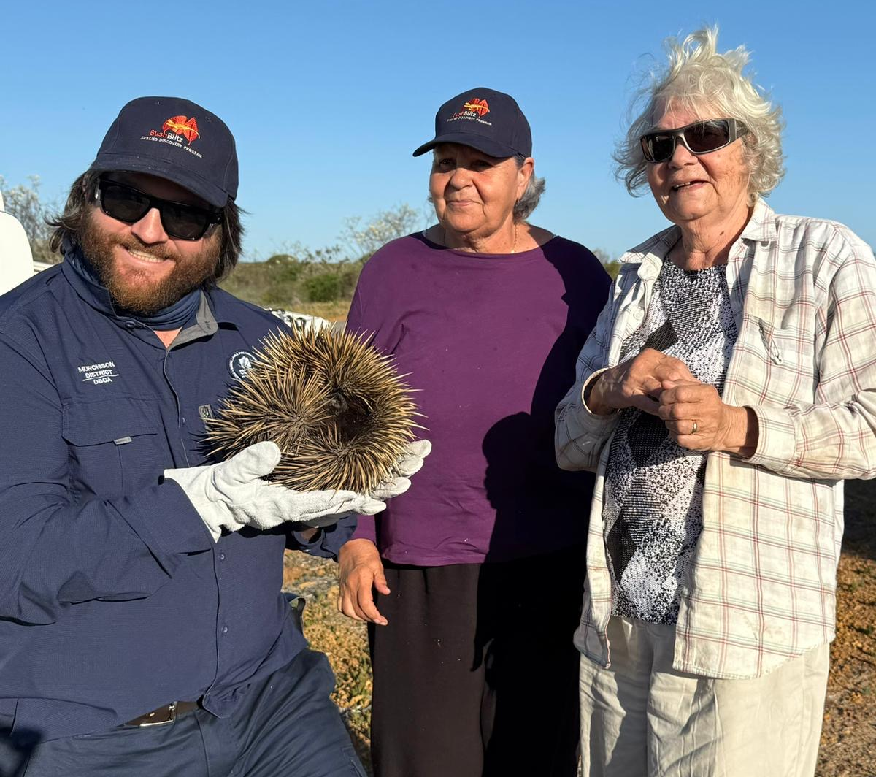
Nanda Country Bush Blitz
Frogs, Reptiles & Mammals
20th to 29th October 2024
Submitted: 30 May 2025
Paul Doughty and Kailah M. Thorn

Photo – Mackay Smith from DBCA (holding echidna) with Nanda Elders

Nomenclature and taxonomy used in this report is consistent with:
The Western Australian Museum Checklist of Terrestrial Vertebrates
Australian Faunal Directory (AFD)

Contents
Contents 2
List of contributors 2
Abstract 3
1. Introduction 3
2. Methods 4
2.1 Site selection 4
2.2 Survey techniques 7
2.2.1 Methods used at standard survey sites 9
2.3 Identifying the collections 9
3. Results and Discussion 10
3.1 Species new to science 10
3.2 Introduced species 10
3.3 Threatened species 11
3.4 Range extensions 11
3.5 Genetic information 12
4. Information on species lists 12
5. Information for land managers 14
6. Conclusions 14
Acknowledgements 15
References 16
Appendices 17
Appendix 1. List of Vertebrates recorded during the Nanda Country Bush Blitz 17

List of contributors
List of contributors to this report.
Name | Institution/affiliation | Qualifications/area of expertise | Level/form of contribution
Paul Doughty | WAM | Reptiles & frogs | Survey participant, Principal author
Kailah Thorn | WAM | Reptiles & frogs | Survey participant, Principal author

Abstract
A survey of the Nanda-Kalbarri area was undertaken for a Bush Blitz survey. We focused on vertebrates, and documented 36 species of reptiles, 7 frogs and several opportunistic mammals and birds. Pit-trapping with funnel traps was conducted at the two Standard Survey Sites and supplemented by active foraging for burrowing reptiles (raking). Road cruising on warm nights also resulted in good returns. BHP and TC participation occurred throughout the surveys. Some slight range extensions for frogs were made at the Murchison River Gorge. We also visited Eurardy Station and carried out active foraging for reptiles. An overnight stay at Noonaegarooda Soak resulted in new records for the area, including several geckos and snakes.

1. Introduction
The study area of the Nanda Country Bush Blitz survey includes Kalbarri National Park, Eurardy Station (managed by Bush Heritage) and the Nanda Reserves. The base camp was in the town of Kalbarri, with most surveys (trap checking, raking, head torching) being conducted via 4WD with one overnight trip via helicopter to a northern Nanda Reserve site.
A previous summary of vertebrates from the “Zuytdorp Coast and hinterland” was provided by Storr and Harold (1980). They summarised previous records supplemented by an increase of survey effort in the area and documented 7 frog and 76 reptile species. The Southern Carnarvon Basin Survey (SCBS) was a major joint survey between Conservation and Land Management, WA, and the Western Australian Museum in the 1990s (Burbidge et al. 2000). This survey included some of the Nanda Country Bush Blitz survey areas but also went as far north as the Lake MacLeod-Kennedy Range area. A recent assessment of the same area as Storr and Harold’s (1980) summary was provided by Maryan et al. (2024). This summary also included the sampling efforts of the SCBS, opportunistic collections as well as using a far more refined taxonomy based on these collections. Maryan et al. (2024) documented the occurrence of 15 frog species and 103 reptile species.
From these previous overviews of the herpetofauna of the area, a key driver of diversity of species was the diversity of habitats, especially substrate types. Therefore, when choosing survey areas and trapping grids, we were very mindful to sample in different habitats to try to capture this diversity.
Prior to conducting this survey, species lists were exported from Atlas of Living Australia, and Danjoo (Western Australia’s biodiversity database, see reference list). These lists were compared with an export from the WA Museum specimen database to decide which taxa were already well-sampled from the Kalbarri region and could therefore be put on the trip’s vouchering ‘amnesty list’. The search also uncovered which taxa are not well-represented in the collection, including the blunt-snouted blindsnake (Anilios obtusifrons) known from only the three type specimens collected from just south of Kalbarri (Ellis et al. 2017). Lerista humphreysi is a Priority 3 listed species for Parks & Wildlife, but the taxonomy is relatively uncertain as this species was described prior to modern genetic sequencing methods. New specimens with fresh tissue for sequencing would be valuable for both taxonomy and conservation. These poorly-sampled taxa, and range extensions for well-represented animals became focal targets for the trip.
Amnesty list
The Terrestrial Vertebrate section routinely has “amnesty” lists of species for abundant, commonly encountered species and those with non-controversial taxonomy or large size (especially potential food species for Aboriginal people such as goannas or turtles).
Pseudophryne guentheri – Guenther’s toadlet – 16 specimens collected with tissues in 2018.
Gowidon longirostris – long-nosed dragon – Multiple trips opportunistically collected whole specimens for skeletons and whole bodies, taxonomy and range extent well-known.
Gehyra variegata – variegated dtella – targeted trip in 2015 covered whole bodies and tissues (WA Museum and others).
Heteronotia binoei – Bynoe’s Gecko – Well-sampled throughout region by multiple surveys (Craig Mortiz and colleagues, ANU, Canberra).
Lerista miopus – Well-sampled by Maryan & co. including genotyped tissues. Taxonomy recently resolved by Amey and Edwards (2017).
Chelodina steindachneri – dinner plate turtle – five individuals taken from Murchison River by Snyder in 2008 with tissues, taxonomy well-resolved.
Taxa of interest – taxonomically suspect or rare records
Lerista humphreysi – Priority 3 listed species of sand-slider (skink)
Anilios obtusifrons – Only known from three specimens

2. Methods

2.1 Site selection
Standard Survey Site 1 was selected by the Botany team. Vertebrate traps laid out for the Western Sheild Project were coincidently already located in this area and were reopened for this survey. Vegetation at this site was relatively dense at waist-height, with patches of open ground exposing Bassendean sands where vegetation had died/burnt. The sands were generally moister at this site than at SSS2.
Standard Survey Site 2 was chosen by the vertebrate survey team, to represent the north-eastern corner of Kalbarri National Park and the Spearwood Dune vegetation system. This location is further away from commonly surveyed public access roads or tourist destinations.
Vegetation at this site presented a mosaic of habitat types with areas of dense brush providing shade, plant litter for burrowing animals and open habitat for diurnal basking.
Noonaeragooda Soak
The vertebrates team nominated Noonaeragooda Soak as one of the selected helicopter sites for this survey, to extend the reach of the team into the new Nanda Reserves, possibly find calling frogs, and survey a different habitat to the National Park (grassland). Noonaeragooda Soak is located east of Zuytdorp Nature Reserve, ~30 km southwest of Billabong Roadhouse. While both of those landmarks and surrounds are well represented in the WA Museum database, this area was relatively bare except for a single record of Lerista humphreysi – a target taxon record for this survey. Unfortunately, the soak was dry, and much of the nearby woodland and low dune systems to the south were difficult to navigate on foot due to shoulder-high weeds. To the north, the open acacia woodland was much healthier, containing areas of dense leaf litter for raking and open red sand patches ideal when spotlighting small vertebrates.

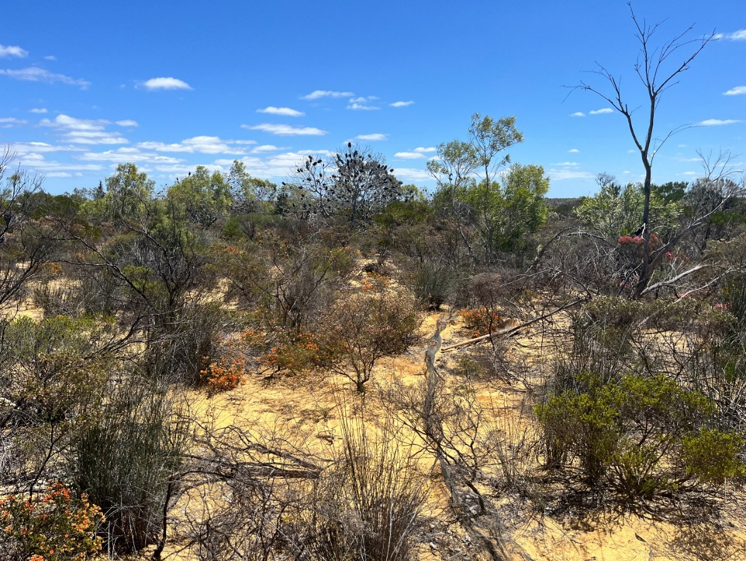
Standard Survey Site 2 habitat example, with one of the two fence (trap) lines running perpendicular to the landscape. Photo by KM Thorn.
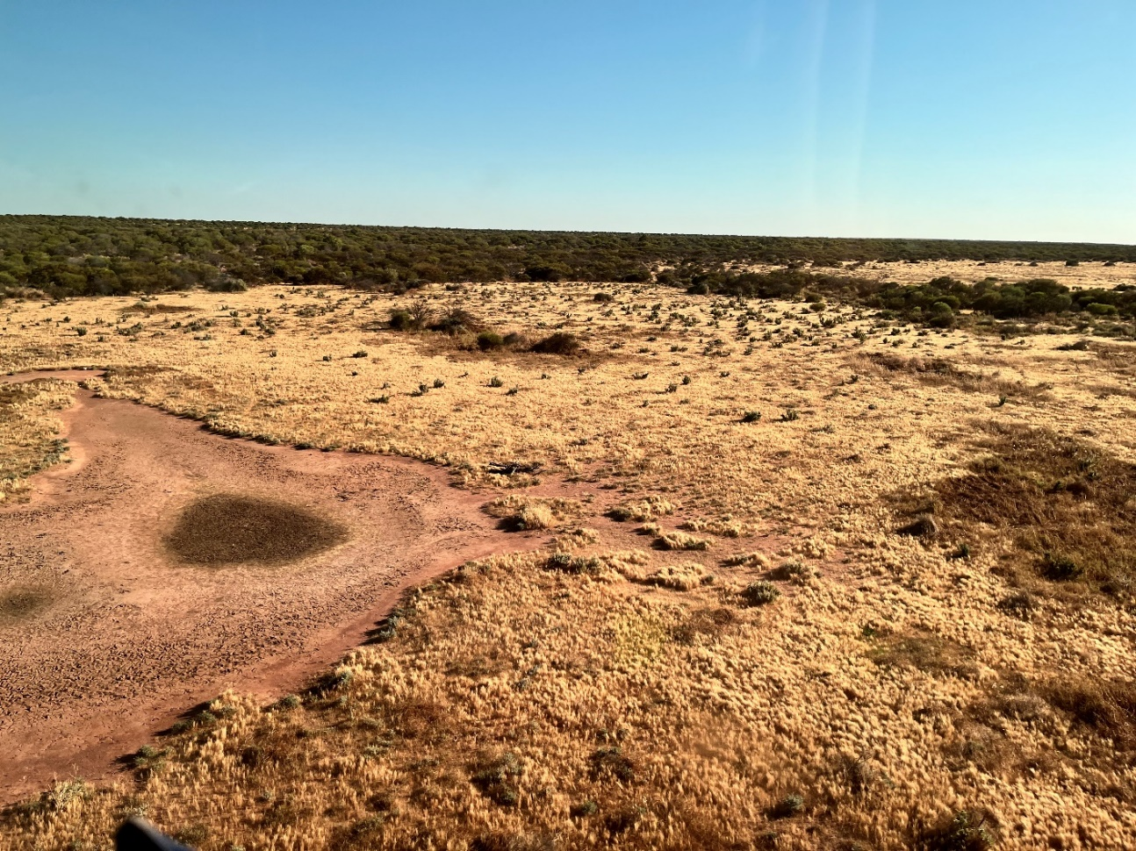Noonaegarooda Soak (clay pan on the left) is a pastoralist-cleared clay pan in open natural grassland, among smaller natural soaks (dense green patches), and surrounded by open acacia woodland. Photo by KM Thorn, taken from helicopter.

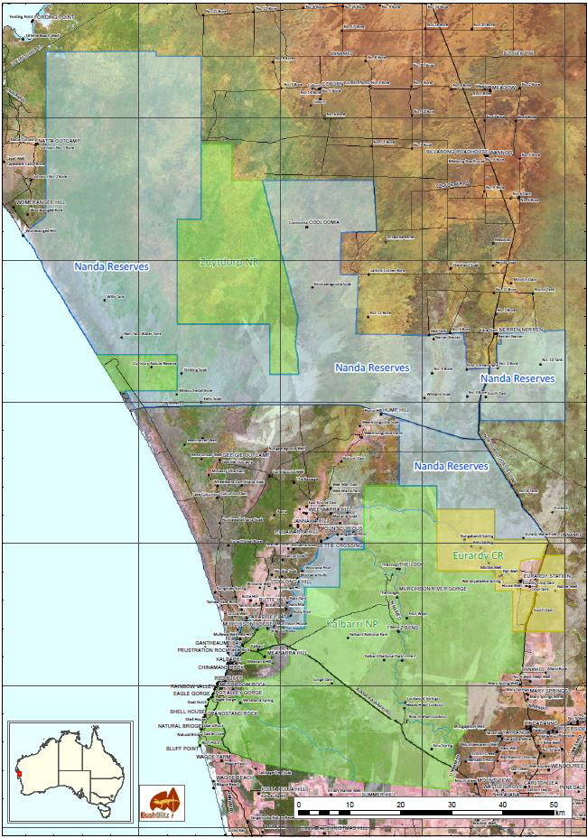
Map of the study area (provided by Bush Blitz).

2.2 Survey techniques
As part of our ongoing commitment to advancing scientific knowledge, the WA Museum employs rigorous and ethically responsible methods in the collection of terrestrial vertebrate specimens. The approach taken is grounded in best practices that prioritise ecological sustainability, animal welfare and adherence to regulatory guidelines. This ensures that collection activities contribute valuable insights while respecting the delicate balance of the ecosystems we study. The amnesty list (above) is an example of how we aim to reduce unnecessary vouchering of common, taxonomically known species.
Photography
Capturing a specimen’s appearance in life is an important part of the vouchering process. In a large tray we create a natural environment, place the animal on the tray, and capture the photograph quickly before the animal moves. In some cases, specimens are photographed as they are encountered in the field with no contact and minimal disturbance. On this survey we have recorded these as observation records and lodged them in iNaturalist.
Ground observation (active foraging)
Foraging for animals is conducted by overturning rocks and large logs or bark pieces. Extreme care is taken to not cause any long-term displacement or loss of habitat through foraging activities. Vegetation, rocks, or substrate that is moved is returned to its best possible original condition. There may be short term displacement when an animal is caught by hand (see below) and released, as even when released to the immediate same area most animals will travel away from that area to escape the animal handler.
Hand capture
The process involves gently and manually capturing reptiles by hand, typically without the use of specialised equipment. Hand capture is often suitable for small reptiles that are not aggressive or venomous. Capture is as fast and as stress-free as possible with the animal transferred to a calico (reptile) or plastic (frog) bag as soon as possible (always carried by field workers).
Most hand captures are possible when spotlighting at night, as the animals are more likely to be exposed rather than sheltering from the sun/predators during daylight hours. Spotlighting or ‘road-cruising’ with high beams on in the early evenings while the ground is still warm proved the most successful capture method on this expedition.
Dry pitfall trap
A pitfall trap is a simple and effective method to capture ground-dwelling vertebrates. A trapline is constructed with a length (20–100 m long; 20–30 cm high) of metal flywire standing upright buried to a third of its height, with different trap types placed along the fenceline to catch different animals. A dry pitfall trap consists of a smooth sided 20L bucket or PVC pipe, typically 60 cm (arm length) deep. A shelter for captured animals is placed in the base of the structure. Animals moving on the soil surface fall into the pit and are unable to escape. The trap is checked twice daily, and animals collected.

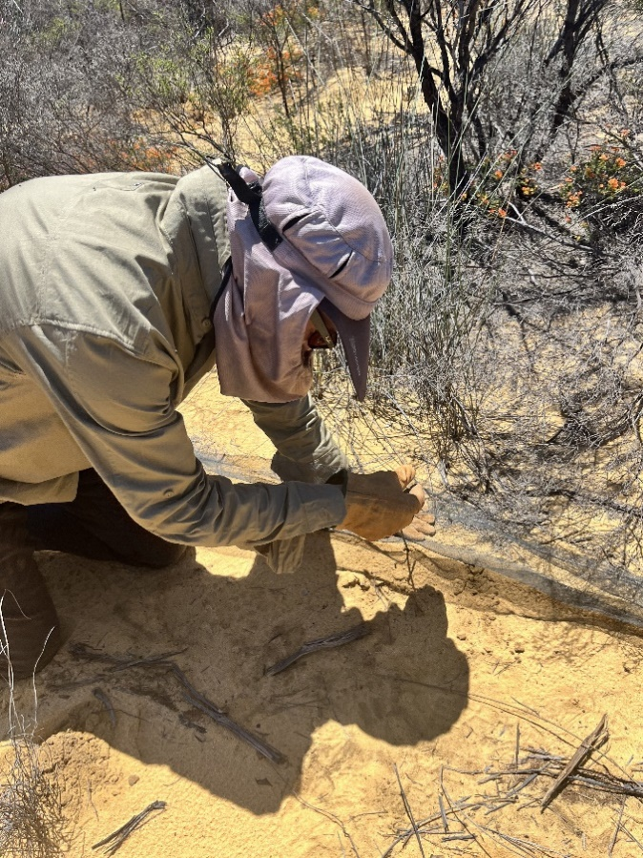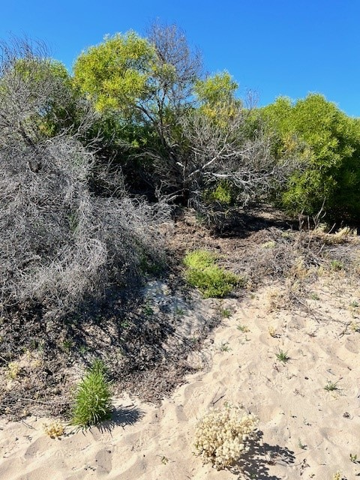
Left: Paul Doughty installing a section of trapline fence consisting of metal flywire and supporting stakes (image by KM Thorn).
Right: raking leaf litter under shrubs and small trees can often procure small burrowing reptiles; this site successfully sampled Lerista species (image P Doughty).
Funnel Trap
Funnel trapping is used to capture small ground dwelling animals such as snakes and legless lizards that would otherwise easily escape a pit trap. The process involves selecting and setting up appropriate traps, placing them strategically along a mesh fence to funnel the animals into the trap. The trap consists of a funnel-shaped entrance that guides animals into a containment chamber, making it challenging for them to escape. They are sold commercially as “yabbie/crayfish traps” and are made of wire, string and shadecloth. The design typically involves a wide opening that narrows down into a tunnel or funnel, leading to a confined space where the captured animals are safely held, much like a traditional fish trap.
Raking
Raking is a method used to capture shallow burrowing animals, particularly those inhabiting soil or sand. It involves dragging a specialized rake-like tool through the substrate to expose and capture subterranean reptiles. The rake typically has long tines that penetrate the burrows, to gently bring the animals to the surface. Typically carried out with a 3-pronged cultivator, raking is often the only way to capture small burrowing reptiles.
Tail tipping – reptiles
Tail tipping in reptiles involves the removal of a portion of the tail with a clean and precise cut to minimise stress and harm to the reptile. A tissue sample <30 mm tip of the tail is taken from large individuals (> 100 mm snout-vent length) for genetic analysis. For smaller species (<100 mm snout-vent length), a 10–20 mm tail tip is sufficient. For snakes, turtles and some lizards, a pair of sharp sterile surgical scissors is used. For many lizards, pinching the tail triggers the natural autotomy response and is preferred. When lizards voluntarily dropped their tails during capture or handling, this was collected as a tissue sample. Natural tail loss and regrowth occur in many species. Reptiles with tails used for specific functions (such as knob tails, blind snakes, and death adders) are not tail tipped because it may compromise the animal’s ability to perform the function.

2.2.1 Methods used at standard survey sites
As well as the trapping methods listed above, raking of leaf litter was implemented to target Lerista (sliding skinks) and burrowing snakes. Each standard survey site was raked on multiple survey days during both the morning and afternoon trap checks.
After a few days of trapping at each standard survey site, the weather began heating up, and so traps were checked earlier each day. Higher temperatures caused diurnal animals to be less active during the afternoon heat (resulting in decreased trapping rates) and leads to an increased risk of dehydration of frogs in the mornings. A decision was made to close the traps, allowing the team to focus on active foraging methods with a lower risk to animal welfare, and to target animals that don’t often fall into traps.

Date | Time | Standard Survey Site | People | Hours
22 | PM | SSS1 | 4 | 1
23 | AM | SSS1 | 2 | 0.5
23 | AM | SSS2 | 4 | 0.75
23 | PM | SSS1 | 1 | 0.5
23 | PM | SSS2 | - | - too hot
24 | AM | SSS1 | 2 | 0.75
24 | AM | SSS2 | - | - traps closed
24 | PM | SSS1 | 1 | 0.5
25 | AM | SSS1 | - | - traps closed
Total raking hours = People x time |  | SSS1 |  | 8.5
 |  | SSS2 |  | 3

2.3 Identifying the collections
Multiple specimens from the slider group – Lerista – were collected by raking through leaf litter over soft sand. Lerista lineopunctulata is distributed along the western coast of WA, and what was once the ‘northern population was recently recognised as its own species: Lerista miopus by Amey and Edwards (2017). Head scale characters listed in Amey and Edwards (2017) were used to identify WAM R182185 as the key in Storr et al. (2000) pre-dates the species description.
For all other reptiles, the series of ‘Lizards of Western Australia’ relevant to each group was taken to Kalbarri for field identifications and referred to again in the WA Museum labs in Welshpool. Some identification characters (i.e. small head scales) are only visible with the aid of a dissection microscope which meant that identifications needed to be checked carefully in a lab environment after the animals had been preserved and rinsed of formalin.
Tail tips from each of the tadpoles (likely to be Neobatrachus burrowing frogs) recovered from Middle Well at Eurardy Station have been sent to Germany to be long-read sequenced by Polina Novikova and Jozefien Van de Velde which will provide us with species-level identifications in a few months' time.
Photographs of the quails flushed while spotlighting were shown to Ron Johnstone, retired Curator of Ornithology who identified the birds using comparative specimens in the collections.

Resources for Identifications
Amey, A.P. & Edwards, D.L. 2017. Taxonomy of the Sand Sliders of Western Australia’s central coast (genus Lerista, Squamata: Scincidae): recognition of Lerista miopus (Günther, 1867). Zootaxa 4317(1):111–133.
Tyler, M.J. & Doughty, P. (2009). Frogs of Western Australia (3rd edition). Western Australian Museum: Perth.
Storr, G.M., Smith, L.A. & Johnstone, R.E. (1983). Lizards of Western Australia I: Dragons and Monitors. Western Australian Museum: Perth.
Storr, G.M., Smith, L.A. & Johnstone, R.E. (1990). Lizards of Western Australia III: Geckos and Pygopods. Western Australian Museum: Perth.
Storr, G.M., Smith, L.A. & Johnstone, R.E. (2000). Lizards of Western Australia II: Skinks. Western Australian Museum: Perth.
Wilson, S. & Swan, G. (2017). A complete guide to reptiles of Australia, fifth edition. Read New Holland: Sydney.

3. Results and Discussion
Appendix 1 lists all vertebrates recorded during the Bush Blitz. Collections made during this Bush Blitz will result in 51 specimens, representing 50 species, being added to public collections and 67 records being added to publicly accessible databases.

3.1 Species new to science
In this report, ‘species new to science’ means species that were not recognised by Western science before this Bush Blitz.

3.2 Introduced species
Table 3. Introduced species recorded
Introduced species | Location sighted/observed | Indication of abundance | Comments
Capra hircus (Goat) | On edge of Kalbarri NP along highway  -27.805350, 114.686838 | 1 adult female with two kids | Also heard bleating in sand dunes south of Natural Bridge within the National Park
Mus musculus (House mouse) | SSS2 – Pitfall trap | 1 specimen collected during survey | Population density levels not detectable using our survey methods

Both these invasive taxa are known from the Kalbarri area and are managed in the National Park. Neither record demonstrates range extensions or population booms of any concern.

3.3 Threatened species
Table 4. Threatened species
Species | Listing status and level (WA Listing) | Location sighted/observed | Indication of abundance
Petrogale lateralis lateralis Gould, 1842 | EN | Z-Bend Gorge | Numerous fresh scats
Leipoa occellata Gould, 1840 | VU | Eurardy Station | Collapsed nest mound
Both above taxa are currently part of ongoing conservation and monitoring projects managed by DBCA in the National Park, and Bush Heritage at Eurardy Station. These two records are within known population ranges.

3.4 Range extensions
Table 5. Range extensions or significant infill in distribution records for species
Species | Location sighted/observed | Distance from nearest known record (km) | Comments
Heleioporus psammophilus (Sand Frog) | SSS1 and Z-bend road in National Park | 30km | Need to genotype to check these specimens are not H. eyrei, as the two species are difficult to tell apart based only on morphology.
Litoria moorei (Motorbike Frog) | Murchison River Gorge at Ross Graham Lookout | 15km (SW), 30km (W) | FrogID recordings previously known from National Park, this will be the first preserved specimen with matching FrogID chorus
Heleioporus albopunctatus  (Western Spotted Frog) | Z-bend road in National Park | 20km | INaturalist records in park are H. psammophilus or H. eyrei, nearest valid specimen record is Highway south of Ross Graham Lookout or Eurardy Frog ID call.
The three range extensions listed above are for frog species commonly recognised as southwest endemics. Their recorded ranges are usually described as southwest WA with Geraldton as the northern extent, with rare, opportunistic specimen records or FrogID choruses taken near Kalbarri. Many of the records of Heleiporus albopunctatus noted on the Atlas of Living Australia website have been imported through iNaturalist and the photographs appear to be misidentified H. psammophilus.
Also of note is that Crinia pseudinsignifera had previously been collected in 1970 and also captured on FrogID. This is the northernmost location for this species. We vouchered 2 specimens, with calls and photographs made and a tissue sample taken from each for genetic verification.
Multiple observations and photographs of Varanus giganteus (Perentie) were taken on this expedition. All existing records of this animal on the Swan Coastal Plain are from citizen science platforms such as iNaturalist. Collection of a roadkill specimen to create a permanent, verifiable, museum record (skeleton or tissue) would be worthwhile.
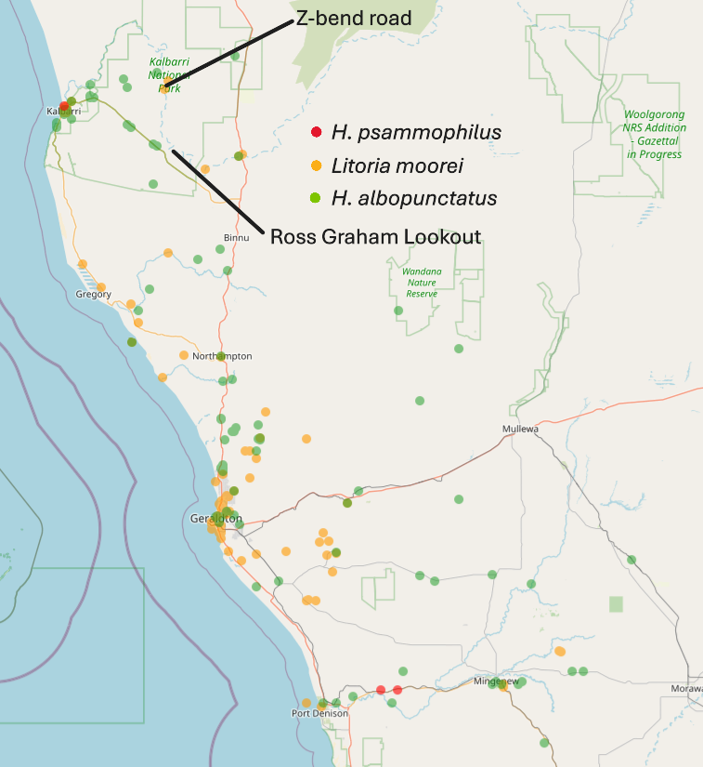

3.5 Genetic information
Tissue samples of all specimens and roadkills encountered have been lodged in the WA Museum and are available for genetic sequencing, as per best practice for field collections.

4. Information on species lists
Frogs
The tail tips from the Neobatrachus tadpoles collected from Middle Well, Eurardy Station are contributing to a project on polyploidy in Neobatrachus frogs of Australia. Such burrowing frogs are “explosive” breeders – coming out in very large numbers for only a few days each year in response to rain. Otherwise, they can be hard to detect. Calls captured via FrogID could also help to more precisely map the different species’ distributions.
Small-bodied burrowing frogs of the family Myobatrachidae were found at SSS#1: the southern sandhill frog, Arenophryne xiphorhyncha, and the crawling toadlet, Pseudophryne guentheri. Both seemed plentiful at this site.
Geckos & pygopods
A reasonable diversity of geckos and pygopods were collected. These include spiny-tailed geckos (Strophurus spinigerus), knob-tailed and barking geckos of the family Carphodactylidae, the ubiquitous Gehyra variegata, ground geckos such as Rhynchoedura and members of the Diplodactylidae and a variety of legless geckos or pygopods (Liasis burtonis and Pygopus spp.).
Dragons (agamid lizards)
Several dragons were recorded, including voucher specimens of the Thorny Devil (Moloch horridus – all from roadkill), several species of Ctenophorus (maculatus, nuchalis, reticulatus and scutulatus) and the western bearded dragon, Pogona minor minor. Not detected was the heath dragon, Ctenophorus butlerorum, but the coastal areas were not targeted, and these dragons are difficult to find and catch.
Skinks
Raking efforts were rewarded on this survey with six different species of Lerista collected between Kalbarri National Park, Eurardy and Noonaergooda Soak. Among these, a specimen of Lerista macropisthopus fuscipes raked from deep leaf litter under mulga woodland at Eurardy will be examined as part of a new ABRS project on Lerista taxonomy. In addition, L. elegans, L. lineata and L. connivens, among others, will also be sequenced as part of this project.
Non-Lerista small-bodied species were a Morethia obscura from SSS#1, a Ctenotus schomburgkii from SSS#2 (both pit-trapped) and several parties observed the large-bodied bobtails (Tiliqua rugosa) during the survey (none were collected).
Goannas (or monitors)
Many observations of the large-bodied Perentie, Varanus giganteus, were made during the survey. These large goannas inhabit the rockier areas of the Kalbarri region and can be identified by the lattice-like markings on the neck. None were vouchered. A road-killed sand goanna, V. gouldii, however, was collected and is being prepared as a specimen.
Two small-bodied (subgenus Odataria) Varanus were encountered: a freshly dead V. caudolineatus, which was found at Noonaeragooda Soak under a rusty barrel; and V. eremius collected as roadkill while spotlighting in the National Park; both will be made into skeletons.
Snakes
Spotlighting in the evenings contributed the best results to our taxonomic diversity sampling on this trip, with a number of small elapids active in leaf litter or crossing sealed roads in the early evening. Spotlighting and/or road cruising with high-beams proved more effective in locating small elapid taxa than the traplines at Standard Survey Sites. Four species of shovel-nosed snakes were detected on this trip by active searching on arm nights with head torches or high-beams – both species of Simoselaps (S. bertholdi and S. littoralis – image below), Brachyurophis semifasciata and B. fasciolatus.
Unfortunately, no records of blindsnakes were recorded, including the very rare newly-described species (see Introduction). For rare blindsnakes, raking and opportunistic trapping will help determine the true distributions of these cryptic species. Further knowledge may require that specialists continue to explore where they might occur in the area.
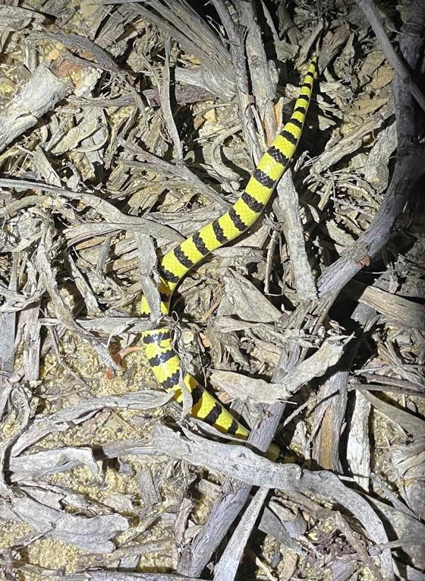
Simoselaps littoralis (WAM R181698) found by arachnologist Mark Harvey while spotlighting, this species is more likely to be active on the surface at night while burrowing through leaf litter during the day. Photo by Mark Harvey.
Mammals
Nyctophilus geoffroyi – Lesser Long-eared bat was found as a mummified body at Eurardy Homestead and has been left complete and registered into the dry collection at the WA Museum (WAM M65581). As no chemical preservatives have been used, this specimen could be a genetic resource in the future.
House mouse (Mus musculus) and goats are known from the area; the Mus specimen was vouchered as a record of the ongoing presence of invasive pests in the area.
Birds
No birds were trapped during this survey, but the mummified Zebra Finch found at Eurardy Homestead represents only the second skeleton for this species in the WA Museum Ornithology Collection.
The quails flushed while spotlighting at Noonaeragooda grasslands were identified from photographs shown to Ron Johnstone, retired Curator of Ornithology at the WA Museum.

5. Information for land managers
Eurardy Station, managed by Bush Heritage, requested a more up-to-date taxonomic list of the vertebrates known from their property. Although we were unable to rigorously survey that property with traplines due to time constraints, alongside the few Eurardy observations in this report, any species recorded from the Woodland sites would likely occur on that property.
Nanda reserves – Noonaeragooda grassland was a unique habitat harbouring small quails and surrounded by open woodland with a different fauna to the coastal plain communities at Kalbarri NP. The proliferation of weeds made it difficult to survey the surrounding dune habitats which may have had interesting taxa.

6. Conclusions
Large numbers of native frog and reptile species were encountered on the survey, as the area is known for high diversity of herpetofauna. Most were vouchered to have a permanent record of the species’ occurrence. This including taking tissue samples which are essential for future genetic work.
Range extensions of several south-western frog species were found at Murchison Gorge, representing a reasonable significant find. Many Lerista skinks were raked out of leaf litter and soil, and these will be prioritised to be genotyped owing to a current PhD student project. Otherwise, no new species were believed to have been captured during the survey.

Acknowledgements
Mid-West DBCA team, especially Mike Raykos, Dave Pongracz, Kurt, Mackay Smith for their local knowledge of the National Park, navigational prowess and use of decent 4WDs (even the one Mike bogged).
Greg Mallard for imparting his valuable traditional owner knowledge of the ‘good spots’ around Kalbarri National Park, and his cool-headed bravery when faced with a sneaky Gwadar ‘observation’ at our Noonaeragooda camp (it was slithering into his tent!).

References
Amey, A.P., and Edwards, D.L. 2017. Taxonomy of the Sand Sliders of Western Australia’s central coast (genus Lerista, Squamata: Scincidae): recognition of Lerista miopus (Günther, 1867). Zootaxa. 4317(1):111-133.
Burbidge, A.H., McKenzie, N.L. & Harvey, M.S. 2000. A biogeographic survey of the southern Carnarvon Basin, Western Australia: background and methods. Records of the Western Australian Museum, Supplement 61: 1–12.
Danjoo Biodiversity Data Repository. 2024. Biodiversity, Conservation and Attractions. Data accessed on the 21 Oct 2024. URL: https://bio.wa.gov.au/dandjoo
Ellis, R.J., Doughty, P., Donnellan, S.C., Marin, J., and Vidal, N. 2017. Worms in the sand: Systematic revision of the Australian blindsnake Anilios leptosoma (Robb, 1972) species complex (Squamata: Scolecophidia: Typhlopidae) from the Geraldton Sandplain, with description of two new species. Zootaxa. 4323 (1) 001-024.
Maryan, B., Gaikhorst, G., and Parkhurst, B. 2024. The terrestrial herpetofauna of the Zuytdorp coast and hinterland of Western Australia: exceptional richness in global diversity hotspot. The Western Australian Naturalist. 33(3) 241-262.
Storr, G.M., and Harold, G. 1980. Herpetofauna of the Zuytdorp coast and hinterland, Western Australia. Records of the Western Australian Museum. 8(3).
Storr, G.M., Smith, L.A. & Johnstone, R.E. (1983). Lizards of Western Australia I: Dragons and Monitors. Western Australian Museum: Perth.
Storr, G.M., Smith, L.A. & Johnstone, R.E. (1990). Lizards of Western Australia III: Geckos and Pygopods. Western Australian Museum: Perth.
Storr, G.M., Smith, L.A. & Johnstone, R.E. (2000). Lizards of Western Australia II: Skinks. Western Australian Museum: Perth.
Tyler, M.J. & Doughty, P. (2009). Frogs of Western Australia (3rd edition). Western Australian Museum: Perth.
Wilson, S. & Swan, G. (2017). A complete guide to reptiles of Australia, fifth edition. Read New Holland: Sydney.

Appendices

Appendix 1. List of Vertebrates recorded during the Nanda Country Bush Blitz
Family | Species | Common name | Species new to science | Threatened species (EPBC Act) | Threatened species (Biodiversity Conservation Act 2016) | Introduced species
Mammals
Bovidae | Capra hircus | Domestic (feral) Goat | N | N | N | Y
Macropodidae | Petrogale lateralis lateralis | Black-flanked Rock Wallaby | N | Y | Y | N
Muridae | Mus musculus | House Mouse | N | N | N | Y
Tachglossidae | Tachyglossus aculeatus | Echidna | N | N | N | N
Vespertilionidae | Nyctophilus geoffroyi | Lesser Long-eared Bat | N | N | N | N
Birds
Accipitridae | Hamirostra melanosternon | Black-breasted Buzzard | N | N | N | N
Anatidae | Cygnus atratus | Black Swan | N | N | N | N
Artodidae | Ardeotis australis | Australian Bustard | N | N | N | N
Estrildidae | Taeniopygia guttata castanotis | Australian Zebra FInch | N | N | N | N
Megapodidae | Leipoa ocellata | Malleefowl | N | Y | Y | N
Turnicidae | Turnix velox | Little Button Quail | N | N | N | N
Reptiles
Agamidae | Ctenophorus maculatus | Central Netted Dragon | N | N | N | N
Agamidae | Ctenophorus nuchalis | Western Netted Dragon | N | N | N | N
Agamidae | Ctenophorus reticulatus | Spotted Military Dragon | N | N | N | N
Agamidae | Gowidon longirostris | Long-nosed Dragon
Agamidae | Moloch horridus | Thorny Devil | N | N | N | N
Agamidae | Pogona minor | Western Bearded Dragon | N | N | N | N
Carphodactylidae | Nephrurus levis occidentalis | Western Knob-tailed Gecko | N | N | N | N
Carphodactylidae | Underwoodisaurus milii | Barking Gecko | N | N | N | N
Diplodactylidae | Diplodactylus ornatus | Ornate Stone Gecko | N | N | N | N
Diplodactylidae | Diplodactylus pulcher | Fine-Faced Gecko | N | N | N | N
Diplodactylidae | Rhynchoedura ornata | Western Beaked Gecko | N | N | N | N
Diplodactylidae | Strophurus spinigerus | South-Western Spiny-tailed Gecko | N | N | N | N
Elapidae | Brachyurophis fasciolatus | Narrow-banded Shovel-nosed Snake | N | N | N | N
Elapidae | Brachyurophis semifasciata | Southern Shovel-nosed Snake | N | N | N | N
Elapidae | Pseudonaja mengdeni | Western Brown Snake, Gwardar | N | N | N | N
Elapidae | Simoselaps bertholdi | Desert Banded Snake | N | N | N | N
Elapidae | Simoselaps littoralis | West-coast Banded Snake | N | N | N | N
Elapidae | Suta monachus | Monk Snake | N | N | N | N
Gekkonidae | Gehyra variegata | Variegated Dtella | N | N | N | N
Pygopodidae | Lialis burtonis | Burtons Legless Lizard | N | N | N | N
Pygopodidae | Pygopus lepidopodus | Common Scaley-foot | N | N | N | N
Pygopodidae | Pygopus nigriceps | Western Hooded Scaley-foot | N | N | N | N
Scincidae | Ctenotus schomburgkii | Barred Wedgesnout Ctenotus | N | N | N | N
Scincidae | Lerista connivens | Blinking Broad-blazed Slider | N | N | N | N
Scincidae | Lerista elegans | Elegant Slider | N | N | N | N
Scincidae | Lerista lineata | Perth Slider | N | N | N | N
Scincidae | Lerista macropisthopus | Unpatterned Robust Slider | N | N | N | N
Scincidae | Lerista miopus | Northern Dotted-Line Robust Slider | N | N | N | N
Scincidae | Lerista praepedita | Western Worm Lerista | N | N | N | N
Scincidae | Morethia obscura | Mallee Snake-eye Skink | N | N | N | N
Scincidae | Tiliqua occipitalis | Western Blue-tongue | N | N | N | N
Scincidae | Tiliqua rugosa rugosa | Bobtail | N | N | N | N
Varanidae | Varanus caudolineatus | Stripe-tailed Goanna | N | N | N | N
Varanidae | Varanus eremius | Rusty Desert Monitor | N | N | N | N
Varanidae | Varanus giganteus | Perentie | N | N | N | N
Varanidae | Varanus gouldii | Sand Goanna | N | N | N | N
Frogs
Limnodynastidae | Heleioporus albopunctatus | Western Spotted Frog | N | N | N | N
Limnodynastidae | Heleioporus psammophilus | Sand Frog | N | N | N | N
Limnodynastidae | Neobatrachus sp. | Burrowing frog | N | N | N | N
Myobatrachidae | Arenophryne xiphorhyncha | Southern Sandhill Frog | N | N | N | N
Myobatrachidae | Crinia pseudinsignifera | False Western Froglet | N | N | N | N
Myobatrachidae | Pseudophryne guentheri | Gunther's Toadlet | N | N | N | N
Pelodryadidae | Litoria moorei | Motorbike Frog | N | N | N | N

