Nanda Country Bush Blitz
Diptera - focusing on lower Brachycera and acalyptrate flies
20-31 October 2024
Submitted: 27 May 2025
Dr Keith M. Bayless

Nomenclature and taxonomy used in this report is consistent with:
Australian Faunal Directory (AFD)

Contents
Contents 2
List of contributors 3
Abstract 4
1. Introduction 4
2. Methods 4
2.1 Site selection 4
2.2 Survey techniques 5
2.2.1 Methods used at standard survey sites 7
2.3 Identifying the collections 8
3. Results and Discussion 9
3.1 Un-named or not formalised taxa 9
3.2 Species new to science 10
3.3 Introduced species 19
3.4 Threatened species 20
3.5 Range extensions 20
3.6 Genetic information 22
4. Information on species lists 23
5. Information for land managers 23
6. Other significant findings 25
7. Conclusions 25
Acknowledgements 26
References 27
Appendices 30
Appendix 1. List of Diptera and Embioptera recorded during the Nanda Country Bush Blitz 30

List of contributors

List of contributors to this report.
Name | Institution/affiliation | Qualifications/area of expertise | Level/form of contribution
Keith M. Bayless (Principal) | Australian National Insect Collection | Diptera | Writing, identification, databasing, collecting specimens, curation, molecular lab work
Nikolai Tatarnic | Western Australian Museum | Hemiptera | Collecting specimens, curation
Erinn Fagan-Jeffries | University of Adelaide | Hymenoptera | Collecting specimens, curation
Ben Parslow | South Australian Museum | Hymenoptera | Collecting specimens, curation
Remko Leijs | South Australian Museum | Hymenoptera | Collecting specimens
Katia Hogendoorn | South Australian Museum | Hymenoptera | Collecting specimens
Jollene Fraser | Australian National Insect Collection | Diptera | Curation, molecular lab work
Olivia Evangelista | Australian National Insect Collection | Hemiptera | Curation, molecular lab work

Abstract
The results of sampling true flies (Diptera) during the Nanda Country Bush Blitz expedition are detailed in this report. Working closely with other insect researchers in the field, flies were sampled with sweep netting, three types of malaise traps, and three types of light traps. Nearly five hundred specimens were collected and identified to family level, representing at least 280 species. At least one specimen of fifty-one fly families were collected, and genus and species level identifications were performed for members of 38 of these families. Sixty-two species are putatively new to science, peppered throughout 19 families. Twenty-two species represent significant range extensions. This demonstrates the scant biodiversity data available for acalyptrate Diptera from Western Australia. Other than groups currently being studied by the primary author, all material will be made available to the taxonomic research community once it is deposited in the Western Australian Museum.

1. Introduction
This survey studied the Diptera of the Kalbarri area, as defined by the Bush Blitz. The focus was on acalyptrate Diptera, an assemblage of generally small-bodied but ecologically diverse flies. A secondary focus was on lower Brachycera, which are often larger and more colourful as adults, and predominantly predators and parasitoids as larvae. Lower Brachycera are comparatively better known at the species level in Western Australia, as several groups have been the subject of recent thorough revisions. Acalyptrate Diptera by contrast are very poorly known. However, their known diversity is centred in less arid environments, suggesting that their diversity in Western Australia may be limited. Alternately, this could be an artefact of prior collecting efforts. Many acalyptrates are plant feeders or parasitoids, so the diversity of other organisms in the Kalbarri area would likely translate to a diversity of Diptera species. Coastal Diptera are also diverse, tend to have restricted ranges, and are poorly known in Western Australia, so that was another focal area. The total expected diversity of acalyptrate Diptera was unclear before the expedition based on their known distribution and ecology.
For the Kalbarri area, in the Australian National Insect Collection database, only 9 Diptera accessions are present, and only 409 for all Insecta. In the Atlas of Living Australia, in the Bush Blitz survey area, which includes Kalbarri, Eurardy, and pastoral land near Tamala for which gazettal is in progress, there are 275 Diptera records. Among these, 86 represent unique values, while the others are repeated, e.g. family level identifications. Only 28 Diptera records in the ALA for the Kalbarri area were identified to species. The expectation was that the knowledge of Diptera in the area would be greatly expanded by sampling multiple habitats with a diversity of methods.

2. Methods

2.1 Site selection
The standard survey sites were determined beforehand. They were rich in floral resources. For Diptera, coastal sites were prioritised as there tends to be endemism in semi-marine habitats. Coastal habitats offer various larval substrates that support diverse fly lineages. Along with that, areas where streams reach the ocean, and cliff faces, offer additional refugia and micro habitats for Diptera. As most flying insects require some access to water, sites near fresh water were also prioritised. These included localities along the Murchison River and also smaller streams, gullies, and wetlands.
Sites with varied vegetation types were prioritised. This included a few areas with mallee. While most vegetation is low, many insects fly upwards, so trees and other stratified habitats may house more species. Some mallee eucalypts were in flower, which also facilitates the collection of flies seeking nectar resources. Areas with different soil types, from rocky to sandy, were prioritised. Many Diptera larvae live in soil and have narrow abiotic niches. Lastly, sites with high vantage points were prioritised for light traps. The broader area that a light trap can reach, the more species will be attracted to the trap.

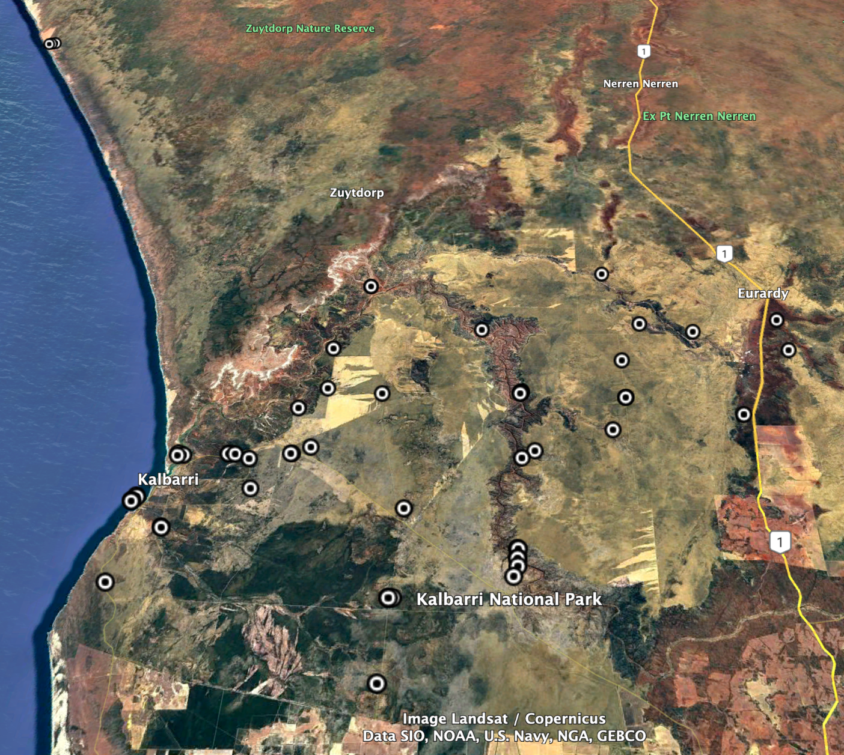
Figure 1. Sites in which Diptera were collected during the Nanda Country Bush Blitz indicated by black and white circles. All were part of Kalbarri National Park, Eurardy station, or Nanda land for which gazettal is in progress

2.2 Survey techniques
The following techniques were used to survey Diptera:
-Malaise traps- These are tent like structures that capture flying insects by hijacking their tendency to fly upwards towards light. Three types of malaise traps were used in this expedition:
Bugdorm style malaise with poles, pegged down and more free-standing than other malaise trap types

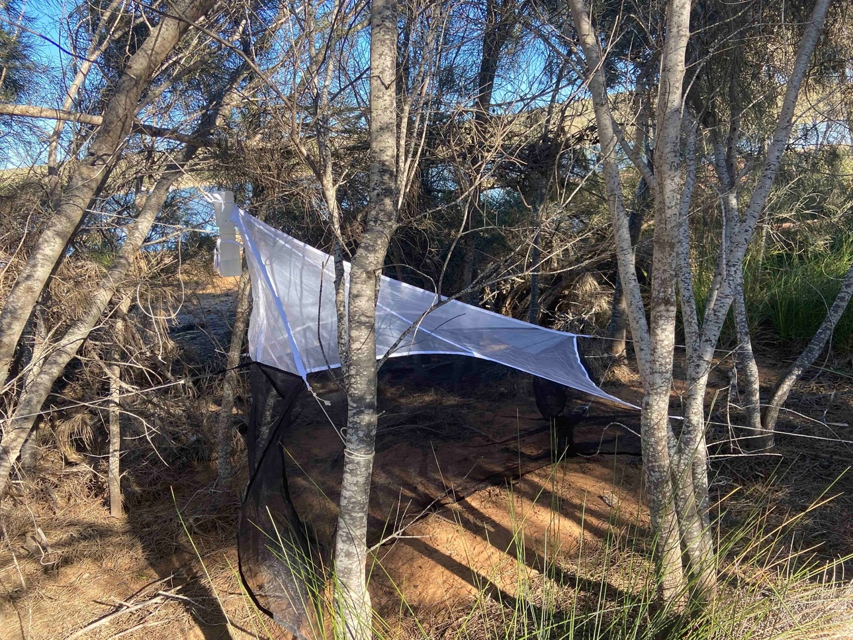
Figure 2 Townes style soft 2m malaise traps, tied to nearby vegetation, rocks, and pegs

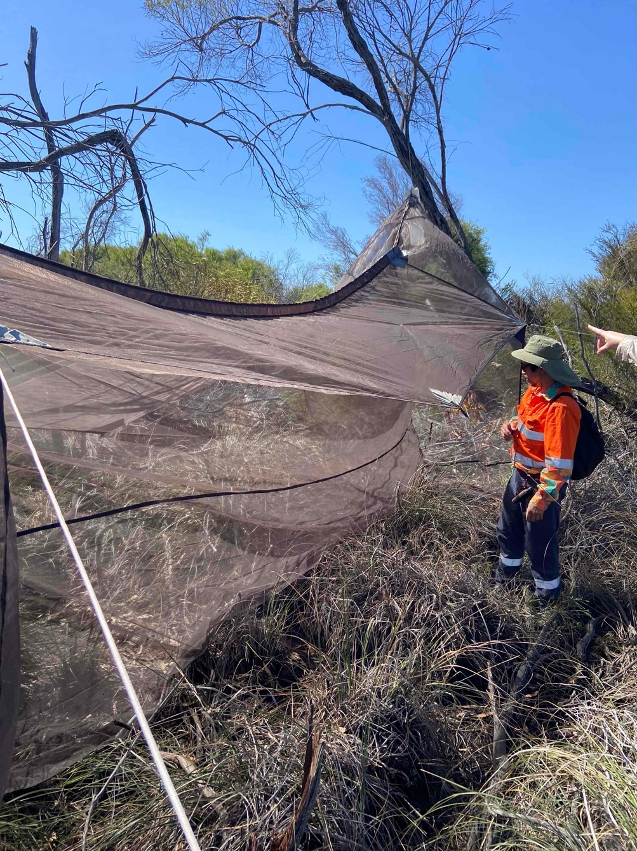
Figure 3. Six-meter diameter malaise traps with two collecting heads, also tied to nearby vegetation
-Sweeping- A wooden, aluminium, or fibreglass handled net with a fine mesh bag was gently dragged through plants and along features like streams and rock overhangs. Damage to vegetation was minimal. The nets were also used to obtain insects observed through visual inspeciction in the air or as they alight on vegetation. An aspirator was used to move living insects into collecting tubes
-Funnel nets attached to vehicles. The vehicle is driven slowly down a track and insects flying above the car are collected in the net
-Light traps- at night, LED, mercury vapor, regular cabin lights interfere with insect’s circadian rhythm and navigation, leading some to be attracted near the lights. Flies were either collected with aspirators, directly into collecting vials, or with a sweep net. Generally, lights at higher vantage points will be more visible and attract more insects.
Specimens were collected into 80% ethanol, or frozen and pinned.

2.2.1 Methods used at standard survey sites
A malaise trap was run for the duration of the expedition at each standard survey site. This was a Bugdorm style trap with poles. Timed sweep netting was also performed at each standard survey site. The entire site was traversed, as far as possible, in 30 minutes, focusing on all flowering plants available. Sweeping also varied from along the ground to the higher tips of vegetation. Hymenoptera and Hemiptera collected at the standard survey sites were shared with the respective teams. Standard survey site 1 had a patch of Mallee in which many Diptera specimens were found. Standard survey site 2 had a diversity of flowering plants.

2.3 Identifying the collections
All Diptera specimens were identified to family level. Most families were separated into morphospecies, except some small lower Diptera which need to be slide mounted. For selected families (and selected subfamilies of Asilidae and Bombyliidae) the identification was continued as far as possible. This generally was possible to the genus level. Identification resources are scattered and of varying age and quality. We expect that even more of these species could be new to science beyond the ~60 putative new species indicated in this report. Some of these identifications are putative as species identity is usually confirmed by dissection and examination of male genitalia, in many cases supported by DNA sequence data. The putative new species here designated have unambiguous morphological characters that support their assignment as different from any scientifically formally described species. Additionally, many of the putative new species are the first representatives of their genera known from Western Australia or even the continent. Some undescribed species are known to be present in the literature but have not been formally described, for example Asteiidae and Chyromyidae in Western Australia. In this report, these new species were not repeated in Table 3.5.
Focal groups, i.e. identified as far as possible, usually genus:
Lower Brachycera: Acroceridae, Apioceridae, Asilidae: Leptogastrinae, Bombyliidae: Mythicomyiinae, Mydidae, Pipunculidae, Scenopinidae, Stratiomyidae, Tabanidae
Acalyptratae: Agromyzidae, Asteiidae, Australimyzidae, Canacidae, Chamemyiidae, Chloropidae (ID resources poor), Chyromyidae, Coelopidae, Conopidae, Cryptochetidae, Drosophilidae, Ephydridae (ID resources poor), Fergusoninidae, Heleomyzidae, Helosciomyzidae, Lauxaniidae, Lonchaeidae, Milichiidae (ID resources poor), Platystomatidae, Pyrgotidae, Sphaeroceridae (ID resources poor), Tephritidae, Ulidiidae.
These identification resources were used for each group-
Overall Diptera: Colless & McAlpine 1994, Marshall et al 2016
Acroceridae- Winterton 2012
Apioceridae- Yeates & Oberprieler 2013
Asilidae: Leptogastrinae (Australian ID resources poor) Dikow 2009
Bombyliidae: Mythicomyiinae- Hull 1973, Lambkin et al 2003, Evenhuis 2025
Mydidae- Papavero & Wilcox 1974
Pipunculidae- Skevington & Yeates 2001, Motamedinia et al 2025
Scenopinidae- Kelsey 1970, Kelsey 1975, Winterton & Gharali 2011
Stratiomyidae- White 1914, Lessard et al 2021
Tabanidae- Mackerras 1956, González & Miranda-Esquivel 2025
Agromyzidae- Spencer 1963, Lonsdale 2014
Asteiidae (Australian ID resources poor) Sabrosky 1963, Freidberg & Friedman 2021
Australimyzidae- Brake & Mathis 2007
Canacidae- McAlpine 2007a, Munari & Mathis 2010
Chamaemyiidae- Tanasijtshuk 1996, Gaimari & Havill 2021
Chloropidae (Australian ID resources poor) Malloch 1940, Spencer 1986
Chyromyidae (Australian ID resources poor) Ebejer 2009
Coelopidae- McAlpine 1991
Conopidae- Schneider 2010
Cryptochetidae (Australian ID resources poor) Malloch 1927
Drosophilidae- Bock 1982, Bock 1989
Ephydridae (Australian ID resources poor) Mathis et al 2021, Mathis & Zatwarnicki 2023
Fergusoninidae (Australian ID resources poor) Davies et al 2018
Heleomyzidae- McAlpine 1985, McAlpine 2007b
Helosciomyzidae- Mcalpine 2012
Lauxaniidae (Australian ID resources poor) Malloch 1925, Kim 1994,
Lonchaeidae (Australian ID resources poor) McAlpine & Steyskal 1982, MacGowan & Rotheray 2021
Milichiidae (Australian ID resources poor) Brake 2000, Swann & Sinclair 2021
Paraleucopidae (Australian ID resources poor) Wheeler & Sinclair 2019
Platystomatidae- McAlpine 1973, McAlpine & Kim 1977, McAlpine 2001,
Pyrgotidae (Australian ID resources poor) Paramonov 1958, McAlpine 1978
Sphaeroceridae (Australian ID resources poor) Richards 1973
Tephritidae- Permkam & Hancock 1994, Hardy & Drew 1996
Ulidiidae- Daniels 1976

3. Results and Discussion
Appendix 1 lists all Diptera recorded during the Bush Blitz. Collections made during this Bush Blitz will result in 484 specimens being added to public collections and 484 records being added to publicly accessible databases.

3.1 Un-named or not formalised taxa
These highly diverse but small bodied fly lineages could not be sorted to morphospecies. Some need to be slide mounted. These groups likely contain additional undescribed species. Many are collected in abundance in malaise traps and also at light traps and in sweep net samples
Table 1. Putatively un-named or not formalised taxa
Taxon | Comment
Cecidomyiidae | 10+ specimens from various samples
Ceratopogonidae | 10+ specimens from various samples
Chironomidae | 10+ specimens from various samples
Phoridae | 10+ specimens from various samples
Psychodidae | 10+ specimens from various samples
Sciaridae | 10+ specimens from various samples

3.2 Species new to science
In this report, ‘species new to science’ means species that were not recognised by Western science before this Bush Blitz. Some of these undescribed species likely range beyond the study area. Some also may be represented by additional specimens in museums or have been collected in other surveys and ecological studies. Information concerning representatives of these species may exist via DNA sequence OTUs or morphospecies codes but have not been indicated to be new species.
Some major findings include:
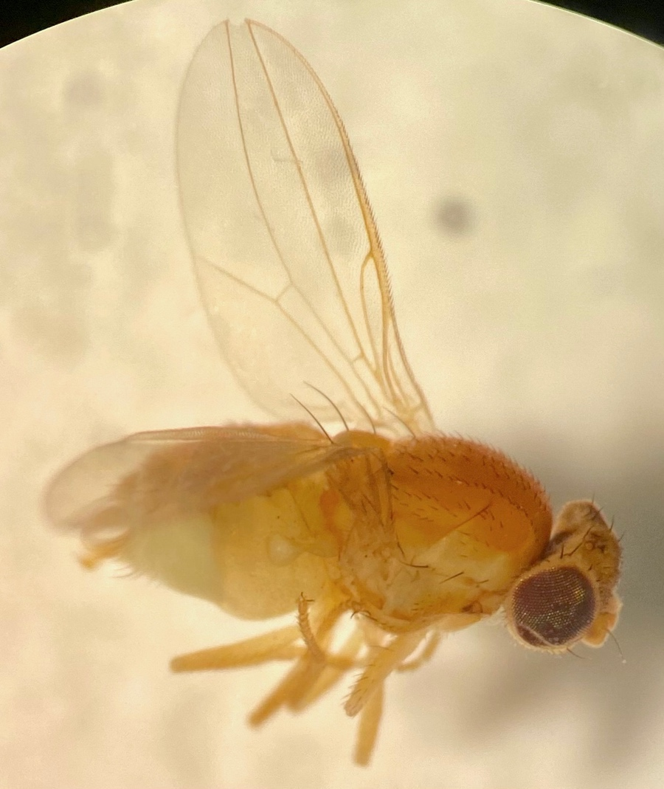
Figure 4. Asteiidae: Phlebosotera sp10033
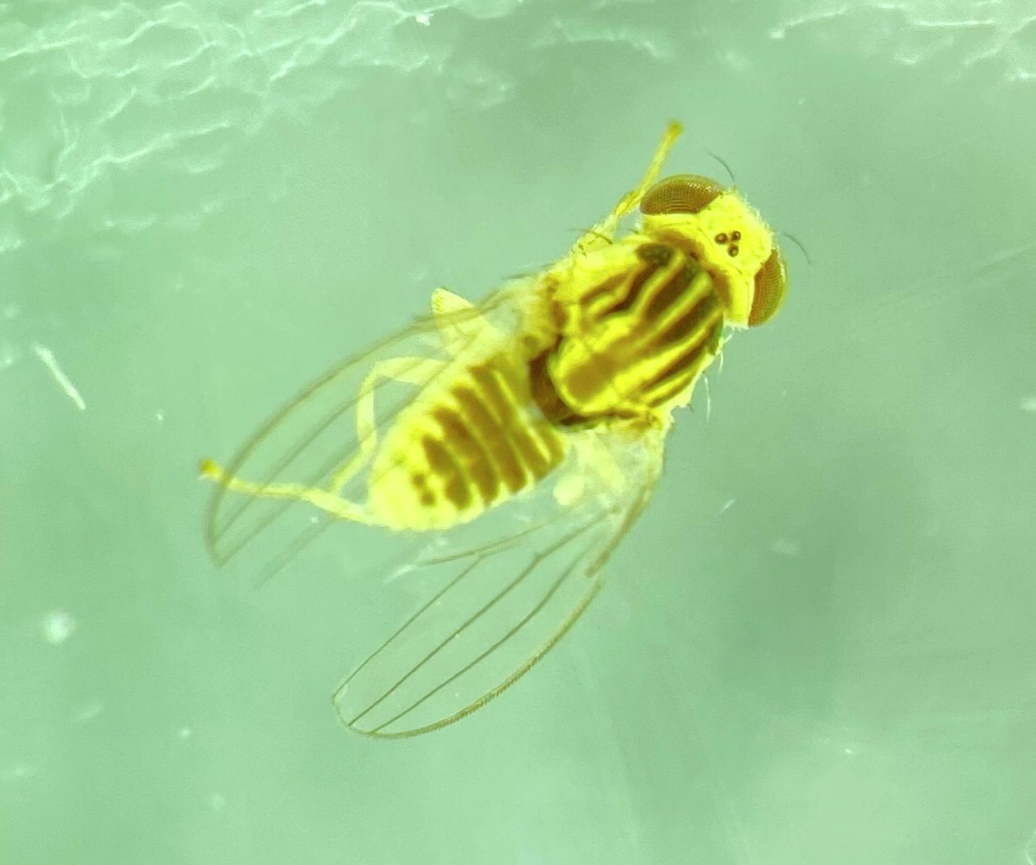
Figure 5. Chyromyidae: Aphaniosoma sp10093

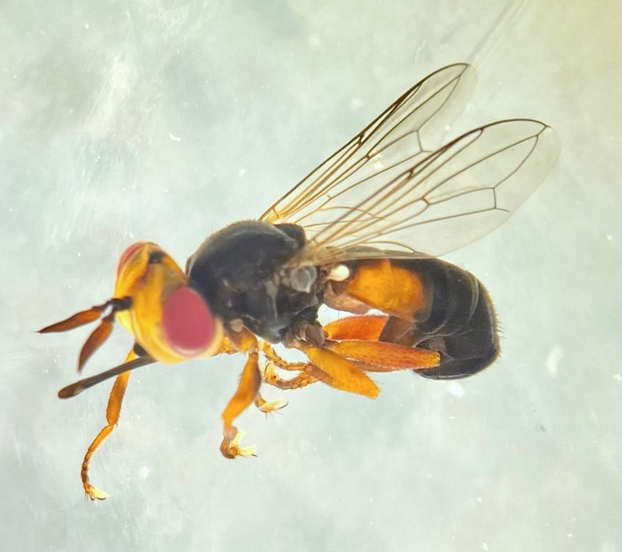
Figure 6. Conopidae: Stenoconops sp10099
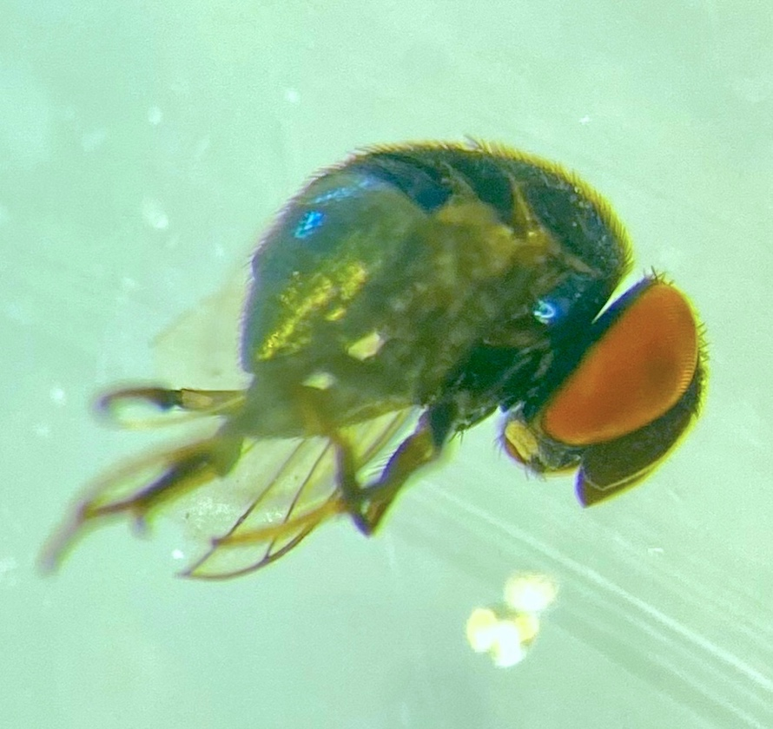
Figure 7. Cryptochetidae: Cryptochetum sp10103
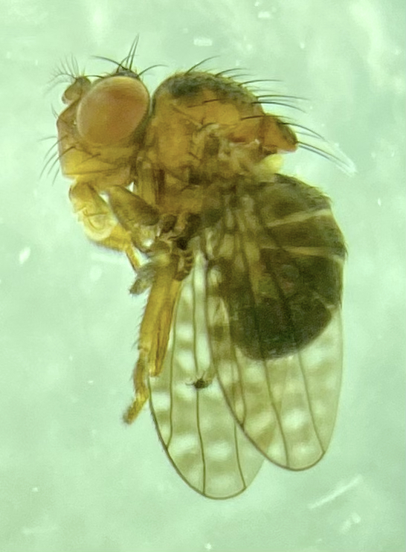
Figure 8. Ephydridae: Donaceus sp10116
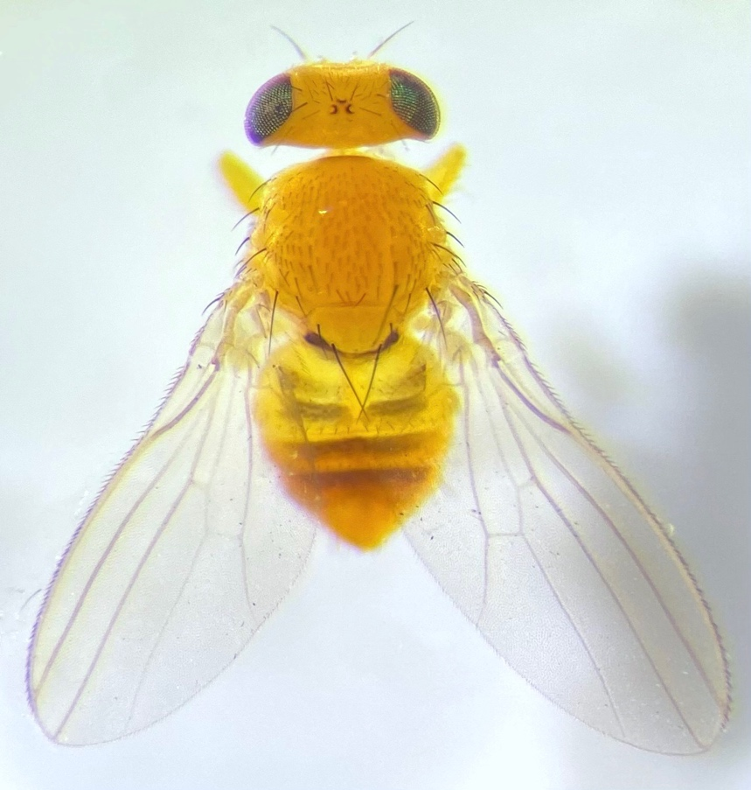
Figure 9. Fergusoninidae: Fergusonina sp10135

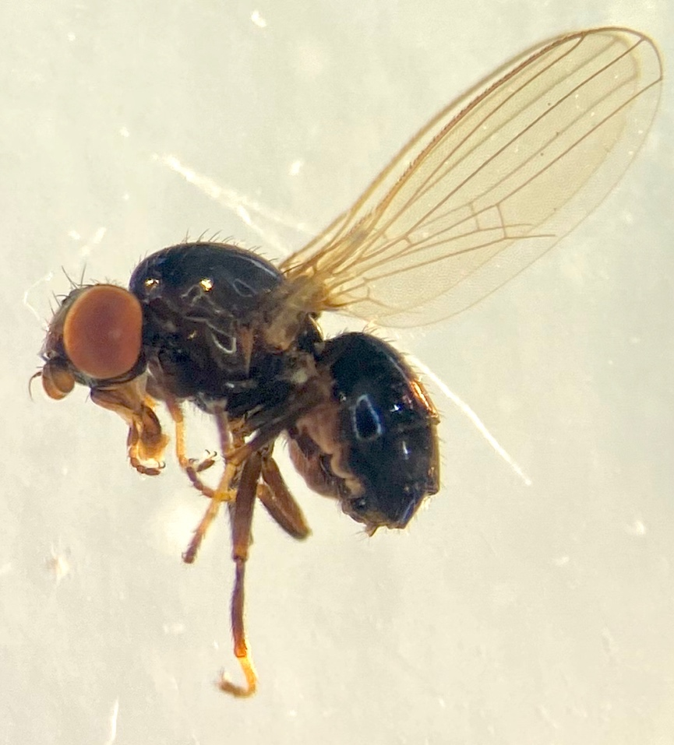
Figure 10. Paraleucopidae sp10260
Table 2. Species new to science
Species | Comment
Asilidae: Leptogaster sp10018 | Australian species of these gracile predatory grass flies have never been revised and many undescribed species occur in Western Australia. Unlike other assassin flies, they can capture prey on vertical surfaces including spider webs.
Asilidae: Leptogaster sp10019
Asilidae: Stichopogon sp10022 | Many undescribed species occur throughout Western Australia, often with apparently narrow ranges related to sandy larval substrate. Adults are often smaller than other assassin flies.
Asilidae: Stichopogon sp10023

Asteiidae: Phlebosotera sp10033 | The genus has been previously recorded from Western Australia but all Australian species are undescribed. Another undescribed species occurs in Banksia heath near Perth. It was found at several localities in Kalbarri.
Canacidae: Dasyrhicnoessa sp10067 | Beach flies from Western Australia are poorly known and this is one of the more diverse genera. Dasyrhicnoessa species are apparently restricted to particular coastal plant communities
Ceratopogonidae: Clinohelea sp10069 | This group of biting midges are predatory on other insects. They are poorly studied, particularly in Australia. Ceratopogonidae is a megadiverse and neglected fly family
Chamaemyiidae: Pseudoleucopis sp10071 | These flies are parasitoids of aphids and adelgids. A large portion of the ~40 species in Australia are known from Black Mountain (ACT), suggesting that the true diversity is much higher. This species is externally distinct from the two known Pseudoleucopis from Western Australia
Chloropidae: Pseudopachychaeta sp10073 | Most Chloropidae collected on this expedition are likely to be undescribed. This report focuses on two for which the genus can be assigned This taxon is different from the widespread Pseudopachychaeta sexta, also collected on this expedition
Chloropidae: Semaranga sp10074 | Another chloropid that can be attributed to genus based on its distinctive antenna. This is different from S. dorsocentralis, known from Queensland
Chyromyidae: Aphaniosoma sp10092 | Only one species of Chyromyidae is described from Australia, a Gymnochiromyia from Victoria. African chyromyids were recently revised and are diverse. The chyromyids of WA seem to be similarly diverse but all are undescribed. Unlike many other acalyptrates, these flies appear to prefer dry habitat. Some African species are coastal, which may be true for species in WA. Additional undescribed Aphaniosoma are known from northern and souther WA
Chyromyidae: Aphaniosoma sp10093
Chyromyidae: Notiochyromya sp10094 | This species is assigned to Notiochyromya based on another undescribed species from the Kimberley which was suggested to be Notiochyromya by Ebejer (specimen in Australian Museum, Sydney). The genus is primarily African but undescribed species are known from Asia and South America. Some African species are associated with caves. The genus level assignment of this taxon is not settled.
Conopidae: Heteroconops sp10095 | Conopids, thick-headed flies, are wasp parasitoids as larvae and pollinators as adults. Some are large and colourful but Australia has seen a radiation of small brown Conopinae in semiarid Australia. Australian conopids were recently and thoroughly revised by Schneider (2010). Her study included four species from the Kalbarri area, of which one was rediscovered during this expedition- Smartiomyia obscura. Many thick-headed fly speices are known from few localities and specimens, suggesting that the true diversity will grow with further focused collecting efforts.
Conopidae: Heteroconops sp10096

Conopidae: Pleurocerina sp10097

Conopidae: Smartiomyia sp10098
Conopidae: Stenoconops sp10099 | This genus was previously known only from the type material. This was a significant discovery.
Cryptochetidae: Cryptochetum sp10102 | Three species of these scale insect parasitoid relatives of Drosophila are described from Australia, none from WA. Cryptochetum are known from throughout the continent and appear to be more diverse in semi-arid environments. The group is currently being revised by the principal author. Fifty undescribed species are known, including these two, known now from a single specimen each.
Cryptochetidae: Cryptochetum sp10103
Ephydridae: Athyroglossa (Athyroglossa) sp10113 | Larvae of Ephydridae are saprophagous in damp soil, and can have narrow niches within the substrate. Many are tolerant to saline environments and live in coastal habitats. The Ephydridae of Australia are very poorly known to the species level but the worldwide genus level taxonomy is comparatively well resolved. Many specimens were collected in coastal habitats but also inland, for instance in malaise traps along streams. Some also visit flowers.
Ephydridae: Atissa sp10114
Ephydridae: Ceropsilopa sp10115
Ephydridae: Donaceus sp10116 | Donaceus is not recorded from Australia but there are also undescribed species in New South Wales
Ephydridae: Nostima sp10119 | There are many undescribed species of these small-bodied ephydrids throughout Australia
Ephydridae: Stratiothyrea sp10123 | This genus is recognisable by distinctive antennal morphology and undescribed species are known from additional localities in Northern Australia
Ephydridae: Zeros sp10124 | Zeros is easily diagnosed by the patterned wings with reduced wing venation. This is not conspecific with the known Zeros species in Australia.
Fergusoninidae: Fergusonina sp10135 | These flies form galls on myrtaceous host plants, aided by symbiotic nematodes. Each species forms galls of a specific configuration on a particular host tissue, for instance leaf buds or stems. One Eucalyptus species can be the host of up to seven species of Fergusonina. Forty Fergusonina species are known in Australia but the total diversity may exceed one thousand. They are more easily obtained through rearing them from host plant tissue.
Fergusoninidae: Fergusonina sp10136
Milichiidae: Desmometopa sp10143 | Although most records are ascribed to the synanthropic Desmometopa m-nigrum, in fact there are multiple undescribed species endemic to Western Australia
Milichiidae: Stomosis sp10144 | Several undescribed species of this genus are known from Australia. Some are colourful- yellow and black, and have long proboscides for nectar feeding
Milichiidae: sp10145 | These tiny flies tend to be kleptoparasites and larvae develop in rotting vegetation. However, many visit flowers and may be quite specific in their pollination range. There is a practically unknown radiation of Milichiidae in Western Australia, likely including multiple undescribed genera. Six different such morphospecies were found on this expedition, mostly represented by singletons. Resolving the true diversity of this group will require extensive effort as the thorough field work of the Kalbarri Bush Blitz uncovered few specimens of each undescribed species
Milichiidae: sp10146
Milichiidae: sp10147
Milichiidae: sp10148
Milichiidae: sp10149
Milichiidae: sp10150
Paraleucopidae: sp10260 | Occasionally indicated in the literature as Mallochianamyia or Gayomyia, this is a representative of an undescribed genus in a family only described in 2019. All Australian species are undescribed. This is the first specimen and speices of the group from Western Australia. This was a significant finding.
Phoridae: Megaselia sp10175 | This is one of the most diverse genera in Diptera, with thousands of undescribed species worldwide. These two are clearly not attributable to the five described species from WA. Additional undescribed species are expected in the region.
Phoridae: Megaselia sp10176
Pipunculidae: Tomosvaryella sp10178 | These are parasitoids of leafhoppers and relatives. Motamedina et al 2025 recently described 100 species of Tomosvaryella from Australia but included no material from Kalbarri or surrounds. These species can’t easily be assigned to described species but investigation into their status should be followed up with examination of dissected genitalia and COX1 DNA barcode data
Pipunculidae: Tomosvaryella sp10179
Pipunculidae: Tomosvaryella sp10180
Platystomatidae: Duomyia sp10181 | This endemic Australian genus includes 84 described species. McAlpine 2007 estimated another 30 undescribed species based on museum specimens, and he had limited material from Western Australia. It seems the group is diverse in semiarid WA, and many species are known from narrow geographic ranges
Platystomatidae: Duomyia sp10182
Platystomatidae: Rivellia sp10183 | This genus occurs worldwide. The larvae attack nitrogen-fixing root nodules of legumes including Acacia. Eight species are described from Australia, one from WA, but McAlpine 2007 estimates 45 undescribed species. Based on morphospecies sorting of pinned collections, and samples in public COX1 barcode databases, the diversity in Australia probably exceeds 200 species. These four species are clearly distinct from the described fauna but may have larger ranges beyond Kalbarri
Platystomatidae: Rivellia sp10184

Platystomatidae: Rivellia sp10185

Platystomatidae: Rivellia sp10186
Pyrgotidae: Cardiacera sp10187 | These colourful scarab beetle parasitoids are often collected at light traps. Paramonov 1958 circumscribed 32 species in Australia, 4 in WA, all from south WA, south of Perth. Many undescribed species are present in collections. Unclear limits between genera also stymies progress in biodiversity discovery of this group
Pyrgotidae: Cardiacera sp10188
Pyrgotidae: Cardiacera sp10189
Scenopinidae: Neopseudatrichia sp10199 | The larvae of these flies are predators in sandy soil, thus they tend to be more diverse in dry environments. This expedition found 9 species of scenopinids in the study site, compared to 82 currently known from Australia. Additional species of e.g. Riekella from this Bush Blitz may be undescribed, but ascertaining that requires dissection, literature reviews, and comparison with type specimens housed outside of Australia. This species has an affinity with Neopseudatrichia, otherwise known from Eastern Australia and SA, and is certainly new
Sphaeroceridae: Limosininae sp10216 | This is another neglected megadiverse group of saprophagous flies. Only one sphaerocerid lineage- flightless soil inhabiting Howickia- have been thoroughly revised including specimens from WA. These species are distinctive and are not covered in Richards 1973. Genus limits are under flux considering Asian and African genera, so these undescribed species are left unassigned to genus.
Sphaeroceridae: Limosininae sp10217
Stratiomyidae: Damaromyia sp10224 | These are black pachygastrine soldier flies whose larvae may be predators in rotting wood. Many pachygastrine species have been overlooked, historically, due to their small body size. Described species of this genus are only known from Eastern Australia but more than 10 undescribed species are known. The group is currently being studied by Dr. Bryan Lessard
Stratiomyidae: Odontomyia sp10225 | This is probably the most diverse genus of soldier flies in Australia, considering undescribed species. They are often seen visiting flowers and many are bee mimics. Few are known from WA and but other undescribed species are known from narrow ranges in semi-arid habitats. The genus is in need of revision (Lessard et al 2020)
Stratiomyidae: Odontomyia sp10226
Tabanidae: Dasybasis sp10259 | The revision of this march fly genus by Mackerras was never completed. Dozens of undescribed species are known from WA and NT, including this distinctively patterned species
Tephritidae: Austrotephritis sp10247 | While Western Australia is recognised as a hotspot of floral diversity, the diversity of some plant feeding fly lineages is unaligned in the published literature. This is true of tephritid fruit flies, for which few species are known from WA. This is likely an artifact of undersampling, as nine species were collected during this expedition, including these three putative new ones. The larvae of other species of Austrotephritis develop inside inflorescences, mainly Asteraceae. Additional data on host plants would improve any formal description of these taxa
Tephritidae: Austrotephritis sp10248

Tephritidae: Austrotephritis sp10249

Introduced species

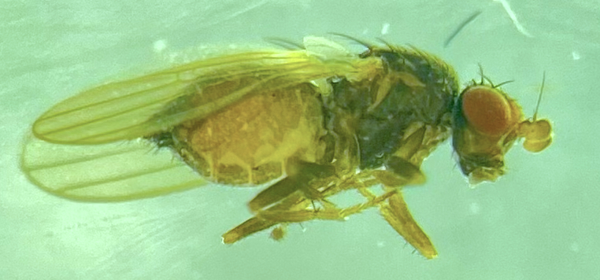
Figure 11. Heteromyzidae: Prosopantrum flavifrons. Female
Table 3. Introduced species recorded
Introduced species | Location sighted/observed | Indication of abundance | Comments
Heteromyzidae: Prosopantrum flavifrons | Meanarra Hill light  (-27.6984, 114.2159) | Low (1 specimen) | This species, originally from Chile, is also invasive in New Zealand, South Africa, and Great Britain. The first Australian observation was in Tasmania and it is slowly spreading. It is associated with coastal habitats and its impact on native ecosystems has not been measured
Lonchaeidae: Lamprolonchaea brouniana | Multiple localities in Kalbarri NP | Medium (4 specimens from 3 sites) | While there are native species of Lamprolonchaea, this species is synathropic and associated with gardens. There are records on iNaturalist from Geraldton
Tephritidae: Ceratitis capitata | PCYC Cabin lights  (-27.6993, 114.1715) | Low (1 specimen) | This is not exactly a pest sighting, and is in fact a good sign, as this fruit fly is part of a sterile male release to suppress potential biosecurity threats. The male specimen obtained is part of that intentional controlled release

3.4 Threatened species
No Diptera species of gazetted conservation concern were collected or observed during the expedition.

3.5 Range extensions
This table does not overlap with Table 2 or Table 3. Some of undescribed species also represent significant range extensions for the family or genus to which they belong.
Major:
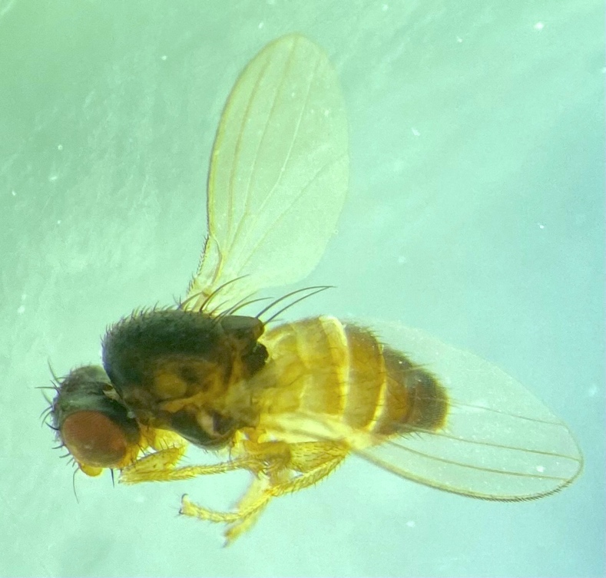
Figure 12. Australimyzidae: Australimyza sp10034
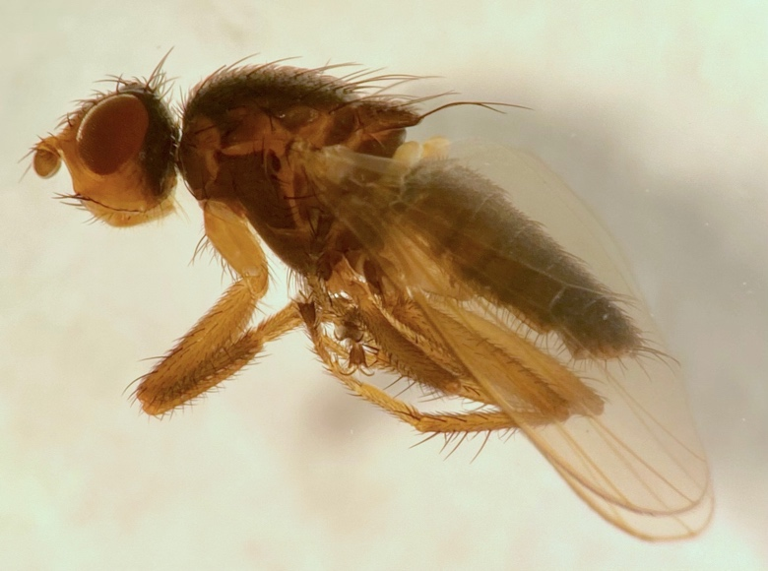
Figure 13. Canacidae: Thitena cadaverina
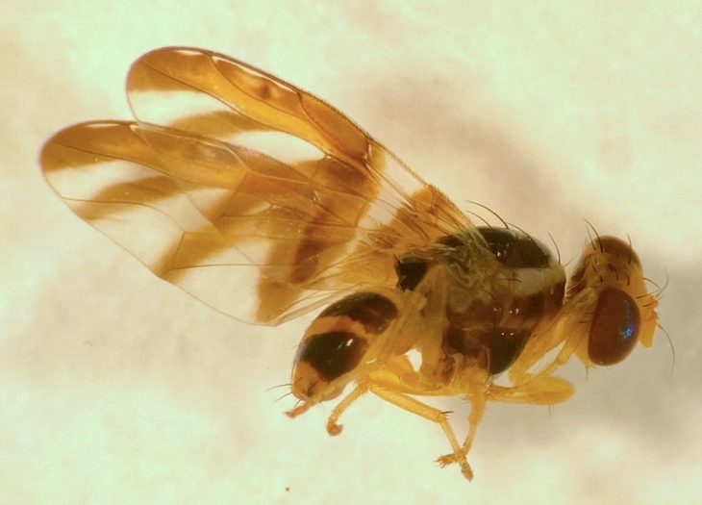
Figure 14. Tephritidae: Paraceratitella eurycephala

Table 5. Range extensions or significant infill in distribution records for species
Species | Location sighted/observed | Distance from nearest known record (km) | Comments
Australimyzidae: Australimyza sp10034 | Tamala: Kalbarri-Nanda Res. 20km SE Womerangee Hill; beach rocks and vegetation (-27.0544, 113.8572) | 230 | The furthest north Australimyza record from WA
Bombyliidae: Mythicomyiinae: Tolkunia sp10043 | Belties Crossing to Corner Rd to Harris Rd Vehicle Net (-27.4968, 114.3212) | 2500 | Known from Alice Springs. Likely a described species but needs to be confirmed with genitalic dissection
Canacidae: Chaetocanace sp10065 | Wittecara creek mouth, beach (-27.7395, 114.1458) | 1000 | The furthest south Chaetocanace known from WA. Likely Chaetocanace flavipes but needs confirmation
Canacidae: Thitena cadaverina | Red Bluff (-27.7445, 114.1437) | 1000 | Previously known only from the type collecting event on Barrow Island. This was a significant finding
Conopidae: Heteroconops gracilis | along Wittecara creek; sweep flowers and dense vegetation (-27.7701, 114.1742) | 2700 | Previously known from Kununurra
Drosophilidae: Scaptomyza sp10110 | Multiple locations | 550
Ephydridae: Notiphila fuscimana |  | 4000 | First documented Australian record. The species is broadly distributed in Asia and Oceania
Helosciomyzidae: Helosciomyza fuscinevris |  | 700
Platystomatidae: Lenophila nila |  | 550
Syrphidae: Chalcosyrphus sp10228 |  | 1800 | Likely a described species but the group needs revisionary work
Tephritidae: Paraceratitella eurycephala |  | 550
Ulidiidae: Physiphora clausa | PCYC Cabin lights  (-27.6993, 114.1715) | 400

3.6 Genetic information
DNA COX1 barcodes for all putative new species will be sequenced. Short read shotgun genome sequencing on an Illumina NovaSeq XPlus, PE 150, 8gb raw data is in progress for the following taxa, which are new species and/ or had no previous genetic data available.
Asteiidae: Phlebosotera sp10033
Canacidae: Thitena cadaverina
Chyromyidae: Aphaniosoma sp10093
Chyromyidae: Notiochyromya sp10094
Ephydridae: Athyroglossa (Athyroglossa) sp10113
Ephydridae: Donaceus sp10116
Fergusoninidae: Fergusonina sp10135
Tephritidae: Paraceratitella eurycephala
Tephritidae: Paraspathulina eremostigma

Additional Diptera species from the Nanda Country Bush Blitz will undergo genome sequencing soon.

4. Information on species lists
Diptera are highly diverse and provide many ecosystem services. As many species are small-bodied, and fast fliers, a thorough account of their diversity is only possible through consistent effort with various methods over a period of time. Very little was previously known about the flies of the area as there hadn’t been a previous targeted survey. The species list for Kalbarri Diptera from ALA was exceeded by nearly ten times. Still, some species previously recorded were not found again, potentially due to seasonality and differences in methodology.
Diptera, the order, is so diverse that not all lineages could be curated and identified for this report. The expectation is that the total diversity of groups like gall midges will bring the count of undescribed species even higher. Many groups have not been revised, so identification is challenging, and additional undescribed species even within the study groups are expected to be discovered in concert with additional genitalic examinations and DNA barcoding data. There are certainly additional undescribed species of small-bodied flies including Dolichopodidae and tachydromiine Hybotidae. Similarly, some larger flies require genitalic dissections to be identified, and this expedition likely collected additional undescribed species, including Tachinidae and miltogrammine Sarcophagidae.
For several groups, the literature and existing collections are so poor that it is currently not possible to assess the genus placement of some morphospecies. This was primarily true for Chloropidae, Ephydridae, Milichiidae, and Sphaeroceridae. Keys to Australian genera are absent or incomplete for these families. With more thorough study, we expect new species and genera of these acalyptrate groups to be present in Western Australia and be represented by material collected during this Bush Blitz. For instance, in Chloropidae, although 20 morphospecies could be differentiated, only three species could be clearly assigned to genus level, and two of those are putative new species within those genera. Milichiidae is a much smaller family, so comparison to known species is more feasible. All eight morphospecies differentiated are putative new species and only two could be unequivocably assigned to genus, suggesting a high ratio of undescribed to described species of Milichiidae in Australia. In Ephydridae, 13 of the 22 morphospecies could be assigned to genus, as the worldwide genus limits are clearer. However, the placement of some undetermined Ephydridae will need additional verification in context with other Australian taxa.

5. Information for land managers
Three notable locations for Diptera diversity were Red Bluff (-27.7445, 114.1437), Wittecara Creek (-27.7693, 114.1738), and 20 km south of Womerangie Hill (-27.0533, 113.8658) - inside the area currently being gazetted. Generally, flies are easier to find in proximity to water resources, and there is a diversity of species restricted to coastal areas. In Red Bluff, the cliff area south of the car park was a refugia for many species. In between the cliffs was a freshwater stream, a combination of resources and refugia that led to a diversity of Diptera being collected at this site. At Wittecara creek, the soil was muddy and a wetland formed along the ill-defined creek margins. Vegetation was dense and some was in flower. Not only semi-aquatic Diptera were collected here, as the flowers and water brought in some arid tolerant groups like Conopidae. The most distinctive site was to the north, 20 km south of Womerangie Hill. Here, there was an assemblage of coastal Diptera different from those collected at Red Bluff. Inland, up the sandy gully, there was an area with caves and dense Acacia bushes. These damp, dark refuges held an abundance and diversity of Diptera. While very remote, there were fishing nets washed on the rocky beach, and some evidence of non-native species including honey bees and goats. This locality was the most distinctive that was surveyed, and fortunately will soon be incorporated into national park land.
An example of a rich microhabitat for collecting small Diptera was a small patch on the edge of Eurardy (-27.547, 114.5876). Here, a small Callitris was growing with a flowering Allocasuarina. The Allocasuarina was much taller, the flowers spreading outwards. The Callitris plant was small but dense, with moist soil at its base. Insects would arrive to obtain nectar resources from the Allocasuarina, then shelter inside the dense Callitris and also obtain water. This is an example of a rare growth pattern throughout the landscape in which a large diversity of flies were collected.

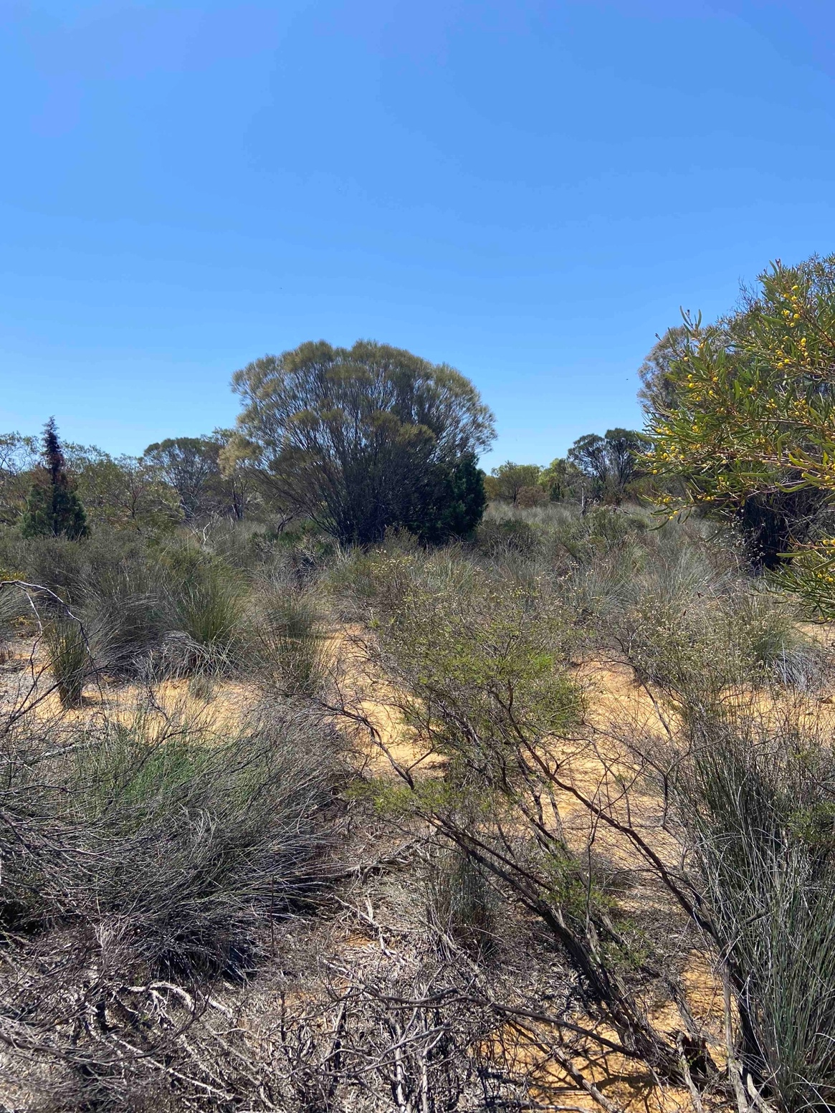
Figure 15. An Allocasuarina growing with a small Callitris offered a combination of floral resources, space to hide, and damp soil that attracted many Diptera species

6. Other significant findings
Based on the current species lists for various families of Diptera, it would have been difficult to predict that the high species diversity of Chloropidae and Ephydridae obtained on the expedition. Chloropidae is ecologically diverse, including plant feeders, parasitoids, and saprophages. Most species of Ephydridae are saprophagous in semi-aquatic habitats, however some are also plant feeders or predators. The diversity of Ephydridae in the area may be explained by the high salt tolerance and narrow niches in many species. Many species are coastal but ephydrid diversity continues inland. Chloropidae are very poorly known in Australia but appear to be diverse in both mesic and semi-arid environments. Malaise traps are an effective method to collect a diversity of Chloropidae as their ecological is so labile. As malaise trapping usage increases, the undescribed diversity of the group in Australia will continue to grow. Both groups are in need of revision in Australia to further quantify and contextualise their diversity.
Western Australia is a well-known hotspot of plant diversity and endemism. However, the diversity of some lineages of plant-feeding Diptera in Western Australia are comparatively lower. One of these is Tephritidae, a group of fruit flies, the most diverse family of acalyptrates. As nine species were found during the expedition, including range extensions and undescribed species, this suggests that the paucity of fruit flies in WA is a historical artefact of collecting efforts. To more thoroughly sample the group, a more prolonged effort with plant rearing is needed.
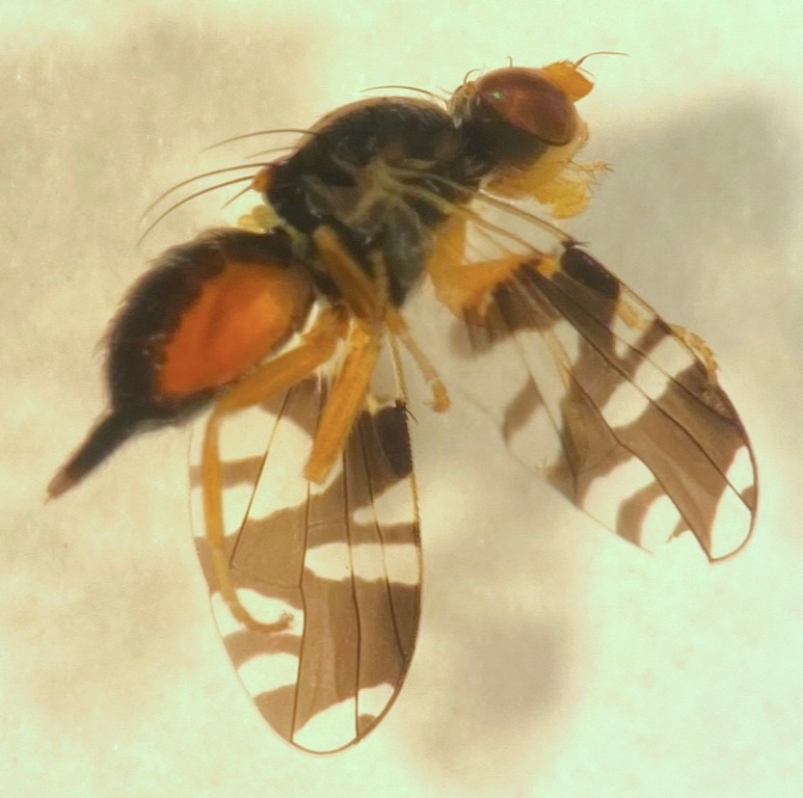
Figure 16. Tephritidae: Paraspathulina eremostigma, a widespread but rare species obtained during the expedition

7. Conclusions
This expedition was the first targeted study of Diptera biodiversity in the Nanda-Kalbarri area. Its success in terms of discovering undescribed species was facilitated by the ideal seasonality- peak flowering after a rainy winter. Each sampling methodology was instrumental to discover different facets of the diversity of flies in the survey area. The DNA of several species is being sequenced and incorporated into current systematic research projects. Several surprising findings may warrant new projects to share findings in peer-reviewed journals. Some new species are known from only one specimen, so additional field work may be needed to more accurately circumscribe the fly diversity of the area.

Acknowledgements
The traditional owners of the land, the Nanda people, are thanked for their guidance and permission for the expedition to take place. The park service rangers are also thanked, particularly the rangers who are part of the Nanda community. EarthWatch and BHP are thanked for helping facilitate the expedition and helping with the survey on the ground. The other researchers on the expedition are also thanked, mainly the entomologists, who worked together and exchanged specimens.

References
Bock, I.R., 1982. Drosophilidae of Australia. V.* Remaining genera and synopsis (Insecta: Diptera). Australian Journal of Zoology Supplementary Series, 30(89), pp.1-164.
Bock, I.R., 1989. New genera and species of Australian Drosophilidae (Diptera). Australian Journal of Entomology, 28(3), pp.169-179.
Brake, I., 2000. Phylogenetic systematics of the Milichiidae (Diptera, Schizophora). Entomologica Scandinavica. Supplement 57: 1-120.
Brake, I. and Mathis, W.N., 2007. Revision of the genus Australimyza Harrison (Diptera: Australimyzidae). Systematic Entomology, 32(2), pp.252-275.
Colless, D. H., and D. K. McAlpine. 1994. Chapter 39. Diptera (Flies). In Systematic and Applied Entomology, ed. I. D. Naumann, pp. 374–387. Melbourne: Melbourne University Press.
Daniels, G. 1976. A key to species of Australian Otitidae (Diptera: Schizophora) with notes on distribution. Aust. Entomol. Mag. 3: 34-35. (July)
Davies, K.A., Ye, W., Taylor, G.S., Scheffer, S., Bartholomaeus, F. and Giblin-Davis, R.M., 2018. Nematodes from galls on Myrtaceae. XI. Descriptions of five new species of Fergusobia from Australia. Zootaxa, 4399(1), pp.1-31.
Dikow, T., 2009. Phylogeny of Asilidae inferred from morphological characters of imagines (Insecta: Diptera: Brachycera: Asiloidea). Bulletin of the American Museum of Natural History, 2009(319), pp.1-175.
Ebejer, M.J., 2009. A revision of Afrotropical Chyromyidae (excluding Gymnochiromyia Hendel) (Diptera: Schizophora), with the recognition of two subfamilies and the description of new genera. African Invertebrates, 50(2), pp.321-434.
Evenhuis, N. 2025. Resolving the genera of Psiloderoidinae in Australia (Diptera: Mythicomyiidae). Bishop Museum Press. 163: pp. 1-44
Freidberg, A. and Friedman, A., 2021. Asteiidae. Manual of Afrotropical Diptera 3 1989-1994
Gaimari, S.D. and Havill, N.P., 2021. A new genus of Chamaemyiidae (Diptera: Lauxanioidea) predaceous on Adelgidae (Hemiptera), with a key to chamaemyiid species associated with Pinaceae-feeding Sternorrhyncha. Zootaxa, 5067(1), pp.1-39.
González, C.R. and Miranda-Esquivel, D.R., 2025. Cladistic analysis and redefinition of the Dasybasis Macquart s. str.(Diptera: Tabanidae) in the Neotropical region. Memórias do Instituto Oswaldo Cruz, 120, p.e240245.
Hardy, D.E. and Drew, R.I., 1996. Revision of the Australian Tephritini (Diptera: Tephritidae). Invertebrate Systematics, 10(2), pp.213-405.
Hull, F.M., 1973. Bee flies of the world: the genera of the family Bombyliidae. Bulletin of the United States National Museum 286: 1-687
Kelsey, L.P., 1970. The Scenopinidae (Diptera) of Australia; including the descriptions of one new genus and six new species. Australian Journal of Entomology, 9(2), pp.103-148.
Kelsey, L.P., 1975. New Australian Scenopinidae (Diptera). Australian Journal of Entomology, 14(3), pp.197-212.
Kim, S.P., 1994. Australian lauxaniid flies: revision of the Australian species of Homoneura van der Wulp, Trypetisoma Malloch, and allied genera (Diptera: Lauxaniidae) (Vol. 1). CSIRO PUBLISHING.
Lambkin, C.L., Yeates, D.K. and Greathead, D.J., 2003. An evolutionary radiation of beeflies in semi-arid Australia: systematics of the Exoprosopini (Diptera: Bombyliidae). Invertebrate Systematics, 17(6), pp.735-891.
Lessard, B.D., Yeates, D.K. and Woodley, N.E., 2021. Revision of the Australian soldier fly genus Antissella White, 1914, including six new species (Stratiomyidae: Antissinae). Insect Systematics & Evolution, 52(4), pp.444-476.
Lonsdale, O., 2014. Redefinition and synonymy of genera in the Ophiomyia genus group, with the description of Euhexomyza new genus (Diptera: Agromyzidae). The Canadian Entomologist, 146(5), pp.481-513.
Mackerras, I.M., 1956. The Tabanidae (Diptera) of Australia. 1. General review. Australian Journal of Zoology, 4(3), pp.376-407.
Malloch, J.R., 1925. Notes on Australian Diptera, No. vi. Proc. Linn. Soc. N.S.W. 50: 80-97.
Malloch J.R., 1927. Notes on Australian Diptera VIII. Proceedings of the Linnean Society of New South Wales 52: 421–423
Malloch, J.R., 1940. Notes on Australian Diptera. XXXVIII. Family Chloropidae, Part ii. In Proceedings of the Linnean Society of New South Wales Vol. 65, No. 3-4, pp. 261-288
Marshall, A.S., Kirk-Spriggs, H.A., Muller, S.B., Paiero, M.S., Yau, T. and Jackson, D.M., 2016. Key to Diptera families-adults 12. Manual of Afrotropical Diptera 1 pp.1-81.
Mathis, W. N., Zatwarnicki, T., Irwin, A. G., 2021. Ephydridae. Manual of Afrotropical Diptera 3 pp.2193-2230
Mathis, W.N. and Zatwarnicki, T., 2023. Phylogeny and taxonomy of the Risa genus-group (Diptera: Ephydridae), with description of a new genus from Australia. Records of the Australian Museum, 75(1).
MacGowan, I. and Rotheray, G. E., 2021. Lonchaeidae. Manual of Afrotropical Diptera 3 pp.1587-1596
McAlpine, D.K., 1973. The Australian Platystomatidae (Diptera, Schizophora) with a revision of five genera. Australian Museum Memoir 15: 1–256
McAlpine, D.K., 1978. Notes on nomenclature and type-specimens of Australian Pyrgotidae (Diptera, Schizophora). The Australian Entomologist, 5(2), pp.27-33.
McAlpine, D.K., 1985. The Australian genera of Heleomyzidae (Diptera: Schizophora) and a reclassification of the family into tribes. Records of the Australian Museum 36(5): 203–251.
Mcalpine, D.K., 1991. Review of the Australian kelp flies Diptera: Coelopidae. Systematic Entomology, 16(1), pp.29-84.
McAlpine, D.K., 2001. Review of the Australasian genera of signal flies (Diptera: Platystomatidae). RECORDS-AUSTRALIAN MUSEUM, 53(2), pp.113-200.
McAlpine, D.K., 2007a. The surge flies (Diptera: Canacidae: Zaleinae) of Australasia and notes on tethinid-canacid morphology and relationships. RECORDS-AUSTRALIAN MUSEUM, 59(1), p.27.
McAlpine, D.K., 2007b. Review of the Borboroidini or wombat flies (Diptera: Heteromyzidae), with reconsider-ation of the status of families Heleomyzidae and Sphaeroceridae, and descriptions of femoral gland-baskets. RECORDS-AUSTRALIAN MUSEUM, 59(2/3), p.143.
McAlpine, D.K., 2012. Notes and descriptions of Australian Helosciomyzidae or comb-winged flies (Diptera: Schizophora). Records of the Australian Museum, 64, pp.51-70.
McAlpine, D. K., and Kim, S. P., 1977. The genus Lenophila (Diptera: Platystomatidae). Records of the Australian Museum 30(13): 309–336.
McAlpine, J.F. and Steyskal, G.C., 1982. A revision of Neosilba McAlpine with a key to the world genera of Lonchaeidae (Diptera). The Canadian Entomologist, 114(2), pp.105-137.
Motamedinia, B., Földvari, M., Skevington, J.H. and Kelso, S., 2025. Revision of Australian Tomosvaryella Aczél (Diptera: Pipunculidae) with description of 100 new species. Zootaxa, 5599(1), pp.1-271.
Munari, L. and Mathis, W.N., 2010. World Catalog of the Family Canacidae (including Tethinidae)(Diptera), with keys to the supraspecific taxa. Zootaxa, 2471(1), pp.1-84.
Papavero, N. and Wilcox, J., 1974. Studies of Mydidae (diptera) systematics and evolution: I. a preliminary classification in subfamilies, with the descriptions of two new genera from the oriental and Australian regions. Arquivos de Zoologia, 25(1), pp.1-34.
Paramonov, S.J., 1958. A review of Australian Pyrgotidae (Diptera). Australian Journal of Zoology, 6(1), pp.89-138.
Permkam, S. and Hancock, D.L., 1994. Australian Ceratitinae (Diptera: Tephritidae). Invertebrate Systematics, 8(6), pp.1325-1341.
Richards, O.W., 1973. The Sphaeroceridae (= Borboridae or Cypselidae; Diptera, Cyclorrhapha) of the Australian Region. Australian Journal of Zoology supplementary series, 21(22), pp.297-401.
Sabrosky, C.W., 1943. New Genera and Species of Asteiidae (Diptera), with a Review of the Family in the Americas. Annals of the Entomological Society of America, 36(3), pp.501-514.
Schneider, M.A., 2010. A taxonomic revision of Australian Conopidae (Insecta: Diptera). Zootaxa, 2581(1), pp.1-246.
Skevington, J.H. and Yeates, D.K., 2001. Phylogenetic classification of Eudorylini (Diptera: Pipunculidae). Systematic Entomology, 26(4), pp.421-452.Spencer, K. A. 1963. The Australian Agromyzidae (Diptera, Insecta). Rec. Aust. Mus. 25(15): 305–354
Spencer, K. A. 1986. The Australian Chloropinae (Diptera: Chloropidae). Journal of natural History, 20(3), pp.503-615.
Swann, J. E. and Sinclair, B. J., 2021. Milichiidae. Manual of Afrotropical Diptera 3 pp. 2015-2034
Tanasijtshuk, V.N., 1996. Silver-flies (Diptera, Chamaemyiidae) of Australia. An International Journal of Dipterological Research, 7(1), pp.1-62.
Wheeler, T.A. and Sinclair, B.J., 2019. Systematics of Paraleucopis Malloch with proposal of Paraleucopidae, a new family of acalyptrate Diptera. Zootaxa, 4668(3), pp.zootaxa-4668.
White, A., 1914. The Diptera-brachycera of Tasmania. Part I. Families Leptidae, Stratiomyidae, Nemestrinidae and Cyrtidae. In Papers & Proceedings of the Royal Society of Tasmania (pp. 35-74).
Winterton, S.L., 2012. Review of Australasian spider flies (Diptera, Acroceridae) with a revision of Panops Lamarck. ZooKeys, (172), p.7.
Winterton, S.L. and Gharali, B., 2011. Iranotrichia gen. n., a new genus of Scenopinidae (Diptera) from Iran, with a key to window fly genera of the world. ZooKeys, (138), p.75.
Yeates, D.K. and Oberprieler, S.K., 2013. Review of the Australian Apiocera minor Norris species-group (Diptera: Apioceridae) with a revised key to species. Zootaxa, 3680(1), pp.195-209.

Appendices

Appendix 1. List of Diptera and Embioptera recorded during the Nanda Country Bush Blitz
Family | Species | Common name | Species new to science | Threatened species (EPBC Act) | Threatened species (Biodiversity Conservation Act 2016) | Introduced species
Flies
Acroceridae | Ogcodes sp10001 | small headed fly | No | No | No | no
Agromyzidae | Agromyzidae sp10008 | leaf mining fly | No | No | No | no
Agromyzidae | Agromyzidae sp10009 | leaf mining fly | No | No | No | no
Agromyzidae | Agromyzidae sp10010 | leaf mining fly | No | No | No | no
Agromyzidae | Liriomyza sp10002 | leaf mining fly | No | No | No | no
Agromyzidae | Liriomyza sp10003 | leaf mining fly | No | No | No | no
Agromyzidae | Liriomyza sp10004 | leaf mining fly | No | No | No | no
Agromyzidae | Melanagromyza sp10005 | leaf mining fly | No | No | No | no
Agromyzidae | Melanagromyza sp10006 | leaf mining fly | No | No | No | no
Agromyzidae | Ophiomyia sp10007 | leaf mining fly | No | No | No | no
Apioceridae | Apiocera sp10011 | flower-loving fly | No | No | No | no
Apioceridae | Apiocera sp10012 | flower-loving fly | No | No | No | no
Apioceridae | Apiocera sp10013 | flower-loving fly | No | No | No | no
Asilidae | Amphisbetetus sp10020 | assassin fly | No | No | No | no
Asilidae | Asilidae sp10024 | assassin fly | No | No | No | no
Asilidae | Asilidae sp10025 | assassin fly | No | No | No | no
Asilidae | Asilidae sp10026 | assassin fly | No | No | No | no
Asilidae | Asilidae sp10027 | assassin fly | No | No | No | no
Asilidae | Asilidae sp10028 | assassin fly | No | No | No | no
Asilidae | Asilidae sp10029 | assassin fly | No | No | No | no
Asilidae | Asilidae sp10030 | assassin fly | No | No | No | no
Asilidae | Asilidae sp10031 | assassin fly | No | No | No | no
Asilidae | Asilidae sp10032 | assassin fly | No | No | No | no
Asilidae | Asilinae sp10014 | assassin fly | No | No | No | no
Asilidae | Asilinae sp10015 | assassin fly | No | No | No | no
Asilidae | Dasypogoninae sp10016 | assassin fly | No | No | No | no
Asilidae | Dasypogoninae sp10017 | assassin fly | No | No | No | no
Asilidae | Leptogaster sp10018 | grass fly | Yes | No | No | no
Asilidae | Leptogaster sp10019 | grass fly | Yes | No | No | no
Asilidae | Ommatius sp10021 | assassin fly | No | No | No | no
Asilidae | Stichopogon sp10022 | assassin fly | Yes | No | No | no
Asilidae | Stichopogon sp10023 | assassin fly | Yes | No | No | no
Asteiidae | Phlebosotera sp10033 | asteiid fly | Yes | No | No | no
Australimyzidae | Australimyza sp10034 | australimyzid fly | No | No | No | no
Bombyliidae | Acreotrichus sp10046 | bee fly | No | No | No | no
Bombyliidae | Anthracinae sp10035 | bee fly | No | No | No | no
Bombyliidae | Anthracinae sp10036 | bee fly | No | No | No | no
Bombyliidae | Anthracinae sp10037 | bee fly | No | No | No | no
Bombyliidae | Bombyliidae sp10052 | bee fly | No | No | No | no
Bombyliidae | Bombyliidae sp10053 | bee fly | No | No | No | no
Bombyliidae | Bombyliidae sp10054 | bee fly | No | No | No | no
Bombyliidae | Bombyliidae sp10055 | bee fly | No | No | No | no
Bombyliidae | Bombyliidae sp10056 | bee fly | No | No | No | no
Bombyliidae | Bombyliidae sp10057 | bee fly | No | No | No | no
Bombyliidae | Bombyliidae sp10058 | bee fly | No | No | No | no
Bombyliidae | Bombyliidae sp10059 | bee fly | No | No | No | no
Bombyliidae | Bombyliidae sp10060 | bee fly | No | No | No | no
Bombyliidae | Bombyliidae sp10061 | bee fly | No | No | No | no
Bombyliidae | Bombyliidae sp10062 | bee fly | No | No | No | no
Bombyliidae | Bombyliinae sp10038 | bee fly | No | No | No | no
Bombyliidae | Bombyliinae sp10039 | bee fly | No | No | No | no
Bombyliidae | Bombyliinae sp10040 | bee fly | No | No | No | no
Bombyliidae | Bombyliinae sp10041 | bee fly | No | No | No | no
Bombyliidae | Comptosia sp10048 | bee fly | No | No | No | no
Bombyliidae | Geron sp10049 | bee fly | No | No | No | no
Bombyliidae | Glabellula sp10042 | bee fly | No | No | No | no
Bombyliidae | Mythicomyiinae sp10044 | micro bee fly | No | No | No | no
Bombyliidae | Mythicomyiinae sp10045 | micro bee fly | No | No | No | no
Bombyliidae | Neosardus sp10050 | bee fly | No | No | No | no
Bombyliidae | Phthiriinae sp10047 | bee fly | No | No | No | no
Bombyliidae | Tolkunia sp10043 | bee fly | No | No | No | no
Bombyliidae | Villa sp10051 | bee fly | No | No | No | no
Calliphoridae | Calliphora sp10063 | blow fly | No | No | No | no
Canacidae | Chaetocanace sp10065 | beach fly | No | No | No | no
Canacidae | Dasyrhicnoessa sp10067 | beach fly | Yes | No | No | no
Canacidae | Tethina ochracea | beach fly | No | No | No | no
Canacidae | Tethina sp10066 | beach fly | No | No | No | no
Canacidae | Thitena cadaverina | beach fly | No | No | No | no
Cecidomyiidae | Cecidomyiidae sp10068 | gall midge | No | No | No | no
Ceratopogonidae | Clinohelea sp10069 | biting midge | Yes | No | No | no
Ceratopogonidae | Forcipomyia sp10070 | biting midge | No | No | No | no
Chamaemyiidae | Leucopis formosana | silver fly | No | No | No | no
Chamaemyiidae | Pseudoleucopis sp10071 | silver fly | Yes | No | No | no
Chironomidae | Chironomidae sp10072 | midge | No | No | No | no
Chloropidae | Chloropidae sp10075 | frit fly | No | No | No | no
Chloropidae | Chloropidae sp10076 | frit fly | No | No | No | no
Chloropidae | Chloropidae sp10077 | frit fly | No | No | No | no
Chloropidae | Chloropidae sp10078 | frit fly | No | No | No | no
Chloropidae | Chloropidae sp10079 | frit fly | No | No | No | no
Chloropidae | Chloropidae sp10080 | frit fly | No | No | No | no
Chloropidae | Chloropidae sp10081 | frit fly | No | No | No | no
Chloropidae | Chloropidae sp10082 | frit fly | No | No | No | no
Chloropidae | Chloropidae sp10083 | frit fly | No | No | No | no
Chloropidae | Chloropidae sp10084 | frit fly | No | No | No | no
Chloropidae | Chloropidae sp10085 | frit fly | No | No | No | no
Chloropidae | Chloropidae sp10086 | frit fly | No | No | No | no
Chloropidae | Chloropidae sp10087 | frit fly | No | No | No | no
Chloropidae | Chloropidae sp10088 | frit fly | No | No | No | no
Chloropidae | Chloropidae sp10089 | frit fly | No | No | No | no
Chloropidae | Chloropidae sp10090 | frit fly | No | No | No | no
Chloropidae | Chloropidae sp10091 | frit fly | No | No | No | no
Chloropidae | Pseudopachychaeta sexta | frit fly | No | No | No | no
Chloropidae | Pseudopachychaeta sp10073 | frit fly | Yes | No | No | no
Chloropidae | Semaranga sp10074 | frit fly | Yes | No | No | no
Chyromyidae | Aphaniosoma sp10092 | chyromyid fly | Yes | No | No | no
Chyromyidae | Aphaniosoma sp10093 | chyromyid fly | Yes | No | No | no
Chyromyidae | Notiochyromya sp10094 | chyromyid fly | Yes | No | No | no
Coelopidae | Coelopella popeae | kelp fly | No | No | No | no
Coelopidae | Gluma nitida | kelp fly | No | No | No | no
Coelopidae | This canus | kelp fly | No | No | No | no
Conopidae | Conopidae sp10100 | thick-headed fly | No | No | No | no
Conopidae | Conopidae sp10101 | thick-headed fly | No | No | No | no
Conopidae | Heteroconops gracilis | thick-headed fly | No | No | No | no
Conopidae | Heteroconops sp10095 | thick-headed fly | Yes | No | No | no
Conopidae | Heteroconops sp10096 | thick-headed fly | Yes | No | No | no
Conopidae | Pleurocerina similis | thick-headed fly | No | No | No | no
Conopidae | Pleurocerina sp10097 | thick-headed fly | Yes | No | No | no
Conopidae | Smartiomyia obscura | thick-headed fly | No | No | No | no
Conopidae | Smartiomyia sp10098 | thick-headed fly | Yes | No | No | no
Conopidae | Stenoconops sp10099 | thick-headed fly | Yes | No | No | no
Cryptochetidae | Cryptochetum sp10102 | scale parasitoid fly | Yes | No | No | no
Cryptochetidae | Cryptochetum sp10103 | scale parasitoid fly | Yes | No | No | no
Dolichopodidae | Dolichopodidae sp10104 | long-legged fly | No | No | No | no
Dolichopodidae | Dolichopodidae sp10105 | long-legged fly | No | No | No | no
Dolichopodidae | Dolichopodidae sp10106 | long-legged fly | No | No | No | no
Dolichopodidae | Dolichopodidae sp10107 | long-legged fly | No | No | No | no
Dolichopodidae | Dolichopodidae sp10108 | long-legged fly | No | No | No | no
Drosophilidae | Scaptodrosophila sp10109 | pomace fly | No | No | No | no
Drosophilidae | Scaptomyza sp10110 | pomace fly | No | No | No | no
Empididae | Empididae sp10111 | dance fly | No | No | No | no
Empididae | Empididae sp10112 | dance fly | No | No | No | no
Ephydridae | Athyroglossa sp10113 | shore fly | Yes | No | No | no
Ephydridae | Atissa sp10114 | shore fly | Yes | No | No | no
Ephydridae | Ceropsilopa sp10115 | shore fly | Yes | No | No | no
Ephydridae | Donaceus sp10116 | shore fly | Yes | No | No | no
Ephydridae | Ephydrella sp10117 | shore fly | No | No | No | no
Ephydridae | Ephydridae sp10125 | shore fly | No | No | No | no
Ephydridae | Ephydridae sp10126 | shore fly | No | No | No | no
Ephydridae | Ephydridae sp10127 | shore fly | No | No | No | no
Ephydridae | Ephydridae sp10128 | shore fly | No | No | No | no
Ephydridae | Ephydridae sp10129 | shore fly | No | No | No | no
Ephydridae | Ephydridae sp10130 | shore fly | No | No | No | no
Ephydridae | Ephydridae sp10131 | shore fly | No | No | No | no
Ephydridae | Ephydridae sp10132 | shore fly | No | No | No | no
Ephydridae | Ephydridae sp10133 | shore fly | No | No | No | no
Ephydridae | Hydrellia sp10118 | shore fly | No | No | No | no
Ephydridae | Nostima sp10119 | shore fly | Yes | No | No | no
Ephydridae | Notiphila fuscimana | shore fly | No | No | No | no
Ephydridae | Ochthera sp10120 | shore fly | No | No | No | no
Ephydridae | Paralimna sp10121 | shore fly | No | No | No | no
Ephydridae | Scatella sp10122 | shore fly | No | No | No | no
Ephydridae | Stratiothyrea sp10123 | shore fly | Yes | No | No | no
Ephydridae | Zeros sp10124 | shore fly | Yes | No | No | no
Fergusoninidae | Fergusonina sp10134 | nematode gall fly | No | No | No | no
Fergusoninidae | Fergusonina sp10135 | nematode gall fly | Yes | No | No | no
Fergusoninidae | Fergusonina sp10136 | nematode gall fly | Yes | No | No | no
Helosciomyzidae | Helosciomyza fuscinevris | helosciomyzid fly | No | No | No | no
Heteromyzidae | Prosopantrum flavifrons | chilean sun fly | No | No | No | Yes
Hybotidae | Tachydromiinae sp10137 | hybotid dance fly | No | No | No | no
Hybotidae | Tachydromiinae sp10138 | hybotid dance fly | No | No | No | no
Lauxaniidae | Homoneura sp10139 | lauxaniid fly | No | No | No | no
Lauxaniidae | Homoneura sp10140 | lauxaniid fly | No | No | No | no
Lonchaeidae | Lamprolonchaea brouniana | Metallic-green tomato fly | No | No | No | Yes
Lonchaeidae | Lamprolonchaea sp10141 | lance fly | No | No | No | no
Lonchaeidae | Silba sp10142 | lance fly | No | No | No | no
Milichiidae | Desmometopa sp10143 | jackal fly | Yes | No | No | no
Milichiidae | Milichiidae sp10145 | jackal fly | Yes | No | No | no
Milichiidae | Milichiidae sp10146 | jackal fly | Yes | No | No | no
Milichiidae | Milichiidae sp10147 | jackal fly | Yes | No | No | no
Milichiidae | Milichiidae sp10148 | jackal fly | Yes | No | No | no
Milichiidae | Milichiidae sp10149 | jackal fly | Yes | No | No | no
Milichiidae | Milichiidae sp10150 | jackal fly | Yes | No | No | no
Milichiidae | Stomosis sp10144 | jackal fly | Yes | No | No | no
Muscidae | Lispe sp10151 | house fly | No | No | No | no
Muscidae | Musca vetustissima | bush fly | No | No | No | no
Muscidae | Muscidae sp10152 | house fly | No | No | No | no
Muscidae | Muscidae sp10153 | house fly | No | No | No | no
Muscidae | Muscidae sp10154 | house fly | No | No | No | no
Muscidae | Muscidae sp10155 | house fly | No | No | No | no
Muscidae | Muscidae sp10156 | house fly | No | No | No | no
Muscidae | Muscidae sp10157 | house fly | No | No | No | no
Muscidae | Muscidae sp10158 | house fly | No | No | No | no
Mycetophilidae | Mycetophilidae sp10159 | fungus gnat | No | No | No | no
Mycetophilidae | Mycetophilidae sp10160 | fungus gnat | No | No | No | no
Mycetophilidae | Mycetophilidae sp10161 | fungus gnat | No | No | No | no
Mycetophilidae | Mycetophilidae sp10162 | fungus gnat | No | No | No | no
Mydidae | Diochlistus sp10163 | mydas fly | No | No | No | no
Mydidae | Diochlistus sp10164 | mydas fly | No | No | No | no
Mydidae | Mitrodetus sp10165 | mydas fly | No | No | No | no
Mydidae | Neorhaphiomidas sp10166 | mydas fly | No | No | No | no
Paraleucopidae | Paraleucopidae sp10260 | bobo fly | Yes | No | No | no
Phoridae | Megaselia sp10175 | scuttle fly | Yes | No | No | no
Phoridae | Megaselia sp10176 | scuttle fly | Yes | No | No | no
Phoridae | Phoridae sp10168 | scuttle fly | No | No | No | no
Phoridae | Phoridae sp10169 | scuttle fly | No | No | No | no
Phoridae | Phoridae sp10170 | scuttle fly | No | No | No | no
Phoridae | Phoridae sp10171 | scuttle fly | No | No | No | no
Phoridae | Phoridae sp10172 | scuttle fly | No | No | No | no
Phoridae | Phoridae sp10173 | scuttle fly | No | No | No | no
Phoridae | Phoridae sp10174 | scuttle fly | No | No | No | no
Pipunculidae | Claraeola sp10177 | big-headed fly | No | No | No | no
Pipunculidae | Tomosvaryella sp10178 | big-headed fly | Yes | No | No | no
Pipunculidae | Tomosvaryella sp10179 | big-headed fly | Yes | No | No | no
Pipunculidae | Tomosvaryella sp10180 | big-headed fly | Yes | No | No | no
Platystomatidae | Duomyia sp10181 | signal fly | Yes | No | No | no
Platystomatidae | Duomyia sp10182 | signal fly | Yes | No | No | no
Platystomatidae | Lenophila nila | signal fly | No | No | No | no
Platystomatidae | Rivellia sp10183 | signal fly | Yes | No | No | no
Platystomatidae | Rivellia sp10184 | signal fly | Yes | No | No | no
Platystomatidae | Rivellia sp10185 | signal fly | Yes | No | No | no
Platystomatidae | Rivellia sp10186 | signal fly | Yes | No | No | no
Pyrgotidae | Cardiacera sp10187 | scarab fly | Yes | No | No | no
Pyrgotidae | Cardiacera sp10188 | scarab fly | Yes | No | No | no
Pyrgotidae | Cardiacera sp10189 | scarab fly | Yes | No | No | no
Rhiniidae | Stomorhina sp10064 | nose fly | No | No | No | no
Sarcophagidae | Miltogramminae sp10190 | satellite fly | No | No | No | no
Sarcophagidae | Sarcophagidae sp10191 | flesh fly | No | No | No | no
Sarcophagidae | Sarcophagidae sp10192 | flesh fly | No | No | No | no
Sarcophagidae | Sarcophagidae sp10193 | flesh fly | No | No | No | no
Sarcophagidae | Sarcophagidae sp10194 | flesh fly | No | No | No | no
Sarcophagidae | Sarcophagidae sp10195 | flesh fly | No | No | No | no
Sarcophagidae | Sarcophagidae sp10196 | flesh fly | No | No | No | no
Scatopsidae | Scatopsidae sp10197 | flesh fly | No | No | No | no
Scatopsidae | Scatopsidae sp10198 | flesh fly | No | No | No | no
Scenopinidae | Neopseudatrichia sp10199 | window fly | Yes | No | No | no
Scenopinidae | Riekiella sp10200 | window fly | No | No | No | no
Scenopinidae | Riekiella sp10201 | window fly | No | No | No | no
Scenopinidae | Riekiella sp10202 | window fly | No | No | No | no
Scenopinidae | Scenopinidae sp10204 | window fly | No | No | No | no
Scenopinidae | Scenopinidae sp10205 | window fly | No | No | No | no
Scenopinidae | Scenopinidae sp10206 | window fly | No | No | No | no
Scenopinidae | Scenopinus sp10203 | window fly | No | No | No | no
Sciaridae | Sciaridae sp10207 | dark-winged fungus gnat | No | No | No | no
Sciaridae | Sciaridae sp10208 | dark-winged fungus gnat | No | No | No | no
Sciaridae | Sciaridae sp10209 | dark-winged fungus gnat | No | No | No | no
Sepsidae | Australosepsis frontalis | black scavenger fly | No | No | No | no
Sepsidae | Sepsidae sp10210 | black scavenger fly | No | No | No | no
Sepsidae | Sepsidae sp10211 | black scavenger fly | No | No | No | no
Simuliidae | Austrosimulium sp10212 | black fly | No | No | No | no
Simuliidae | Austrosimulium sp10213 | black fly | No | No | No | no
Sphaeroceridae | Limosininae sp10214 | small dung fly | No | No | No | no
Sphaeroceridae | Limosininae sp10215 | small dung fly | No | No | No | no
Sphaeroceridae | Limosininae sp10216 | small dung fly | Yes | No | No | no
Sphaeroceridae | Limosininae sp10217 | small dung fly | Yes | No | No | no
Sphaeroceridae | Sphaeroceridae sp10218 | small dung fly | No | No | No | no
Sphaeroceridae | Sphaeroceridae sp10219 | small dung fly | No | No | No | no
Sphaeroceridae | Sphaeroceridae sp10220 | small dung fly | No | No | No | no
Sphaeroceridae | Sphaeroceridae sp10221 | small dung fly | No | No | No | no
Sphaeroceridae | Sphaeroceridae sp10222 | small dung fly | No | No | No | no
Stratiomyidae | Antissella kalbarriensis | soldier fly | No | No | No | no
Stratiomyidae | Clitellariinae sp10223 | soldier fly | No | No | No | no
Stratiomyidae | Damaromyia sp10224 | soldier fly | Yes | No | No | no
Stratiomyidae | Odontomyia sp10225 | soldier fly | Yes | No | No | no
Stratiomyidae | Odontomyia sp10226 | soldier fly | Yes | No | No | no
Syrphidae | Chalcosyrphus sp10228 | flower fly | No | No | No | no
Syrphidae | Psilota sp10229 | flower fly | No | No | No | no
Syrphidae | Psilota sp10230 | flower fly | No | No | No | no
Syrphidae | Syrphidae sp10231 | flower fly | No | No | No | no
Syrphidae | Syrphidae sp10232 | flower fly | No | No | No | no
Syrphidae | Syrphinae sp10227 | flower fly | No | No | No | no
Tabanidae | Dasybasis sp10233 | march fly | No | No | No | no
Tabanidae | Dasybasis sp10259 | march fly | Yes | No | No | no
Tachinidae | Exoristinae sp10234 | bristle fly | No | No | No | no
Tachinidae | Phasiinae sp10235 | bristle fly | No | No | No | no
Tachinidae | Rutilia sp10236 | bristle fly | No | No | No | no
Tachinidae | Tachinidae sp10237 | bristle fly | No | No | No | no
Tachinidae | Tachinidae sp10238 | bristle fly | No | No | No | no
Tachinidae | Tachinidae sp10239 | bristle fly | No | No | No | no
Tachinidae | Tachinidae sp10240 | bristle fly | No | No | No | no
Tachinidae | Tachinidae sp10241 | bristle fly | No | No | No | no
Tachinidae | Tachinidae sp10242 | bristle fly | No | No | No | no
Tachinidae | Tachinidae sp10243 | bristle fly | No | No | No | no
Tachinidae | Tachinidae sp10244 | bristle fly | No | No | No | no
Tachinidae | Tachinidae sp10245 | bristle fly | No | No | No | no
Tephritidae | Austrotephritis sp10246 | fruit fly | No | No | No | no
Tephritidae | Austrotephritis sp10247 | fruit fly | Yes | No | No | no
Tephritidae | Austrotephritis sp10248 | fruit fly | Yes | No | No | no
Tephritidae | Austrotephritis sp10249 | fruit fly | Yes | No | No | no
Tephritidae | Bactrocera sp10250 | fruit fly | No | No | No | no
Tephritidae | Ceratitis capitata | fruit fly | No | No | No | Yes
Tephritidae | Dioxyna hyalina | fruit fly | No | No | No | no
Tephritidae | Paraceratitella eurycephala | fruit fly | No | No | No | no
Tephritidae | Paraspathulina eremostigma | fruit fly | No | No | No | no
Therevidae | Acupalpa melanophaeos | stiletto fly | No | No | No | no
Therevidae | Agapophytinae sp10251 | stiletto fly | No | No | No | no
Therevidae | Agapophytus sp10252 | stiletto fly | No | No | No | no
Therevidae | Therevidae sp10254 | stiletto fly | No | No | No | no
Therevidae | Therevidae sp10255 | stiletto fly | No | No | No | no
Therevidae | Therevidae sp10256 | stiletto fly | No | No | No | no
Therevidae | Therevidae sp10257 | stiletto fly | No | No | No | no
Therevidae | Therevidae sp10258 | stiletto fly | No | No | No | no
Ulidiidae | Physiphora clausa | picture-winged fly | No | No | No | no
Webspinners (Embioptera)
Oligotomidae | Oligotomidae sp10167 | webspinner | No | No | No | Yes

