Nanda Country Bush Blitz
Arachnida & Myriapoda
21–31 October 2024
Submitted: 24 April 2025
Jeremy D. Wilson, Julianne M. Waldock, Volker W. Framenau, Mark S. Harvey

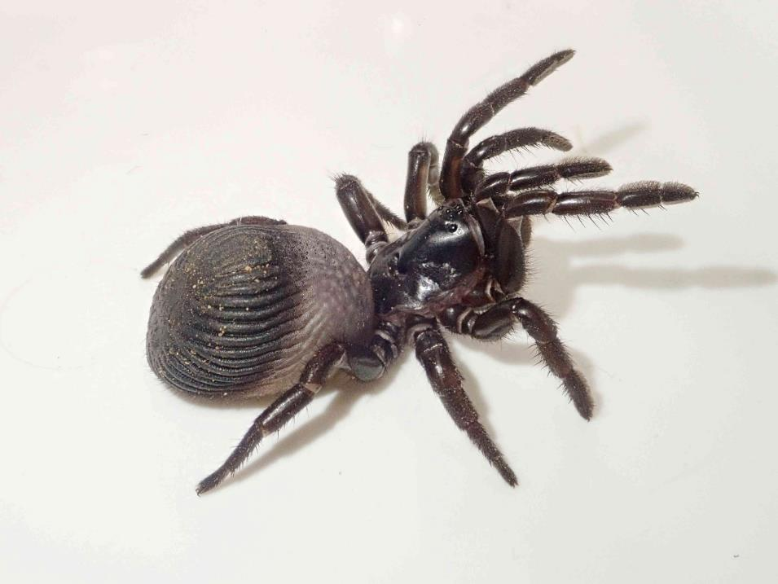
Figure 1. Idiosoma arenaceum (WAM T166785), the Geraldton sandplain shield-backed trapdoor spider.

Nomenclature and taxonomy used in this report is consistent with:
Australian Faunal Directory (AFD)

Contents
Contents 2
List of contributors 2
Abstract 3
1. Introduction 4
2. Methods 5
2.1 Site selection 5
2.2 Survey techniques 5
2.2.1 Methods used at standard survey sites 5
2.3 Identifying the collections 6
3. Results and Discussion 6
3.1 Un-named or not formalised taxa 6
3.2 Species new to science 7
3.3 Introduced species 7
3.4 Threatened species 8
3.5 Genetic information 8
4. Information for land managers 8
5. Other significant findings 9
6. Conclusions 9
Acknowledgements 9
References 11
Appendices 12
Appendix 1. List of arachnid and myriapod species recorded during the Nanda Country Bush Blitz. 12

List of contributors
List of contributors to this report.
Name | Institution/affiliation | Qualifications/area of expertise | Level/form of contribution
Jeremy D Wilson | Western Australian Museum | Arachnida | Principal author, in-field IDs
Julianne M. Waldock | Western Australian Museum | Arachnida & Myriapoda | Laboratory IDs - general
Volker W. Framenau | Murdoch University | Arachnida & Myriapoda | Laboratory IDs Araneidae and Lycosidae
Mark S. Harvey | Western Australian Museum | Arachnida & Myriapoda | in-field IDs, laboratory IDs of Pseudoscorpiones

Abstract
We conducted a Bush Blitz survey to assess arachnid and myriapod diversity in the Geraldton Sandplains bioregion, with a particular focus on Kalbarri National Park, Eurardy Nature Reserve (Bush Heritage), and Zuytdorp Nature Reserve. The region comprises a variety of habitats, including eucalypt woodlands, coastal heathlands, limestone gorges and plateaus, and riparian corridors. Over a 10-day expedition, we employed a wide range of collection methods to target both active and sedentary taxa. These included active searching for burrows and webs, nocturnal spotlighting for spiders, UV detection of scorpions, rock flipping, bark peeling, and leaf litter sifting/sieving. Additionally, valuable by-catch from other teams, primarily collected through sweep-netting and pitfall trapping, was incorporated into our survey. The resulting assemblage reflects a blend of arid-zone and coastal sandplain-adapted species, including a diverse range of burrowing spiders (mygalomorphs, lycosids, zodariids) as well as more cryptic and sedentary groups like scorpions, pseudoscorpions, centipedes, and millipedes. Many of these cryptic taxa likely represent undescribed species, emphasising the underexplored invertebrate diversity of the region.

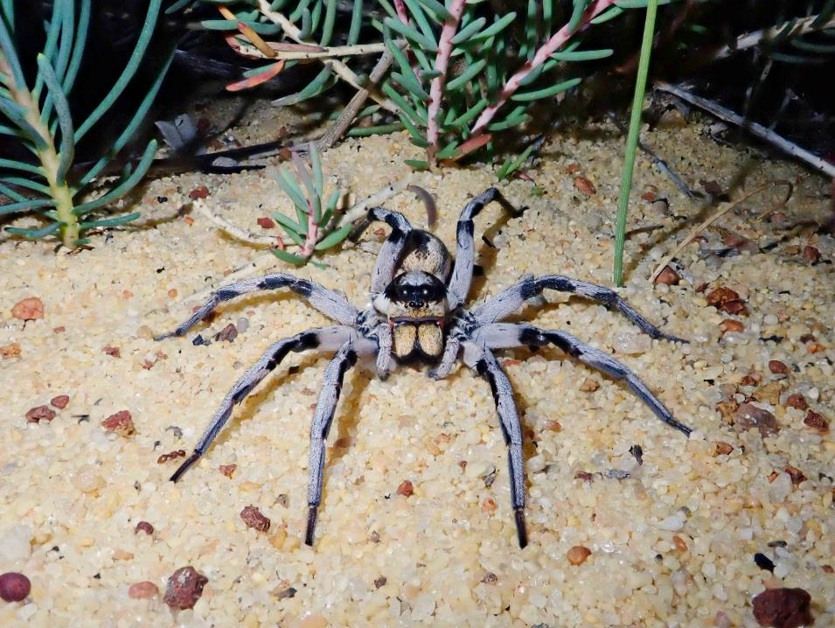
Figure 2. Undescribed species of wolf spider ‘Lycosidae gen. nov. sp. nov. KBB1’ (specimen voucher – WAM T166722) found in Banksia heath in the Kalbarri region.

1. Introduction
The survey area, around the town of Kalbarri, is situated at the northern edge of the Geraldton Sandplains bioregion, near the transitional boundaries with the Yalgoo and Carnarvon bioregions. This intersection supports a mosaic of landscapes and vegetation types, including coastal heathlands, eucalypt woodlands, limestone gorges and plateaus, and riparian systems along the Murchison River. The region’s nutrient-poor sandy soils are renowned for their botanical richness and contribute to its status as a biodiversity hotspot. However, the invertebrate fauna - particularly sedentary and cryptic groups - remains poorly studied. Many of these groups are expected to exhibit high levels of short-range endemism, underscoring the need for targeted surveys to understand their distribution and inform conservation efforts.
A pre-survey analysis of the Western Australian Museum (WAM) database revealed particularly high diversity among burrowing and ground-dwelling arachnids and myriapods in the Kalbarri region. We anticipated finding a rich diversity of mygalomorph spiders (trapdoor spiders) from the families Anamidae, Idiopidae, and Barychelidae; wolf spiders (Lycosidae); ant-eating spiders (Zodariidae); tube-web spiders (Segestriidae); and desert scorpions in the family Urodacidae. These groups typically construct burrows or retreats and can be detected by daytime searching for burrow entrances, by nighttime spotlighting (including using UV lights for scorpions), or by passive sampling with pitfall traps.
Other expected taxa included prowling spiders (Miturgidae), huntsman spiders (Sparassidae), flat spiders (Selenopidae and Trachycosmiidae), centipedes (Chilopoda), millipedes (Diplopoda), scorpions in the family Buthidae, and pseudoscorpions. These groups shelter in cryptic microhabitats such as under rocks, bark, or within leaf litter, and are best sampled through daytime rock-turning, bark peeling, litter extraction, and nighttime spotlighting. Web-building spiders, including orb-weavers (Araneidae), were also anticipated, although they are relatively well-known in the region.
Of particular interest were mygalomorph spiders of the families Anamidae (e.g. the genera Aname and Kwonkan – e.g. Harvey et al. 2018) and Idiopidae (e.g. Bungulla, Euoplos, and Idiosoma – see Rix et al. 2017), as well as wolf spiders (Lycosidae – e.g. McKay 1973; Langlands and Framenau, 2010; Framenau and Baehr, 2016). A high diversity of both described and undescribed species in these groups is known from the region, and specimens of undescribed species collected during the survey will contribute directly to ongoing taxonomic research. These groups are currently under revision, with established expertise in Australia supporting timely taxonomic outcomes. The genus Bungulla is especially diverse in the area. Although most species have been described, the revision was largely based on male specimens and female morphology and burrowing behaviour remain poorly understood.
Efforts were concentrated on methods targeting burrowing and cryptic, sedentary taxa, as these groups harbor significant undescribed diversity and are often of conservation interest due to their typically small natural distributions.
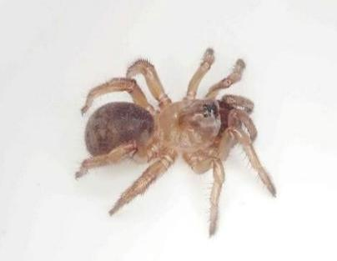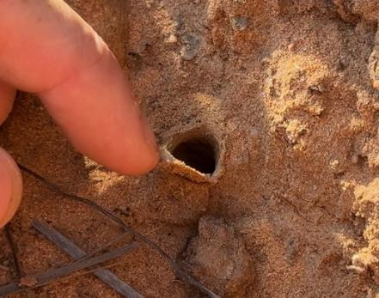
Figure 3. Burrow entrance (left) and female spider (right) of Bungulla ajana (specimen voucher – WAM T166820), previously only known from male specimens.

2. Methods

2.1 Site selection
Survey sites were selected to capture a representative range of habitat types across the region, including coastal heathlands, areas surrounding limestone gorges, riparian environments within the gorges, and inland eucalypt woodlands. Specific sites were identified by driving slowly through the park, observing fine-scale changes in soil type and vegetation, which often correspond with shifts in arachnid and myriapod assemblages. Sampling was largely opportunistic and did not follow a structured or randomised design – our goal was to sample as many different species as possible, particularly of the groups highlighted earlier.

2.2 Survey techniques
To maximise the sampling of our target arachnid and myriapod groups, we employed a variety of active survey techniques during both day and night and incorporated specimens collected by other teams using passive sampling methods.
Daytime active collecting methods included:
- Visual burrow searching – We inspected the soil surface for evidence of burrows, photographed the entrances, and excavated the burrows to extract specimens.
- Visual web searching – Some web-building species leave their webs intact during the day. When encountered, efforts were made to collect the occupant, typically found in the web or nearby foliage.
- Rock flipping – Many arachnid and myriapod species shelter beneath rocks. These were carefully flipped to locate and collect specimens, which were then placed in vials before returning the rocks to their original position.
- Bark peeling – Bark was peeled from trees, and the exposed area was inspected for small arachnids, particularly pseudoscorpions, that inhabit this microhabitat.
- Litter sifting – Leaf litter was sifted to detect small arachnids and myriapods living in this moist and sheltered microclimate.
Nighttime active collecting methods included:
- Spotlighting – Wolf spiders (Lycosidae), huntsman spiders (Sparassidae), and prowling spiders (Miturgidae) were detected by the reflection of their eyes under torchlight. Many web-building spiders were also easily located and collected from their webs, which they construct at night.
- UV spotlighting – Scorpions fluoresce under ultraviolet light, making UV torches an effective tool for detecting them while they are active at night.
Passive and incidental methods used by other teams included:
- Pitfall trapping – Dry pitfall traps and funnel traps set by the herpetology team often capture a range of ground-active invertebrate species, including centipedes, scorpions, wandering male trapdoor spiders, and cursorial hunting spiders.
- Sweep netting – Entomology teams using sweep nets to sample foliage-dwelling insects also collected spiders from this microhabitat (e.g. crab spiders – Thomisidae, lynx spiders – Oxyopidae), which were passed on to us.

2.2.1 Methods used at standard survey sites
At both standard survey sites, we actively searched for burrows and webs, sifted leaf litter in the small mallee patches present, and peeled bark. Searches at these sites were conducted for one hour. Additionally, other teams deployed pitfall traps for several days, which yielded some ground-active species from these sites.

2.3 Identifying the collections
Specimens were initially identified in the field to the lowest practical taxonomic level, often to genus, or to species in cases where they were well-known. However, for the sake of efficiency, no attempt was made in the field to confirm identifications or consult the literature.
Upon returning to the Western Australian Museum, Julianne Waldock confirmed or corrected identifications using a stereo microscope and relevant literature, as well as comparison with previously identified material in the WAM collections. Final taxonomic identifications were made by the following experts:
- Mygalomorphae – Jeremy Wilson
- Lycosidae and Araneidae – Volker Framenau
- Pseudoscorpions and scorpions – Mark Harvey
- All other taxa – Julianne Waldock
Tissue was sampled from specimens in the field and stored in 100% ethanol at minus 20°C. These samples have been added to the Western Australian Museum’s tissue collection and can be used in future for taxonomic confirmation or inclusion in phylogenetic studies investigating evolutionary relationships.

3. Results and Discussion
Appendix 1 lists all arachnids and myriapods recorded during the Bush Blitz. Collections made during this Bush Blitz will result in 157 specimens being added to public collections and 152 records being added to publicly accessible databases (this number is less because some records contain multiple specimens).

3.1 Un-named or not formalised taxa
Table 1. Putatively un-named or not formalised taxa
Taxon | Comment
Aname sp. nov. `MYG633` | Many females of an undescribed species of wishbone spider widespread around Kalbarri were collected. This undescribed species is already recognised with a MYG code in the WAM collection.
Idiommata sp. nov. `MYG409` | Two males of an undescribed species of brush-footed trapdoor spider were collected. This undescribed species is already recognised in the WAM collection with a MYG code.
Euoplos sp. nov. `KBB1` | A female specimen belonging to an undescribed species of the golden trapdoor spider genus Euoplos. This genus is quite diverse in the region and several undescribed species are recognised based on male specimens, but assigning this female specimen to one of them cannot be done with confidence due to sexual dimorphism.
Idiosoma sp. nov. `KBB1 hard wafer door` | One undescribed Idiosoma species was previously known from the region, but we collected females of two undescribed species, meaning that at least one of the collected undescribed species has not been recognised previously. However, it is impossible to know which, because the previously recognised species is known from male specimens only, and it is very difficult to match the females confidently to males due to sexual dimorphism.
Idiosoma sp. nov. `KBB2 punk door`
Lycosa sp. nov. `woonda grp` | A female of an undescribed species, related to Lycosa woonda, was collected. This undescribed species, along with many others in this species-group, have been recognised previously by VWF.
Ariadna sp. nov. `KBB1` | A female and juvenile of an undescribed species of tube-web spider were found in open silk-lined burrows around Kalbarri, however various undescribed species are already recognised from the location and this likely represents one of them.
Neosparassus sp. nov. `KBB1` | An undescribed but previously recognised badge huntsman spider.
Emertonella sp. nov. `KBB1` | Undescribed theridiid spiders, some of which have been included in long term projects that have not yet been published.
gen. nov. `Ctenopalpus` sp. nov. `KBB1`
Steatoda sp. nov. `native KBB1`
Isometroides sp. nov. `KBB1` | Undescribed scorpion species from the region, mostly recognised already through previous sampling efforts in the region.
Lychas sp. nov. `KBB1`
Lychas sp. nov. `KBB2`

3.2 Species new to science
In this report, ‘species new to science’ means species that were not recognised by Western science before this Bush Blitz.
Table 2. Species new to science
Species | Comment
Kwonkan sp. nov. `MYG906` | Two males of an undescribed species of the collar-door wishbone spider genus Kwonkan were collected. This species has not been recognised previously.
Lycosidae gen. nov. sp. nov. `KBB1` | An adult male and adult female of an undescribed species, belonging to a new wolf spider genus (per VWF), were collected. This species has not been recognised previously.
Urodacus sp. nov. `megamastigus spp. group` | An undescibed species of desert scorpion, closely related to Urodacus megamastigus was collected. This species has not been recognised previously.

3.3 Introduced species
None sampled.

3.4 Threatened species
Table 4. Threatened species
Species | Listing status and level (EBPC, State/Territory) | Location sighted/observed | Indication of abundance
Idiosoma arenaceum - Geraldton Sandplain shield-backed trapdoor spider | WA Priority 3 | Two relatively healthy populations of Idiosoma arenaceum were located, one around: -27.25745, 114.06931; and the other around -27.61909, 114.38682. | Around both locations, various specimens were identified, of varying size classes, suggesting healthy, stable population.

3.5 Genetic information
No genetic information is yet available, but tissue samples were taken from most specimens collected on the trip, allowing future genetic analysis.

4. Information for land managers
Of particular interest to land managers, both for documenting undescribed diversity and for ecological monitoring, are the rich diversity of burrowing arachnids that occur in the region, including trapdoor spiders (primarily the families Anamidae and Idiopidae), wolf spiders (Lycosidae), ant-eating spiders (Zodariidae), tube-web spiders (Segestriidae), and desert scorpions (Urodacidae). These groups construct distinctive burrows that, once recognised, can be identified and monitored over time with minimal disturbance. Because burrows are generally genus- or even species-specific in structure they provide a reliable, non-invasive way to track population presence and activity.

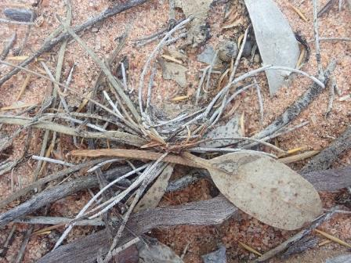
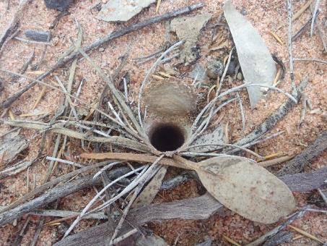
Figure 4. Burrow entrance closed (left) and open (right) of one of the three Idiosoma species ‘KBB2 punk door’ collected on the expedition (specimen voucher – WAM T166823).
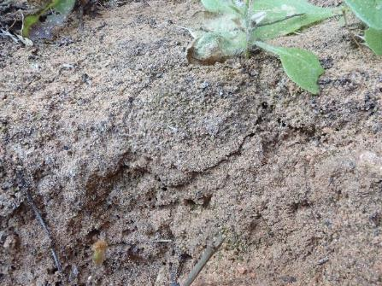
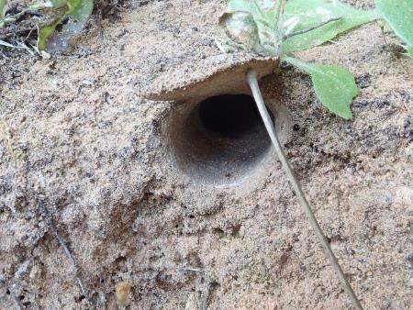
Figure 5. Burrow entrance closed (left) and open (right) of another of the three Idiosoma species ‘KBB1 hard wafer door’ collected on the expedition (specimen voucher – WAM T166816).
As is clear from our survey data, many of the taxa collected during the Bush Blitz remain scientifically undescribed, and some, particularly members of the idiopid genera Bungulla and Idiosoma, may have restricted distributions tied to specific habitat features such as soil type, vegetation structure, or microclimate. This makes them potentially significant from a conservation perspective, particularly in areas undergoing environmental change or land-use pressure.

5. Other significant findings
We collected female specimens of two Bungulla species (Idiopidae) during the trip. Although the genus has been recently revised, most species were described from male specimens only, leaving gaps in our understanding of female morphology, burrow architecture, and microhabitat preferences. Our collection of two females, along with documentation of their burrow structures, provides valuable natural history data for a group lacking such information.

6. Conclusions
This Bush Blitz survey uncovered a diverse assemblage of arachnid and myriapod species from across the Geraldton Sandplains bioregion, with a particular focus on Kalbarri National Park and surrounding reserves. Our methods successfully targeted cryptic and burrowing taxa, revealing a high proportion of undescribed or poorly understood species, particularly among mygalomorph spiders, scorpions, and centipedes. Three species are here recognised as being collected for the first time. The results underscore the ecological significance and taxonomic richness of this region, and highlight the importance of continued, targeted sampling to document short-range endemism, to understand distributions of more widespread species, and to support future taxonomic and conservation efforts. Specimens and tissue samples collected will contribute directly to museum collections, taxonomic revisions, and long-term biodiversity research.

Acknowledgements
We thank Bush Blitz and its supporting partners for funding and logistical support. We further thank the Nanda Rangers and Nanda people for their support and allowing us onto their country, and we thank the Department of Biodiversity, Conservation and Attractions (DBCA) that supported the expedition. We further thank Bush Heritage and acknowledge Bush Heritage Australia for granting access to Eurardy Nature Reserve. We thank the other survey teams, particularly the herpetology and entomology groups, for sharing valuable by-catch specimens, and all field participants for their collaboration and enthusiasm throughout the expedition.

References
Framenau, V.W. and Baehr, B.C. (2016). Revision of the Australian Union-Jack wolf spiders, genus Tasmanicosa (Araneae, Lycosidae, Lycosinae). Zootaxa 4213: pp. 1–82.
Framenau, V.W., Dupérré, N., Blackledge, T.A. and Vink, C. (2010). Systematics of the new Australasian orb-weaving spider genus Backobourkia (Araneae: Araneidae: Araneinae). Arthropod Systematics & Phylogeny 68: pp. 79–111.
Gray, M.R. (1983). A new genus of spiders of the subfamily Metaltellinae (Araneae, Amaurobioidea) from southeastern Australia. Proceedings of the Linnean Society of New South Wales 106: pp. 275–285.
Harvey, M.S. (1995). The systematics of the spider family Nicodamidae (Araneae: Amaurobioidea). Invertebrate Taxonomy 9: pp. 279–386.
Harvey, M.S., Hillyer, M.J., Main, B.Y., Moulds, T.A., Raven, R.J., Rix, M.G., Vink, C.J. and Huey, J.A. (2018). Phylogenetic relationships of the Australasian open-holed trapdoor spiders (Araneae: Mygalomorphae: Nemesiidae: Anaminae): multi-locus molecular analyses resolve the generic classification of a highly diverse fauna. Zoological Journal of the Linnean Society 184: pp. 407–452.
Hirst, D.B. (1991). Revision of Australian species of the genus Holconia Thorell (Heteropodidae: Araneae). Records of the South Australian Museum 24: pp. 91–109.
Hirst, D.B. (1993). Revision of the genus Isopedella (Araneae: Heteropodidae). Invertebrate Taxonomy 7: pp. 33–87.
Langlands, P.R. and Framenau, V.W. (2010). Systematic revision of Hoggicosa Roewer, 1960, the Australian ‘bicolor’ group of wolf spiders (Araneae: Lycosidae). Zoological Journal of the Linnean Society 158: pp. 83–123.
McKay, R.J. (1973). The wolf spiders of Australia (Araneae: Lycosidae): 1. The bicolor group. Memoirs of the Queensland Museum 16: pp. 375–398.
Rix, M.G., Raven, R.J., Main, B.Y., Harrison, S.E., Austin, A.D., Cooper, S.J. and Harvey, M.S. (2017). The Australasian spiny trapdoor spiders of the family Idiopidae (Mygalomorphae: Arbanitinae): a relimitation and revision at the generic level. Invertebrate Systematics 31: pp. 566–634.

Appendices

Appendix 1. List of arachnid and myriapod species recorded during the Nanda Country Bush Blitz.
Family | Species | Common name | Species new to science | Threatened species (EPBC Act) | Threatened species (Biodiversity Conservation Act 2016) | Introduced species
MYGALOMORPH spiders (trapdoor spiders, tarantulas, and relatives)
Anamidae | Aname sp. nov. `MYG633` | na | no | no | no | no
Anamidae | Kwonkan sp. nov. `MYG906` | na | yes | no | no | no
Barychelidae | Idiommata sp. nov. `MYG409` | na | no | no | no | no
Idiopidae | Bungulla ajana | na | no | no | no | no
Idiopidae | Bungulla banksia | na | no | no | no | no
Idiopidae | Euoplos sp. nov. `KBB1` | na | no | no | no | no
Idiopidae | Idiosoma arenaceum | na | no | no | Priority 3 | no
Idiopidae | Idiosoma sp. nov. `KBB1 hard wafer door` | na | no | no | no | no
Idiopidae | Idiosoma sp. nov. `KBB2 punk door` | na | no | no | no | no
ARANEOMORPH spiders (modern spiders)
Araneidae | Argiope protensa | Tailed Grass Spider | no | no | no | no
Araneidae | Austracantha minax | Jewel Spider | no | no | no | no
Araneidae | Backobourkia collina | na | no | no | no | no
Araneidae | Backobourkia heroine | na | no | no | no | no
Araneidae | Trichonephila edulis | Australian Golden Orb-weaving Spider | no | no | no | no
Corinnidae | Nucastia eneabba | na | no | no | no | no
Deinopidae | Asianopis schomburgki | na | no | no | no | no
Desidae | Badumna insignis | Black House Spider | no | no | no | no
Lamponidae | Lamponina scutata | na | no | no | no | no
Lycosidae | Hoggicosa sp. indet. `cf forresti` | na | no | no | no | no
Lycosidae | Lycosa sp. nov. `woonda grp` | na | no | no | no | no
Lycosidae | Lycosidae gen. nov. sp. nov. `KBB1` | na | yes | no | no | no
Lycosidae | Mainosa longipes | na | no | no | no | no
Lycosidae | Tasmanicosa leuckartii | na | no | no | no | no
Miturgidae | Mituliodon tarantulinus | na | no | no | no | no
Miturgidae | Miturga sp. indet. | na | no | no | no | no
Nicodamidae | Nicodamus mainae | Main Red And Black Spider | no | no | no | no
Oxyopidae | Oxyopes amoenus | na | no | no | no | no
Pholcidae | Pholcitrichocyclus nigropunctatus | na | no | no | no | no
Salticidae | Adoxotoma sp. indet. | na | no | no | no | no
Salticidae | Apricia sp. nov. `KBB1` | na | unknown | no | no | no
Salticidae | Maratus sp. indet. `cf griseus?` | na | no | no | no | no
Segestriidae | Ariadna sp. nov. `KBB1` | na | no | no | no | no
Sparassidae | Holconia westralia | na | no | no | no | no
Sparassidae | Isopedella saundersi | na | no | no | no | no
Sparassidae | Neosparassus sp. nov. `KBB1` | na | no | no | no | no
Tetragnathidae | Tetragnatha sp. `KBB1` | na | unknown | no | no | no
Theridiidae | Cryptachaea veruculata | na | no | no | no | no
Theridiidae | Emertonella sp. nov. `KBB1` | na | no | no | no | no
Theridiidae | Latrodectus hasseltii | Redback Spider | no | no | no | no
Theridiidae | Steatoda sp. nov. `native KBB1` | na | no | no | no | no
Theridiidae | Theridiidae gen. nov. `Ctenopalpus` sp. nov. `KBB1` | na | no | no | no | no
Trachycosmidae | Longrita sp. indet. | na | no | no | no | no
Zodariidae | Cavasteron sp. indet. | na | no | no | no | no
Zodariidae | Neostorena sp. indet. | na | no | no | no | no
Myriapods (centipedes and millipedes)
Paradoxosomatidae | Antichiropus sp. `cf DIP089` | na | unknown | no | no | no
Scolopendridae | Scolopendra laeta | Striped Centipede | no | no | no | no
Scolopendridae | Scolopendra morsitans | Red-headed Centipede | no | no | no | no
Pseudoscorpions
Garypidae | Synsphyronus mimulus | na | no | no | no | no
Garypidae | Synsphyronus tenuis | na | no | no | no | no
Olpiidae | Austrohorus sp. indet. | na | no | no | no | no
Scorpions
Buthidae | Isometroides sp. nov. `KBB1` | na | no | no | no | no
Buthidae | Lychas sp. nov. `KBB1` | na | no | no | no | no
Buthidae | Lychas sp. nov. `KBB2` | na | no | no | no | no
Urodacidae | Urodacus sp. nov. `megamastigus spp. group` | na | yes | no | no | no
Mites and ticks
Ixodidae | Amblyomma triguttatum | Common Kangaroo Tick | no | no | no | no
na Not available.

