

Approach to Market

To establish Contract for Bush Blitz 2024 Taxonomy Research

Reference ID: DNP-BCK-2324-030

UNSPSC: 70160000 Wildlife and flora

This Approach to Market (ATM) is for the provision of: The publication of new species and resolution of problematic species groups in peer-reviewed journals, and the addition of new species names into the Australian Faunal Directory

Director of National Parks (the Customer) is seeking submissions for the provision of the services (the Requirement) as described in this ATM comprising:

* this CCS ATM, including the Statement of Requirement
* the CCS ATM Response Form
* the CCS ATM Annexes (if any)
* the Commonwealth ATM Terms
* the Additional Contract Terms (if any)
* the Commonwealth Contract Terms
* the Commonwealth Contracting Suite Glossary and Interpretation.

In submitting a response, Potential Suppliers are required to comply with all requirements set out in the Commonwealth Approach to Market Terms (a copy of which is included in this document), and if successful, agree to enter into a contract which incorporates the Commonwealth Contract Terms available at [https://www.finance.gov.au/government/procurement/commonwealth-contracting-suite-ccs#ccs-terms](https://www.finance.gov.au/government/procurement/commonwealth-contracting-suite-ccs).

Statement of Requirement

A.A.1 Key Information and Dates

Approach to Market

|  |  |  |  |
| --- | --- | --- | --- |
|  |  |  |  |
| Event | Details | | |
| ATM Closing Date | Monday, 15 July 2024 | | |
| ATM Closing Time | 3:00 pm ACT local time | | |
| Industry Briefing | Unless otherwise notified by an addendum, there are no industry briefing sessions for this ATM. | | |
| Site Inspection | Unless otherwise notified by an addendum, there are no site inspections for this ATM. | | |
| Question Closing Date and Time | Questions will be permitted up until 5:00 pm Wednesday, 10 July 2024, ACT local time. | | |
| Email address for lodgement of Responses | [BushBlitz@dcceew.gov.au](mailto:BushBlitz@dcceew.gov.au) | | |
| Minimum Content and Format Requirements | For a Potential Supplier’s Response to be eligible for consideration the Potential Supplier’s Response must comply with the matters addressed in A.B.4.2 of the Commonwealth ATM Terms. | | |
| Conditions for Participation | The Customer will exclude from participation any Potential Supplier that does not demonstrate compliance with:   1. The respondent must be associated or employed by a legal entity. The respondent’s answer must be a Yes or No; 2. Specified Personnel must be affiliated with an institution holding Bush Blitz collections, or have an agreement in writing to gain access to facilities, data and material from collections; 3. Specified Personnel must have the relevant scientific qualifications and experience to undertake taxonomic and/or systematics work to publish new species or revise classifications; and 4. Institutions and Specified Personnel must have submitted any overdue reports associated with previous ABRS National Taxonomy Research Grant Program (NTRGP) grants, and any other contracts with Bush Blitz. | | |

Proposed Contract

|  |  |
| --- | --- |
| Event | Details |
| Proposed Start Date: | Monday, 12 August 2024 |
| Contract Term: | The Contract will remain in force for a period of 18 months from the date the Contract is entered into. |
| Contract Extension Option | The Contract will include the following extension option(s): six months. |

A.A.2 The Requirement

Bush Blitz requires the submission of manuscripts to peer-reviewed journals that:

1. publish new species using specimens and data collected on Bush Blitz expeditions; or
2. resolve problematic groups of species using specimens and data collected on Bush Blitz expeditions;

Background

Bush Blitz is a species discovery partnership program funded by the Australian Government and BHP.

Biodiversity survey expeditions are conducted in understudied areas of Australia to discover new species and increase knowledge about the distribution of known species. Taxonomists and other scientific researchers, from museums/herbaria in the state or territory where expeditions are conducted, are contracted to undertake the surveys.

Specimens are collected for presumed new species and other poorly known species. These specimens are accessioned into the museum/herbarium in the state or territory in which the survey is conducted. For new species to be recognised the specimens need to be studied and descriptions and classifications published in a scientific journal. In some cases, the taxonomy of problematic groups of species related to specimens collected on Bush Blitz expeditions may also need to be resolved.

New species are added to the Australian National Species List and the Australian Faunal Directory which is the property of Australian Biological Resources Study (ABRS).

Further information about Bush Blitz can be found on the website: <https://bushblitz.org.au/>

Details

Proposals may target one, or several, taxa.

Suppliers may develop a maximum of 2 proposals (operating in parallel), each focused on different taxa.

Sharing of knowledge and expertise by established researchers, collaborating and co-applying with early career researchers to support and develop their track records, is encouraged.

Proposals must:

1. list the taxa being described or resolved;
2. list the Bush Blitz expedition/s where data and specimens were collected. If collections were made by a researcher not listed as a Specified Personnel, the researcher’s name and institutional affiliation must also be provided;
3. include a Project Title and a Project Summary which uses plain English and includes the scientific significance of the project;
4. describe the methods to be used to undertake the project,
5. include details of any field and/or laboratory work to be conducted and the analysis methods to be used.

A copy of all publications resulting from the contract must be submitted to Bush Blitz on publication.

Each contract will be awarded a maximum of $22,000 (GST inclusive.).

Criteria

The criteria for evaluation will encompass the:

1. extent to which the potential Supplier’s Response meets the Customer’s Requirement, as set out in clause A.A.2;

2. potential Supplier’s demonstrated capability and capacity to provide the Requirement, as set out in clause A.A.2; and

3. value for money, as determined by the Customer.

Unless stated otherwise in the Approach to Market documentation, the above three (3) criteria for evaluation will be of equal importance.

A.A.2(a) Standards

Potential Suppliers must ensure that any goods and services proposed are capable of complying with all applicable Australian standards and any Australian and international standards specified in this Statement of Requirement. Potential Suppliers should note that they may be required to enable the Customer, or an independent assessor, to conduct periodic audits to confirm compliance with those standards.

Web Content Accessibility

The Supplier must ensure that any website, associated material and/or online publications (where applicable) complies with the *Web Content Accessibility Guidelines* available at: <https://www.w3.org/WAI/intro/wcag>.

A.A.2(b) Security Requirements

None Specified

A.A.2(c) Work Health and Safety

The Supplier must ensure that appropriate risk management systems, policies and procedures are in place to avoid or manage foreseeable risks to its Personnel, the Customer’s Personnel, and any third parties present in or near the location where the Contract Requirements will be undertaken or performed.

The Supplier must produce evidence of its systems, policies and procedures referred to above, and their implementation, immediately upon request by the Customer.

The Supplier must, jointly with the Customer, prepare, finalise and implement a detailed risk assessment addressing foreseeable risks to its Personnel, the Customer’s Personnel, and any third parties present in or near the location where the Contract Requirements will be undertaken or performed, prior to commencing performance of the Contract Requirements.

The Supplier must, in carrying out its obligations under this Contract, comply, and use reasonable endeavours to ensure that its Personnel comply, with any of the Customer’s work health and safety policies as notified, referred to, or made available, by the Customer to the Supplier in writing.

The Supplier must, in carrying out its obligations under this Contract, comply, and use reasonable endeavours to ensure that its Personnel comply, with the provisions of all relevant work health and safety laws and requirements of a work health and safety authority administering those laws.

The Supplier and its Personnel must, where the Goods and/or Services being supplied under this Contract require the Service Provider to attend, perform or supply those Goods and/or Services to an area of the Customer’s premises (Supply Location):

a) not attend, or commence performing or supplying those Goods and/or Services, without having first:

i. completed the Customer’s WHS Handbook and Induction pack; and

ii. received a site induction in relation to the Customer’s premises generally, and the Supply Location specifically, from a member of the Customer’s Personnel, and

b) control access to the Supply Location during the supply of the Goods and/or Services so that visitors, and unauthorised Personnel and third parties cannot enter the Supply Location (including, if necessary, through the establishment of barricades and fencing and management of entry and exit points); and

c) during the supply of the Goods and/or Services, conduct regular hazard inspections of, and rectify any unreasonable hazards present in, the Supply Location.

The Supplier and its Personnel must be competent, medically fit, and hold all necessary and appropriate qualifications and licences to carry out its obligations under this Contract.

The Supplier must ensure that its Personnel are supplied all necessary and appropriate safety equipment to carry out the Supplier’s obligations under this Contract in a safe manner.

If the Supplier is required by a work health and safety law to report an incident arising out of the provision of the Contract Requirements to a work health safety authority:

(a) at the same time, or as soon as is possible thereafter, the Supplier must notify the Customer of the incident and provide a copy of any written report submitted to the work health safety authority; and

(b) the Supplier must provide to the Customer, within such time as is specified by the Customer, a report detailing the circumstances of the incident, the results of investigations into its cause, and any recommendations or strategies for prevention in the future.

In this clause, ‘Personnel’ includes a party’s officers, employees, agents and subcontractors.

A.A.2(d) Delivery and Acceptance

The Customer must accept or reject any deliverables under the Contract in accordance with the Commonwealth Contract Terms [Clause C.C.11].

|  |  |  |
| --- | --- | --- |
| Milestone Description | Delivery Location | Due Date |
| Execution of Contract | [BushBlitz@dcceew.gov.au](mailto:BushBlitz@dcceew.gov.au) | 12/08/2024 |
| Delivery of progress report | [BushBlitz@dcceew.gov.au](mailto:BushBlitz@dcceew.gov.au) | 30/05/2025 |
| Submission of at least one scientific manuscript | A peer-reviewed journal | 27/02/2026 |
| Forwarded email of journal submission | [BushBlitz@dcceew.gov.au](mailto:BushBlitz@dcceew.gov.au) | 27/02/2026 |

Reports

During the term of the Contract the Supplier must provide the Customer with reports as set out in the table below:

|  |  |  |
| --- | --- | --- |
|  | | |
| Report Type | Detailed Description | Due Date |
| Progress report | The Supplier must provide the Customer with a progress report on the work that has been undertaken towards the journal publication using the template provided | 4:00 pm 30/05/2025 |
| Forwarded email of journal submission | The Supplier must forward the emailed manuscript submission to the Customer | 4:00 pm 27/02/2026 |

A.A.2(e) Meetings

The Supplier is not required to attend meetings.

A.A.2(f) Facilities and Assistance Offered by the Customer

The Customer will not make any facilities or assistance available to the Supplier.

A.A.2(g) Customer Material

The Customer will not provide any material.

A.A.3 ATM Distribution

Email Distribution

Updates to this ATM will be distributed via email.

A.A.4 Lodgement of Responses

Email

Responses must be lodged via email to [BushBlitz@dcceew.gov.au](mailto:BushBlitz@dcceew.gov.au) quoting reference number DNP-BCK-2324-030 by the Closing Time specified in A.A.1 [Key Information and Dates].

**Response File Format, Naming Convention and Size**

The Customer will accept Responses lodged in the following formats:

* Microsoft Word (.docx)
* PDF (.pdf)

The Response file name/s should:

1. incorporate the Potential Supplier’s full legal organisation name; and
2. reflect the various parts of the bid they represent (where the Response comprises multiple files).

Response files must not exceed a combined file size of 5 megabytes per email.

Responses must be completely self-contained. No embedded files can be included. No hyperlinked or other material may be incorporated by reference.

A.A.5 Customer’s Contact Officers

A.A.5(a) ATM Contact Officer

For all matters relating to this ATM, the Contact Officer is:

Name/Position: Helen Cross

Email Address: [BushBlitz@dcceew.gov.au](mailto:BushBlitz@dcceew.gov.au)

Note: Question Closing Date and Time is set out at item A.A.1 [Key Information and Dates].

A.A.5(b) Complaints Handling

Complaints relating to this ATM should be directed to:

|  |  |
| --- | --- |
| Name/Position: | DNP Procurement Manager |
| Email Address: | [DNPprocurement@dcceew.gov.au](mailto:DNPprocurement@dcceew.gov.au) |

Information relating to the handling of complaints is available on the Customer’s website at: <https://www.dcceew.gov.au/about/contact/client-feedback/guidelines> .

If your issue is not resolved refer <https://www.finance.gov.au/business/procurement/complaints-handling-charter-complaints> for more information relating to complaints.

A.A.5(c) Public Interest Disclosure

Public officials (disclosers) who suspect wrongdoing within the Commonwealth public sector can raise their concerns under the [Public Interest Disclosure Act 2013](https://aus01.safelinks.protection.outlook.com/?url=https%3A%2F%2Fwww.legislation.gov.au%2FSeries%2FC2013A00133&data=05%7C02%7Cdnpprocurement%40dcceew.gov.au%7C0c3f2e1551904bc2f23a08dc85cec009%7C2be67eb7400c4b3fa5a11258c0da0696%7C0%7C0%7C638532370237044869%7CUnknown%7CTWFpbGZsb3d8eyJWIjoiMC4wLjAwMDAiLCJQIjoiV2luMzIiLCJBTiI6Ik1haWwiLCJXVCI6Mn0%3D%7C0%7C%7C%7C&sdata=tTKCfnpaM4mwB0ihNNVuvZJeHsbdgAxRbc75HPLgdl8%3D&reserved=0) (Cth) (PID Act).

Allegations made under the PID Act are public interest disclosures (PID).

All Australian Government agencies, Commonwealth companies and public authorities have responsibilities under the PID Act to:

Conduct which may be the subject of a PID includes, but is not limited to:

* a contravention of the law
* corruption
* perverting the course of justice
* maladministration
* an abuse of public trust
* falsifying scientific research
* wastage of public money conduct that is a danger to health, safety and the environment

The PID Act offers protection to disclosers (‘whistle blowers’) from reprisal action.

|  |  |
| --- | --- |
| Name/Position: | DCCEEW Integrity Team |
| Email Address: | [PID.Inbox@dcceew.gov.au](mailto:PID.Inbox@dcceew.gov.au) |
| Telephone: | 1800 434 010 |

Additional Contract Terms

An executed contract will incorporate the Commonwealth Contract Terms and also the following Additional Contract Terms:

A.C.1 Intellectual Property

The Customer owns the Intellectual Property Rights in the Material created under the Contract.

To the extent the Supplier or a third party holds any Intellectual Property Rights in any existing Material, the Supplier hereby agrees to licence the Customer to enable the Customer to exercise full rights and interests in the Intellectual Property Rights in any Material provided under the Contract. The Supplier agrees to create, execute or sign any documents and perform all acts which may be necessary to allow the use of those rights by the Customer for any purpose.

The Customer grants to the Supplier a non-exclusive, non-transferable, irrevocable, royalty-free licence for the Contract Term to exercise the Intellectual Property Rights in the Material for the sole purpose of fulfilling its obligations under the Contract. The licence in this clause is subject to any conditions or limitations of third parties that the Customer notifies to the Supplier.

Intellectual Property Rights in Goods provided under the Contract or pre-existing Intellectual Property of the Supplier, set out below (if any), will not change as a result of the Contract.

A.C.2 Payment Terms

The Customer must pay the amount of a Correctly Rendered Invoice to the Supplier within twenty (20) calendar days after receiving it, or if this day is not a Business Day, on the next Business Day.

A.C.3 Insurance

(a) For the purpose of clause C.C.14, the Supplier must effect and maintain, and must ensure that its subcontractors effect and maintain, the minimum insurance coverage types and amounts set out in clause (b), on and from the date of this Contract for the period specified in clause (c).

(b) Minimum insurance requirements:

i. Public liability insurance of at least $20,000,000 per claim and in aggregate; and

ii. Workers compensation insurance as required by law.

(c) Any insurance policies held by the Supplier that provide cover on a ‘claims made’ basis must be maintained for no less than seven (7) years after the completion of the Contract Requirements. Any insurance policies that provide cover on an ‘occurrence’ basis must be maintained during the Contract Term.

(d) The Supplier must, on request, promptly provide to the Customer any relevant insurance policies and certificates of currency for inspection.

A.C.4 Compliance with environmental laws

Without limiting clause C.C.21, the Supplier must, in the provision of the Contract Requirements, comply with:

(a) the *Environment Protection and Biodiversity Conservation Act 1999* (Cth) (‘EPBC Act’), the *Environment Protection and Biodiversity Conservation Regulations 2000* (Cth) (‘EPBC Regulations’), and any Management Plan(s) for the Commonwealth reserve(s) forming part of, or encompassing, the location in which the Contract Requirements are to be provided; and

(b) all State or Territory laws that apply to the provision of the Contract Requirements.

For the purpose of this clause, a ‘Management Plan’ for a Commonwealth reserve means a management plan made and in force under section 388 of the EPBC Act.

A.C.5 Indigenous Cultural and Intellectual Property

For the purposes of this clause, Indigenous Cultural and Intellectual Property (ICIP) means all aspects of Aboriginal or Torres Strait Islander peoples’ cultural products, expressions, knowledge and heritage, whether:

* intangible, such as songs, dances, stories, ecological and cultural knowledge; or
* tangible, such as human remains, artworks and artefacts.

If, in the delivery of the Goods and/or Services or performance of its obligations under this Contract, the Supplier seeks to access or use, or engage Aboriginal or Torres Strait Islander persons to contribute ICIP, the Supplier must:

* negotiate a separate agreement with the relevant Aboriginal or Torres Strait Islander persons or their representatives which must, amongst other things:
  + detail the purposes for which the relevant ICIP may be used, ensuring that those purposes are consistent with this Contract;
  + document the free, prior and informed consent of the relevant Aboriginal or Torres Strait Islander persons to the use of the relevant ICIP for those purposes; and
  + require the Supplier to negotiate a separate agreement with those Aboriginal or Torres Strait Islander persons or their representatives if they wish to use that ICIP for any other purpose or if they wish to access or use additional ICIP at a later time, and
* only use ICIP in accordance with the terms of those separate agreement/s with the relevant Aboriginal or Torres Strait Islander persons or their representatives; and
* provide a copy of those separate agreement/s with the relevant Aboriginal and Torres Strait Islander persons or their representatives to the Customer, upon request.

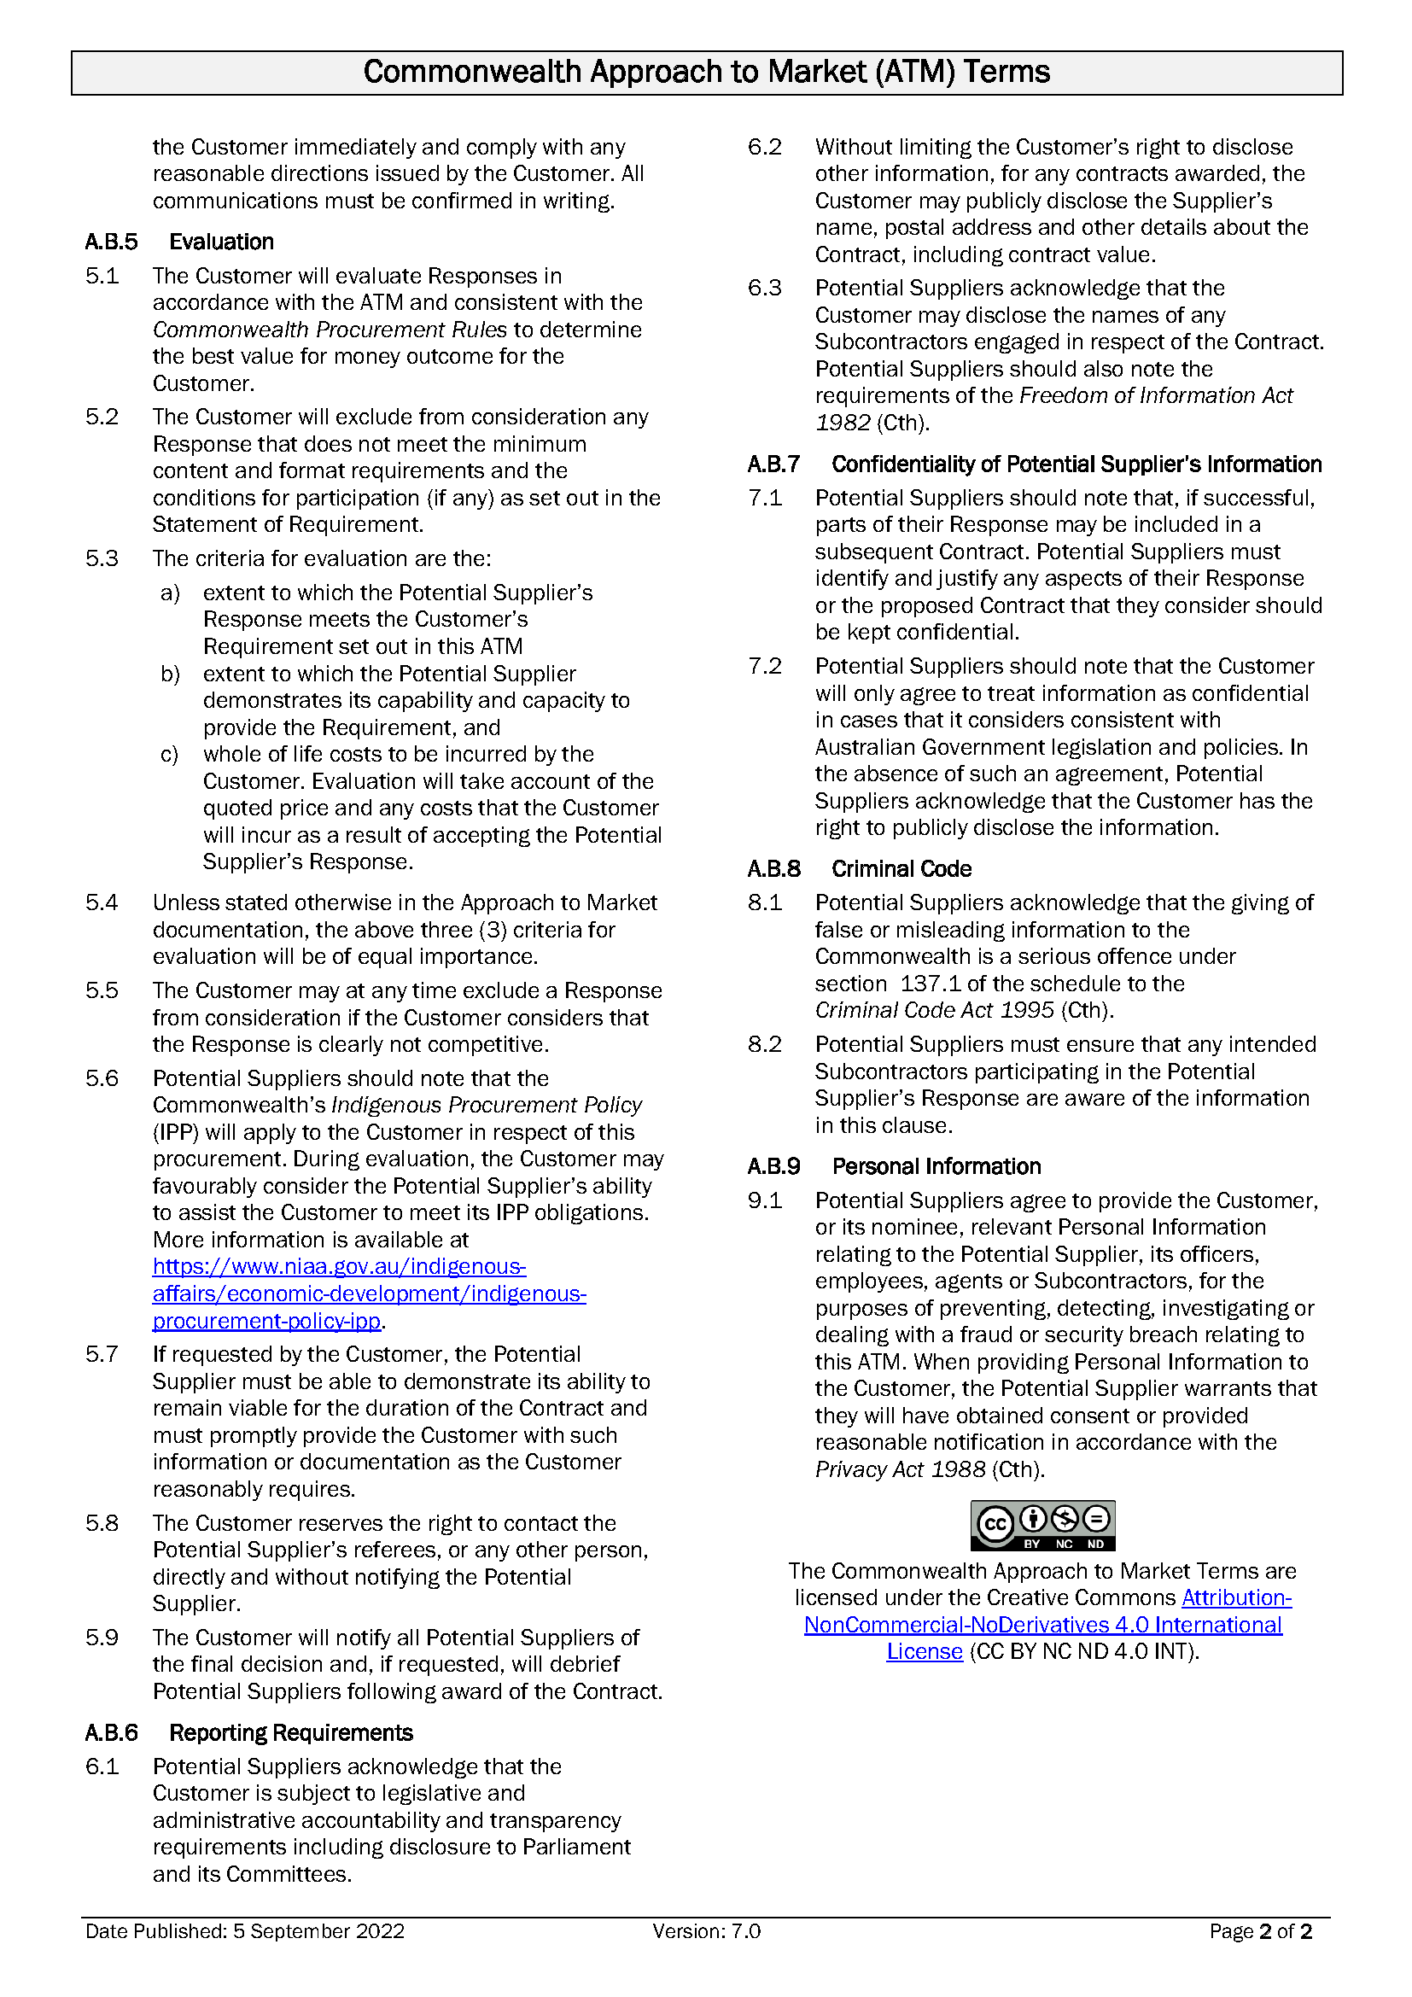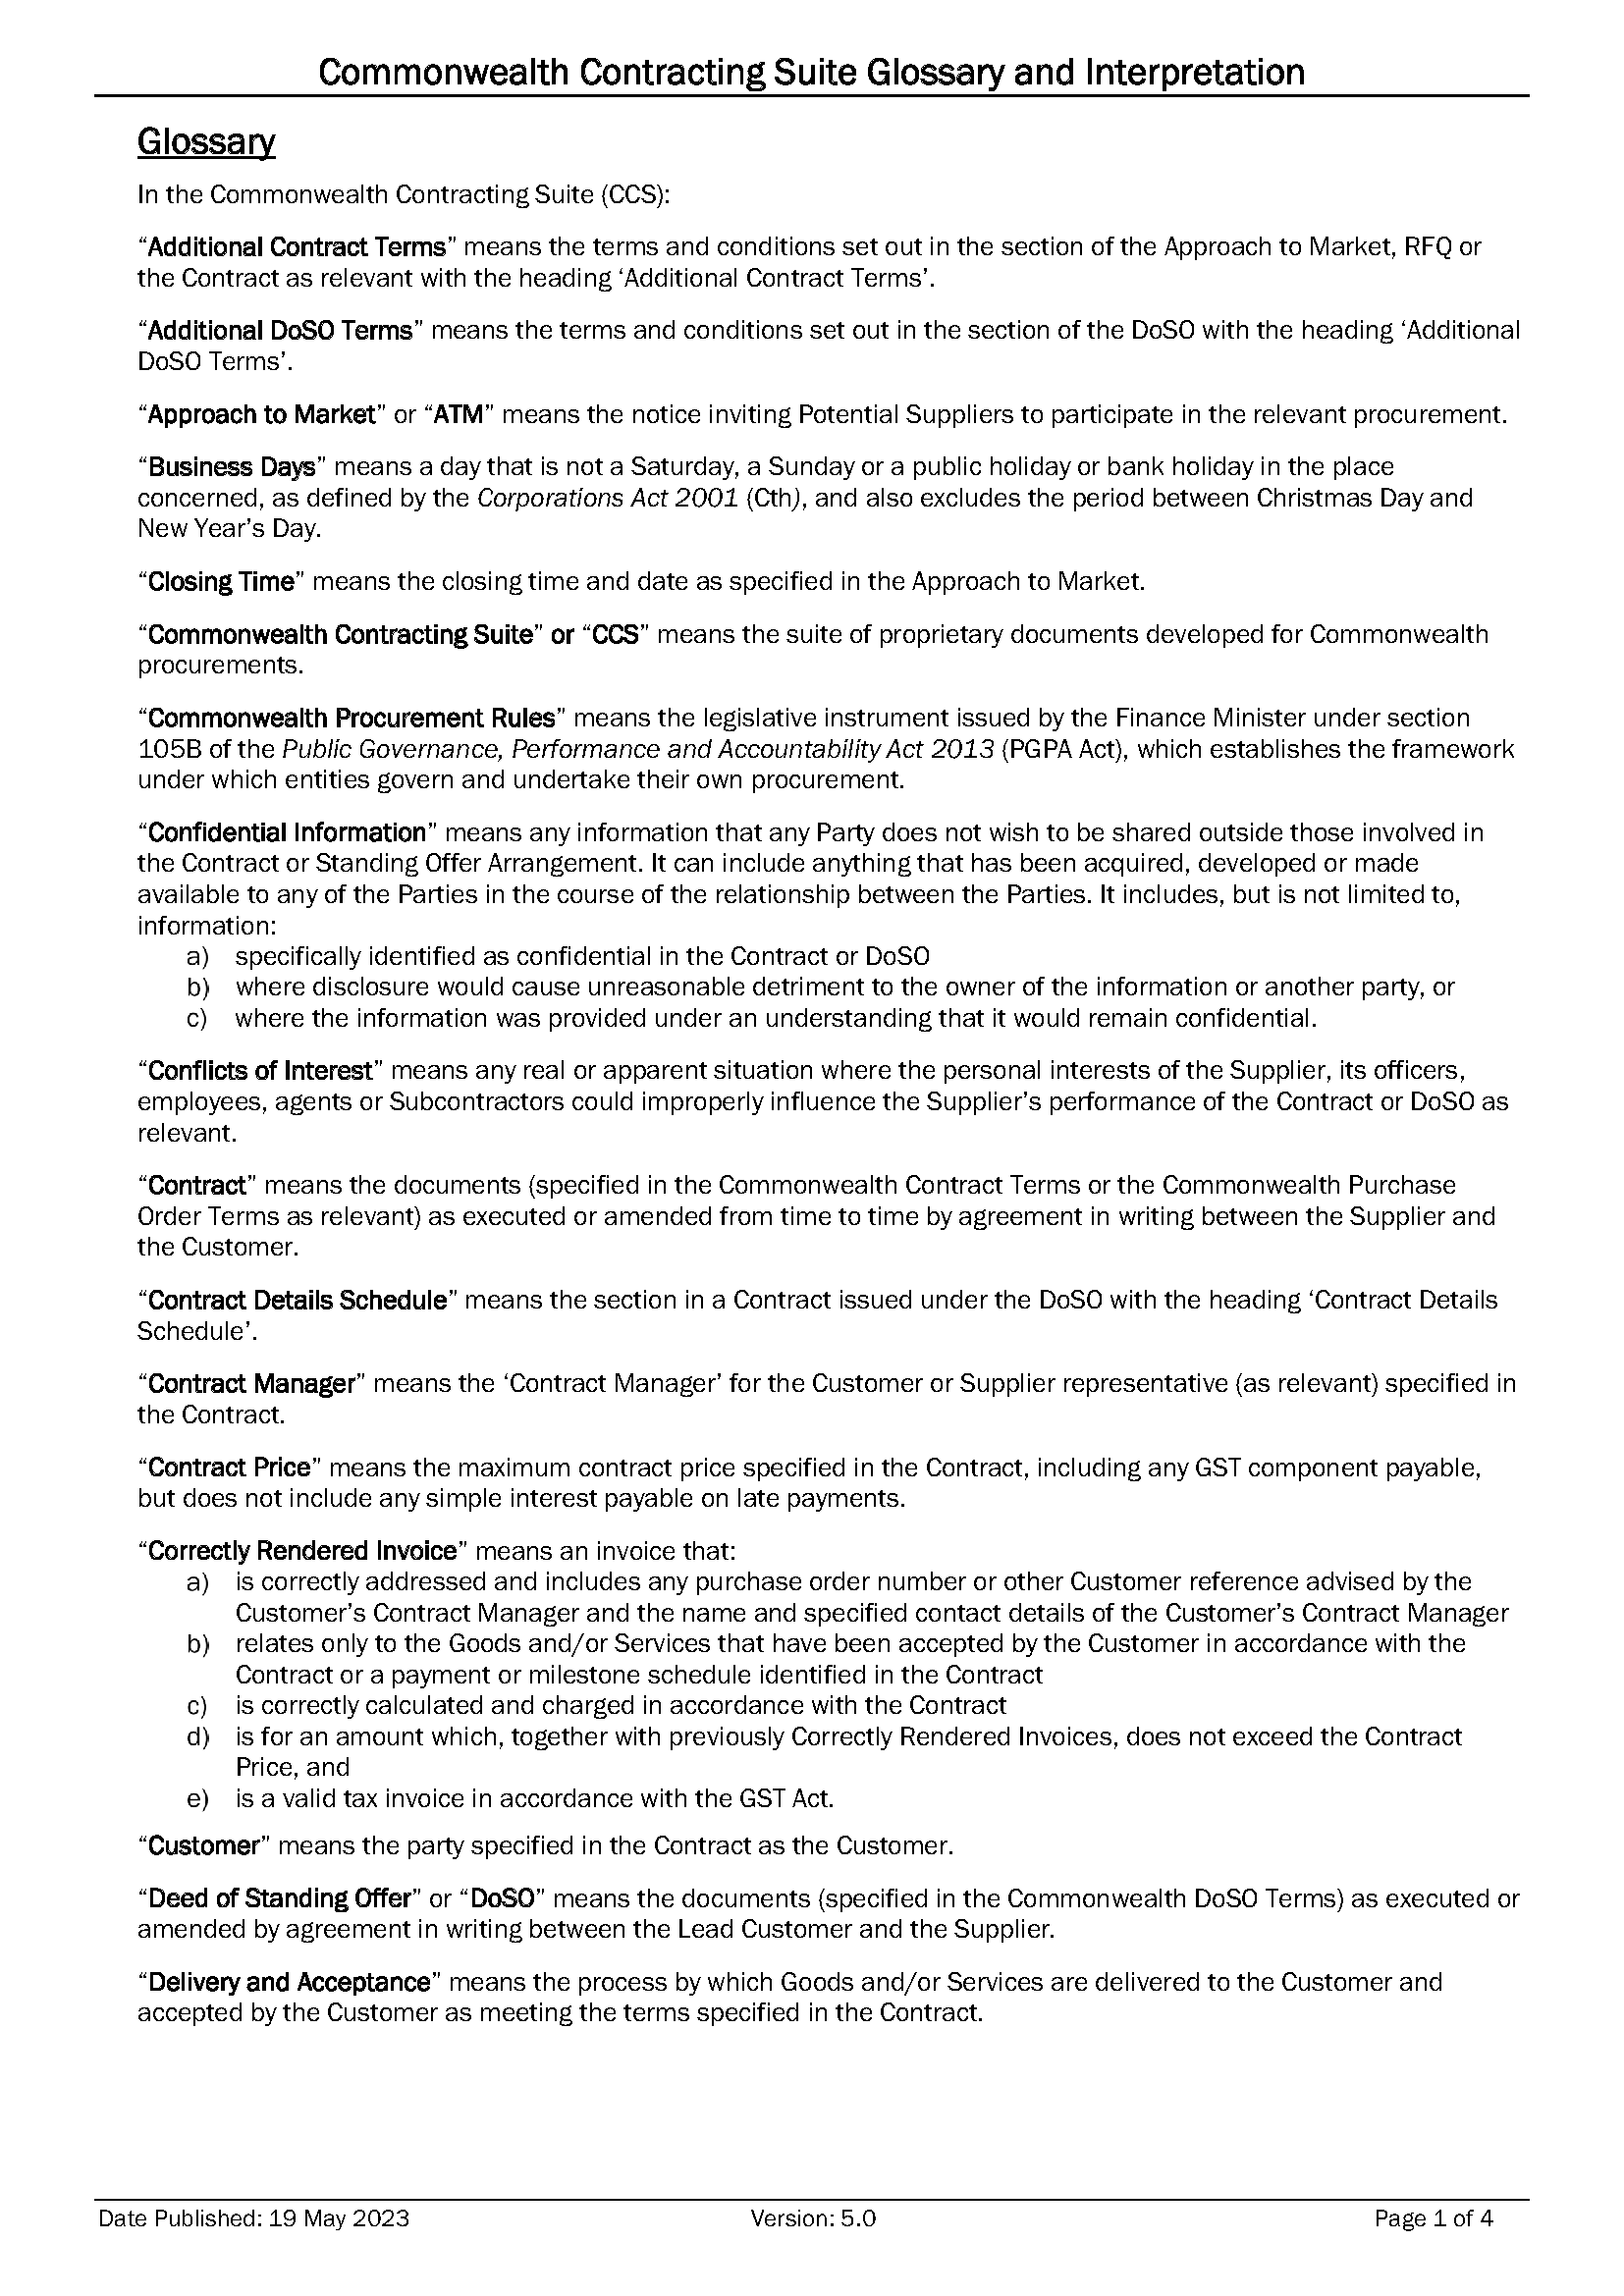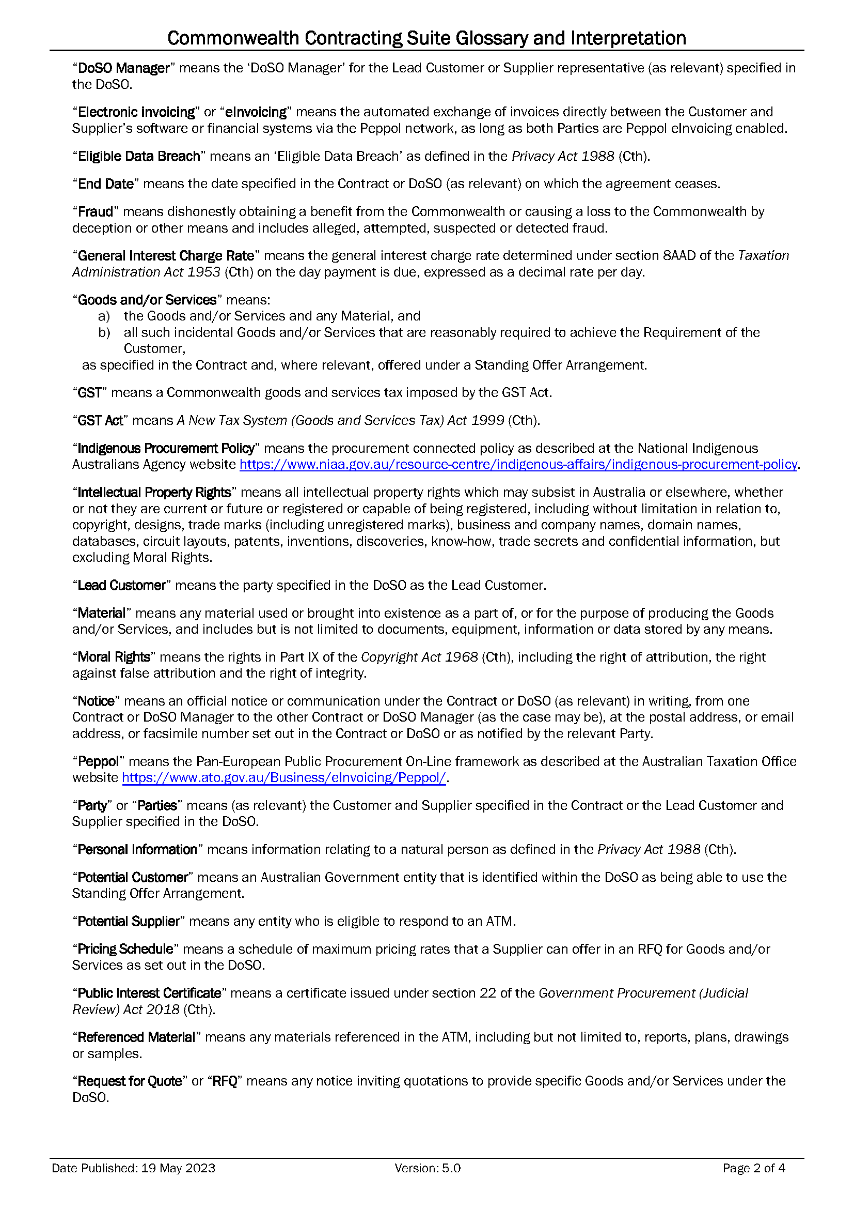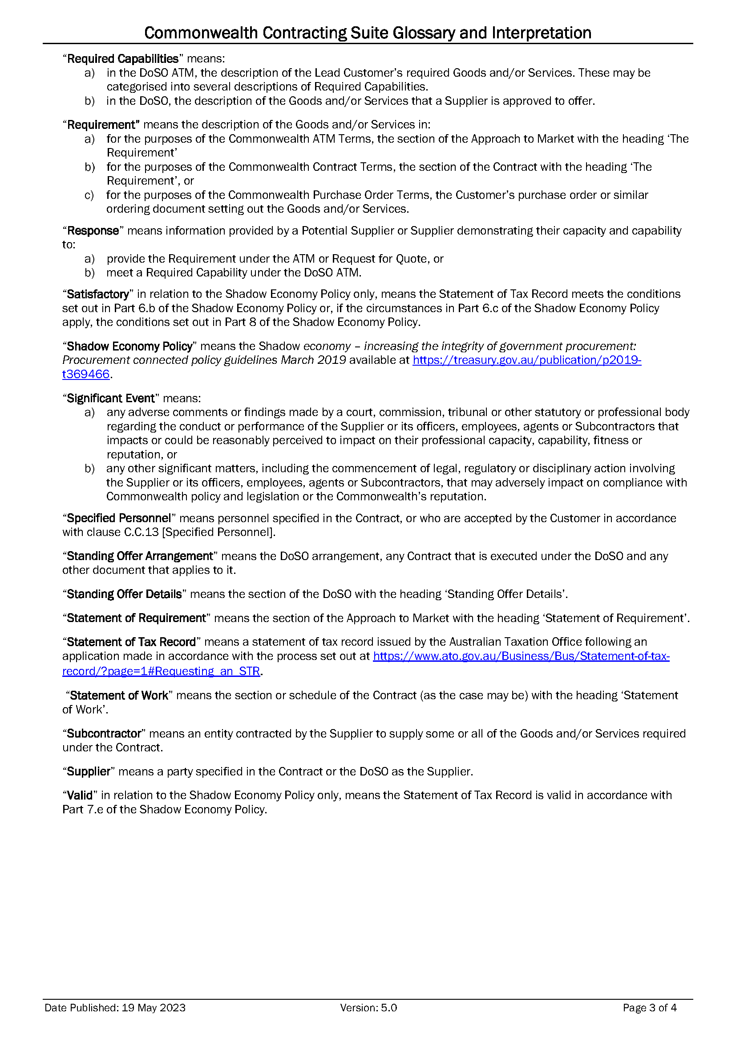

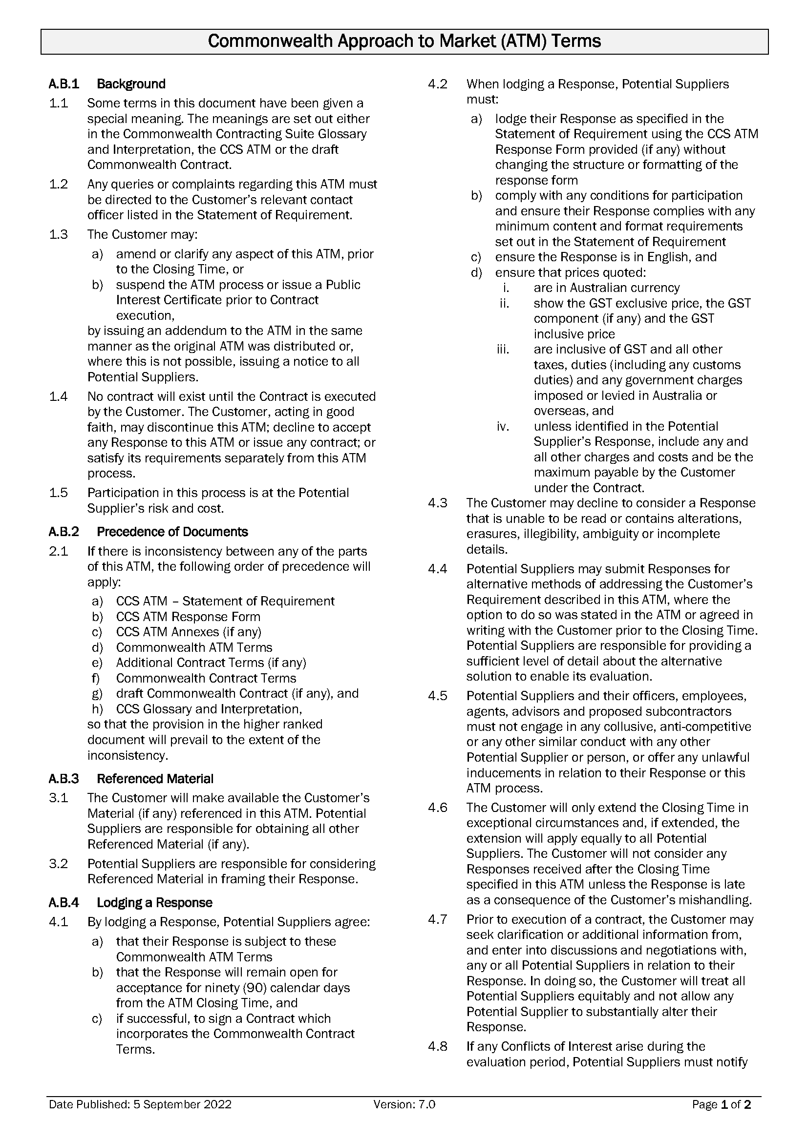

INSTRUCTIONS FOR POTENTIAL SUPPLIER

1. Before you start
2. This Response is not an offer for work.
3. Read the all documentation provided by the Customer and distributed with this Response form and decide whether your organisation has the **necessary skills and experience** to meet the Customer’s requirement.
4. Do not proceed further if:
   1. your organisation cannot agree to the Commonwealth Contract Terms, available at <https://www.finance.gov.au/government/procurement/commonwealth-contracting-suite-ccs>. These terms are non-negotiable and will form part of the Contract if you are successful in this ATM process.
   2. your organisation does not meet and/or agree to the Minimum Content and Format Requirements and the Conditions for Participation (if any), set out at item A.A.1 [Key Information and Dates], as failure to do so will mean your response cannot be considered.
   3. your organisation is a **trust** where the Trustee is not empowered to sign contracts on behalf of the Trust. Before proceeding, contact the Customer’s ATM Contact Officer at item A.A.5(a) [ATM Contact Officer].
   4. you are an **Individual** without an ABN and you do not meet the Australian Taxation Office’s (ATO) definition of an independent contractor available at: <https://www.ato.gov.au/business/employee-or-contractor/how-to-work-it-out--employee-or-contractor>. Before proceeding, contact the ATM Contact Officer set out at item A.A.5(a) [ATM Contact Officer] to seek advice.
5. The Customer will evaluate all valid Responses received by the ATM Closing Time [Item A.A.1] that meet the Minimum Content and Format Requirements and the Conditions for Participation (if any), to determine which Potential Supplier has proposed the best value for money outcome for the Customer. Responses will be evaluated as per the criteria set out in Clause A.A.1 [Evaluation].
6. Participation in this ATM is at your organisation’s risk and cost. **Please note** this is a competitive process and your organisation may incur costs in responding. If you are unsuccessful, you will be unable to recoup these costs.
7. Format Requirements
8. You **MUST** use this form (CCS ATM Response Form) to submit your Response, which **MUST** comply with the Commonwealth ATM Terms, available at: <https://www.finance.gov.au/government/procurement/commonwealth-contracting-suite-ccs>.
9. As this form is set out to facilitate the evaluation of responses, Potential Suppliers are to use the form as provided and are **not permitted to make any changes to the structure or formatting of the document.**
10. Guidance for completing your Response
11. **Specific questions** about this ATM **must** be directed to the ATM Contact Officer set out at Item A.A.5(a) [ATM Contact Officer] before Question Closing Date and Time set out at item A.A.1 [Key Information and Dates].
12. In preparation of this Response, **please note** the Commonwealth Indigenous Procurement Policy (IPP) available at: <https://www.niaa.gov.au/indigenous-affairs/economic-development/indigenous-procurement-policy-ipp> may apply to the Customer in respect of this procurement. During evaluation of responses, the Customer may consider the Supplier’s ability to assist the Customer to meet its IPP obligations.
13. Ensure your Response is as concise as possible while including all information that your organisation wants the evaluation team to consider. Do not include general marketing material or assume that the evaluation team has any knowledge of your organisation’s capabilities or personnel.
14. Do not include pricing in any other part of your response except in the relevant Pricing Schedule.
15. The successful Supplier will have demonstrated its ability to provide the best value for the Customer. This will not necessarily be the lowest price.
16. **Submit** the form as required by Item A.A.4 [Lodgement of Responses].
17. If your organisation is **unsuccessful** with this Response, you may request a debrief to assist with future responses. The ATM Contact Officer set out at Item A.A.5(a) [ATM Contact Officer] can arrange this for you.

|  |
| --- |
| **Drafting Note:**  **Before** you finalise and submit your Response, please **delete** all Drafting Notes, including this entire section [Instructions for Potential Suppliers].  Do not type any information within the drafting note guidance tables as any drafting notes remaining in your Response may be removed by the Customer prior to evaluation. |

|  |  |
| --- | --- |
| Response to Approach to Market  to establish  Contract for Bush Blitz 2024 Taxonomy Research  ATM Reference ID: DNP-BCK-2324-030 | |
| This Response will be prepared and lodged in accordance with the Minimum Content and Format requirements as set out in A.A.1 [Key Information and Dates]. | **Yes  No:** Do not proceed as your Response will not be eligible for further consideration |
| This Response will demonstrate our ability to meet the Conditions for Participation as set out in A.A.1 [Key Information and Dates]. | **Yes  No:** Do not proceed as your organisation will not have the ability to fulfil the requirements of the procurement. |

Potential Supplier’s Contact Officer

For all matters relating to this Response, the Potential Supplier’s Contact Officer is:

|  |  |
| --- | --- |
| Potential Supplier Name: |  |
| Contact Name: |  |
| Position: |  |
| Telephone: |  |
| Email Address: |  |
| Postal Address: |  |

Part 1 – Potential Supplier’s Details

|  |
| --- |
| Drafting Note:  The following details will appear in the Contract should your Response be successful. The details you provide should be for the legal organisation that would be the Supplier under the Contract. |

1.1 Potential Supplier’s Details

|  |  |
| --- | --- |
| Organisation’s Full Legal Name: | **Drafting Note**:  Insert your organisation’s full legal name. If your organisation is successful in this ATM process, this will be the name of the Supplier for the Contract. |
| Legal Entity Type: | Individual/Sole Trader  Partnership  Company  Sole Director Company  Trust **(see note below)**  Educational Institution **(see note below)**  Other (please state): |
| **NOTE FOR TRUSTS**: If the Potential Supplier is **trading as a trust**, please provide details of the relevant trust (and trustee) including a copy of the relevant trust deed (including any variations to that deed) as an attachment to this Response. | |
| **NOTE FOR EDUCATIONAL INSTITUTIONS**: If your Response is successful, prior to entering a Contract you will be required to provide details of any enabling legislation as well as details of any delegations or other authorisations that are relevant to the execution of a contract. | |
| Potential Supplier Entity’s Country of Tax Residency: | **Drafting Note**:  Insert your organisation’s country of tax residency. Information to assist you to identify this information is available at [https://treasury.gov.au/policy-topics/taxation/country-tax-residency-disclosures](https://aus01.safelinks.protection.outlook.com/?url=https%3A%2F%2Ftreasury.gov.au%2Fpolicy-topics%2Ftaxation%2Fcountry-tax-residency-disclosure&data=05%7C01%7CCooper.Rawiri%40finance.gov.au%7C499a27e2b84641571b4d08db777a25e9%7C08954cee47824ff69ad51997dccef4b0%7C0%7C0%7C638235139258133424%7CUnknown%7CTWFpbGZsb3d8eyJWIjoiMC4wLjAwMDAiLCJQIjoiV2luMzIiLCJBTiI6Ik1haWwiLCJXVCI6Mn0%3D%7C3000%7C%7C%7C&sdata=kkcgCLqymBTk%2B02pLWtPZRqEplYZuUht1bo5T6b8eso%3D&reserved=0) |
| Potential Supplier’s Ultimate Parent Entity’s Country of Tax Residency: | Guidance for Potential Suppliers: [https://treasury.gov.au/policy-topics/taxation/country-tax-residency-disclosures](https://aus01.safelinks.protection.outlook.com/?url=https%3A%2F%2Ftreasury.gov.au%2Fpolicy-topics%2Ftaxation%2Fcountry-tax-residency-disclosure&data=05%7C01%7CCooper.Rawiri%40finance.gov.au%7C499a27e2b84641571b4d08db777a25e9%7C08954cee47824ff69ad51997dccef4b0%7C0%7C0%7C638235139258133424%7CUnknown%7CTWFpbGZsb3d8eyJWIjoiMC4wLjAwMDAiLCJQIjoiV2luMzIiLCJBTiI6Ik1haWwiLCJXVCI6Mn0%3D%7C3000%7C%7C%7C&sdata=kkcgCLqymBTk%2B02pLWtPZRqEplYZuUht1bo5T6b8eso%3D&reserved=0)  **Drafting Note**:  Insert your organisation’s ultimate parent entity’s country of tax residency (if different from above).  Complete with “AS ABOVE” if same as your organisation’s country of tax residency. |
| Australian Business Number (ABN): | **Drafting Note**:  If the Potential Supplier is an entity registered on the Australian Business Register, then the ABN used by the business must be given. |
| Australian Company Number (ACN): | **Drafting Note**:  If the Potential Supplier is an Australian company, then the ACN must be given. |
| Australian Registered Body Number (ARBN): | **Drafting Note**:  If the Potential Supplier’s business is an entity registered on the business names register kept under the law of a State or Territory of Australia, then each ARBN used by the business must be given in respect of each State or Territory of registration. |
| Registered Address: | **Drafting Note**:  Insert the supplier’s main business address as registered with the Australian Business Register. |

1.2 Previous Judicial Decisions

|  |  |
| --- | --- |
| Has your organisation, or where relevant any of its directors, ever had a judicial decision against them (not including decisions under appeal) relating to employee entitlements or engaged in practices that have been found to be dishonest, unethical or unsafe? | Yes, **see below.**  No |
| **If yes**, what was the date of discharge?  *The Supplier acknowledges that the giving of false or misleading information to the Commonwealth is a serious offence under section 137.1 of the schedule to the Criminal Code Act 1995 (Cth).* | (DD/MM/YYYY)  *Note: The Customer cannot enter a contract with a supplier who has an undischarged judicial decision relating to employee entitlements.* |

1.3 Workplace Gender Equality

|  |  |
| --- | --- |
| Is your organisation classified as a ‘relevant employer’ under the [*Workplace Gender Equality Act 2012*](https://www.wgea.gov.au/about-legislation/workplace-gender-equality-act-2012) (the WGE Act)? See <https://www.wgea.gov.au/about> | Yes, I am a relevant employer  No, I am not a relevant employer |
| **If yes**, you are required to provide a current letter of compliance with the WGE Act prior to entering into a contract. Have you provided a letter of compliance with this Response? | Yes  No, I will provide a current letter of compliance prior to contract |
| **NOTE:** If the Potential Supplier is successful in this ATM process and where the Supplier is a relevant employer under the WGE Act, the Supplier **must** provide evidence that it complies with its obligations under the WGE Act **before** commencement of any Contract and, if the term is more than 18 months, within 18 months of commencement and annually thereafter for the duration of the Contract.  If the Supplier becomes non-compliant with the WGE Act during the course of the Contract, the Supplier must notify the Customer’s Contact Manager in writing within 10 Business Days. Compliance with the WGE Act does not relieve the Supplier from its responsibilities to comply with its obligations under the Contract. | |

1.4 Indigenous Businesses

|  |  |
| --- | --- |
| Is your organisation:   * 50% or more Indigenous owned? * a joint venture that is 50% or more indigenous owned which can demonstrate equal indigenous representation and involvement in the management of the joint venture? | Yes – **see question below**.  No – proceed to section 1.5. |
| Is your organisation registered on Supply Nation? | Yes  No – see note below  Not Applicable |
| **NOTE**: Please provide a certificate or letter from a recognised Indigenous organisation such as Land Council, Indigenous Chamber of Commerce or Office of the Registrar of Indigenous Corporations verifying Indigenous ownership. | |

1.5 Potential Supplier’s Contract Manager

|  |
| --- |
| Drafting Note:  Provide details for the person you propose will be the Contact Manager if your Response is successful and your organisation is awarded a contract. |

For matters relating to the proposed Contract, the Potential Supplier’s Contract Manager will be:

|  |  |
| --- | --- |
| Name: |  |
| Position Title: |  |
| Telephone: |  |
| Mobile: |  |
| Email Address: |  |
| Postal Address: |  |

1.6 Potential Supplier’s Address for Notices (if different from the Contract Manager)

|  |
| --- |
| Drafting Note:  Complete with “AS ABOVE” if same as Contact Manager. |

|  |  |
| --- | --- |
| Name: |  |
| Position Title: |  |
| Email Address: |  |
| Postal Address: |  |

Part 2 – Executive Summary

2.1 Executive Summary of Potential Supplier’s Proposal

|  |
| --- |
| Drafting Note:  You may find it useful to complete this section after you have completed your response.  Provide a brief (less than one page) summary of your Response highlighting its key features. The Executive Summary should not merely replicate information provided elsewhere in your Response. This section brings together all aspects of your proposal and is your opportunity to “sell” its unique features. |

2.2 Conditions for Participation

|  |
| --- |
| Drafting Note:  Respond to the Conditions for Participation here. **Do not** proceed further if you cannot meet the Conditions for Participation as your Response cannot be considered. The Customer will exclude from consideration any Response that does not meet the Conditions for Participation.  Include a statement about how your organisation meets the Conditions for Participation (if any) detailed at A.A.1 [Key Information and Dates].  If no Conditions for Participation specified, include the words: No Conditions for Participation specified. |

Part 3 – Ability to Meet the Requirement

3.1 Detailed Proposal to Meet the Customer’s Requirement

|  |
| --- |
| Drafting Note:  Your response should address each aspect of the Statement of Requirement and explain/demonstrate how your response/solution meets the Requirement.  Provide a detailed description of your proposal to supply the Customer’s Requirement, including any delivery methodology. This is your opportunity to convince the evaluation team that your organisation understands the Requirement and can deliver it to a high standard. Do not provide general marketing material.  Highlight your competitive advantage as well as special or unique features of your proposal. Depending on the Requirement, your response may propose a detailed project plan including project milestones and completion dates, timeframes, quality standards or performance indicators. It may also detail critical issues or key delivery risks of which the Customer should be aware.  If meeting the Customer’s Requirement involves reporting, travel or attendance at meetings, you should clearly identify how you will meet these requirements, including details of personnel involved. Do not include any pricing or pricing information in Part 3. You should ensure that you clearly address any costs in your response to Part 5.  Do not rely on your organisation’s reputation. The evaluation team can only consider information you provide in this submission. |

1. Standards

|  |
| --- |
| Drafting Note:  Provide full details and evidence of compliance with all applicable Australian standards, and any Australian and international standards and requirements specified in The Requirement. Potential Suppliers are encouraged to demonstrate how any standard(s) are proposed to be specifically used in the delivery of the goods/services (i.e. provide evidence that demonstrates how your organisation complies with applicable standards in the context of the requested goods/services and attach supporting evidence as necessary).  Where you do not propose to comply with a standard which has been included in The Requirement, propose an alternative standard and justify your reasons. Where no standard has been specified, list any applicable standards with which you propose to comply.  Type “Not Applicable” below if no standards apply. |

Part 4 – Potential Supplier’s Demonstrated Capability and Capacity

4.1 Statement of Skills and Experience

|  |
| --- |
| Drafting Note:  This section should be used to demonstrate to the evaluation team your organisation’s proven capability and capacity to meet the Customer’s Requirement to a high standard and consistent quality. You should highlight your organisation’s capacity and any unique capabilities that provide it with a competitive advantage.  Provide clear, concise description of your organisation’s relevant skills and experience to deliver the Requirement.  Depending on the Requirement, this could include a detailed description of recent relevant experience in successfully supplying a similar requirement. It could also include your organisation’s expertise in this field, brief information on relevant personnel (highlighting relevant expertise and experience), details of relevant intellectual property or unique products used.  Do not include any pricing or pricing information in this Part. All pricing information should be included in Part 5. |

4.2 Specified Personnel

|  |
| --- |
| Drafting Note:  Only propose Specified Personnel where your proposal has referenced the skills of specific personnel and you reasonably expect them to perform the roles nominated. Include their role, the percentage of the project they will complete, and if relevant, their current Commonwealth Government security clearance. Add extra lines to the table as required.  You may also attach brief supporting information specific to the requirement including tailored CVs for Specified Personnel.  Where there are a number of staff who could perform a particular role, include details of the position/role and the percentage of project time which this role will perform. In these circumstances it would not be necessary to name the person.  Include details for subcontractor personnel if applicable. You will need to give additional details for subcontractors in the next section.  If no Specified Personnel are proposed, insert “Not Applicable”. |

|  |  |  |  |
| --- | --- | --- | --- |
|  |  |  |  |
| Name | Position/Role | Current Security Clearance Level# | Percentage of  Total Project Time |
|  |  |  |  |
|  |  |  |  |
| Total personnel time | | | 100% |
|  |  |  |  |

*# if requested at A.A.2(b)*

4.3 Subcontractors

|  |
| --- |
| Drafting Note:  The Customer may be required to publicly disclose information about subcontractors. Provide details for each subcontractor organisation you will use below.  In support of the Indigenous Procurement Policy (<https://www.niaa.gov.au/indigenous-affairs/economic-development/indigenous-procurement-policy-ipp>), also highlight any Indigenous subcontractors you are proposing to use, or any Indigenous staff who will work on the project.  If no subcontractors are proposed insert “Not Applicable” |

|  |  |
| --- | --- |
|  |  |
| Full Legal Name: |  |
| Postal Address: |  |
| ABN/ACN/ARBN: |  |
| Is this subcontractor registered on Supply Nation or 50% or more Indigenous owned? |  |
|  |  |

* 1. Scope of Works to be Subcontracted

|  |
| --- |
| Drafting Note:  If no subcontractors are proposed insert “Not Applicable”.  Provide details of the roles (or specific parts of the contract) each subcontractor will perform.  The Supplier is solely responsible for all obligations under the Contract, including subcontractor performance and management. The Supplier must ensure that any subcontract arrangement that is entered into imposes necessary obligations on the subcontractor.  If you are intending to include subcontractors, read and understand your obligations under the Commonwealth Contract Terms, Subcontracting [Clause C.C.10], Relationship of the Parties [Clause C.C.2], Compliance with the Laws and Policy [Clause C.C.21] specifically relate to subcontractors. |

4.4 Conflicts of Interest

|  |
| --- |
| Drafting Note:  Commonwealth officials have an obligation to disclose Conflicts of Interest under section 29 of the [*Public Governance, Performance and Accountability Act 2013*](https://www.legislation.gov.au/Series/C2013A00123) (Cth). Suppliers to Commonwealth entities need to assist the Commonwealth to meet its obligations by complying with the same standard of conduct.  Conflicts can be real or apparent. The perception of a conflict can be just as damaging to the public’s confidence in public administration as an actual conflict based on objective facts.  Provide full details of any Conflicts of Interest (if any) that could arise as a result of entering into the Contract with a Customer and propose a strategy to manage the conflict. For complex issues, you may choose to attach a Conflict of Interest Management Plan detailing your proposed approach.  After this response is submitted, Potential Suppliers must report any Conflicts of Interest that may have arisen or been identified during the evaluation period to the Customer without delay.  If no Conflicts of Interest were identified, type “Nil”. |

The Potential Supplier has identified the following potential Conflicts of Interest and management strategies:

|  |  |
| --- | --- |
| Details | Management Strategy |
|  |  |
|  |  |

4.5 Referees

|  |
| --- |
| Drafting Note:  Provide daytime contact details for three (3) referees who can attest to your capacity to meet the Requirement. You may prefer to include details of referees for Specified Personnel. A reference is stronger if your organisation and/or Specified Personnel has recently provided the referee with similar goods/services. It is good practice to ensure that nominated referees are aware they may be contacted.  Note clause A.B.5 [Evaluation]: The Customer reserves the right to contact any referees, or any other person, directly and without notifying the Potential Supplier. |

|  |  |  |  |  |  |
| --- | --- | --- | --- | --- | --- |
|  |  | |  |  | |
|  |  |  |  | |  |
| Referee Name | Position | Organisation | Phone Number | | Email Address |
|  |  |  |  | |  |
|  |  |  |  | |  |
|  |  |  |  | |  |
|  |  |  |  | |  |

4.6 Pre-existing Intellectual Property of Potential Supplier

|  |
| --- |
| Drafting Note:  List your pre-existing Intellectual Property (if any) noting that:  *The Supplier grants to, or in the case of Third-Party Material, must obtain for, the Customer a non-exclusive, irrevocable, royalty-free, perpetual, world-wide licence (including the right to sub-licence) to exercise the Intellectual Property Rights in all Pre-existing Material and Third- Party Material incorporated into the Material to enable the Customer to receive the full benefit of the Goods and/or Services and the Material and to exercise its rights in relation to the Material.*  If no pre-existing Intellectual Property is proposed insert “Not Applicable”. |

4.7 Confidentiality of Potential Supplier’s Information

|  |
| --- |
| Drafting Note:  Identify any information in your Response, or the proposed Contract, which you consider should be kept confidential, with reason(s).  The Customer will only agree to treat information as confidential in cases that meet the Commonwealth’s guidelines and which the Customer considers appropriate. If the Customer does not agree that the information meets the guidelines to be treated as confidential, the Customer has the right to disclose any information contained in the Contract.  Information to assist you to assess whether the Customer is able to treat particular information as confidential is available at: <https://www.finance.gov.au/government/procurement/buying-australian-government/additional-reporting-confidentiality>.  If none, type “Not Applicable”.  Add extra lines to the table as required. |

The Potential Supplier has assessed that the commercial information in the table below meets the requirements available at <https://www.finance.gov.au/government/procurement/buying-australian-government/additional-reporting-confidentiality> and is seeking that information be kept confidential.

|  |  |
| --- | --- |
|  | |
| Information to be kept Confidential | Reasons for Confidentiality Request |
|  |  |
|  |  |
|  | |

4.8 Proven Ability to Meet Regulatory Considerations

|  |
| --- |
| Drafting Note:  Suppliers are expected to comply with all laws applicable to the performance of the Contract and any Commonwealth policies relevant to the Requirement.  Provide a brief statement of how you propose to comply with all relevant regulations, including but not limited to any Work Health and Safety requirements. |

4.9 Sustainability Considerations

|  |
| --- |
| Drafting Note:  The Australian Government has a commitment to sustainable procurement practices. Sustainable procurement aims to reduce adverse social, environmental and economic impacts of purchased goods and services throughout their life.  Provide a brief statement of how your organisation intends to provide sustainable procurement benefits. You may also wish to include information about how your organisation implements the principles of sustainable procurement within your organisation’s supply chain.  Potential Suppliers are encouraged to refer to the [Sustainable Procurement Guide](https://www.awe.gov.au/environment/protection/waste/publications/sustainable-procurement-guide) in forming their Response. |

4.10 Additional Information

|  |
| --- |
| Drafting Note:  Any information included here should be relevant to this proposal and should be as concise as possible.  To facilitate the Customer’s reporting responsibilities under the Indigenous Procurement Policy, if you are an Indigenous business, have Indigenous employees, or are proposing Indigenous subcontractors you should highlight that information here and explain how you will report the ongoing participation of Indigenous people in fulfilling the proposed Contract.  To facilitate the Customer’s reporting responsibilities, if you are a business that primarily exists to provide the services of persons with a disability highlight that information here and explain how you will report ongoing participation of disabled people in fulfilling the proposed Contract.  The Commonwealth’s Fraud Control Framework requires the Customer to manage risk of fraud and corruption as part of contracting and procurement activities. You should include details of controls (if any) you will have in place to prevent fraud and corruption against the Commonwealth.  This section should **NOT** be used to include generic marketing information that is not specific to the Requirement. |

Part 5 – Total Costs to be incurred by the Customer

|  |
| --- |
| Drafting Note:  The information you provide in this section will be used to assess the total costs the Customer will incur under your proposal. |

5.1 Pricing

Fixed Price (including all expenses)

|  |
| --- |
| Drafting Note:  Complete the following table including fixed prices for each item. Fixed prices must include taxes, duties and other government charges which may be imposed or levied in Australia and overseas, and all other costs associated with providing the services, including delivery fees where applicable.  Make sure you include, costs of any reporting and attending necessary meeting as well as any travel, accommodation and associated costs.  Add additional lines to the table as required. |

|  |  |  |  |  |
| --- | --- | --- | --- | --- |
|  | | | | |
| Due Date | Milestone Description | Total Price GST Exclusive | GST Component | Total Price  GST Inclusive |
|  |  |  |  |  |
|  |  |  |  |  |
|  |  |  |  |  |
|  |  |  |  |  |
|  |  |  |  |  |
| Total Fixed Price for Services | | | |  |
|  | | | | |

Adjustment to Fixed Pricing for Contract Variation/Extension

|  |
| --- |
| Drafting Note:  Explain how the above pricing would be adjusted, if a contract variation (for either an increase or decrease in the Requirement) was requested.  For example, if the contract is for a one-year period, what would the rates be in the second year? If the quantity of goods increased or decreased what would be the effect on price? |

5.2 Proposed Payment Schedule

|  |
| --- |
| Drafting Note:  Complete the table below if you propose that progress payments be made.  Do not propose a payment schedule that reflects more than the value of the milestones or deliverables you have delivered at any stage.  This payment schedule is for the Fixed Fees and Charges portion of the arrangement only. Variable costs will only be reimbursed after they have been incurred and invoiced.  **Note**: The Customer may propose alternative payment arrangements.  If you are not proposing any progress payments type “Not Applicable”. |

|  |  |  |  |  |
| --- | --- | --- | --- | --- |
|  | | | | |
| Due Date | Milestone Description | Total Price (GST Exclusive) | GST Component | Total Price  (GST Inclusive) |
| 12/08/2024 | Execution of Contract (60%) |  |  |  |
| 27/02/2026 | Submission of proposed scientific manuscript/s to peer-reviewed journal/s (40%) |  |  |  |
| Total Milestone Payments | | | |  |
|  | | | | |

5.3 Additional Facilities and Assistance

|  |
| --- |
| Drafting Note:  Should you require the Customer to provide facilities and assistance, in addition to that stated at Clause A.A.2(f) [Facilities and Assistance Offered by the Customer], provide details here. If no additional facilities or assistance required insert “Not Applicable”.  If the pricing provided above is based on the provision of Additional Facilities and Assistance this should be stated below. |

5.4 Non-Compliance

|  |
| --- |
| Drafting Note:  If your response is successful, you will be offered a Contract which incorporates the *Commonwealth Contract Terms* available at <https://www.finance.gov.au/government/procurement/commonwealth-contracting-suite-ccs>. The Terms have been designed to enable Commonwealth officials to comply with their legislated responsibilities and are therefore **NOT** negotiable.  If you have reasons why any of the Additional Contract Terms should be changed, complete the following table, as these additional terms may be negotiable.  Any costs the Customer would incur in obtaining legal advice (including in-house legal advice) or negotiating the Customer’s Additional Contract Terms will be included in the Customer’s total costs assessment. |

|  |  |  |
| --- | --- | --- |
|  | | |
| Clause | Reason for Non-Compliance | Proposed New Wording |
|  |  |  |
|  |  |  |
|  |  |  |
|  |  |  |
|  | | |