**Backyard Species Discovery – a virtual, citizen science Bush Blitz**

Bush Blitz is Australia’s largest species discovery program—we document Australia’s vast biodiversity through expeditions to remote locations. Backyard Species Discovery is a virtual expedition that everyone can join! While we can’t promise you’ll find a new species, you will discover some amazing plants and animals living in your own backyard, contribute valuable data to Australia’s official databases and become a citizen scientist.

## How does it work?

We want you to search for organisms in your local area and upload images or sound recordings of them to our Backyard Species Discovery project on iNaturalist. When you add observations to iNaturalist, experts help identify them. Your record will be added to the Atlas of Living Australia (ALA), so researchers and land managers can find and use your data. We also run competitions, highlight our favourite observations on our social media and add new videos and fact sheets to our website to help you discover even more of the plants and animals that live near you.

1. Record your observations:
   1. Search your house, garden or other local area for organisms you’d like to record. You can record anything that is/was living (e.g. insect, plant) or evidence of it (e.g. footprint, bone). It must be living in the wild (not a pet or something that was planted) but can be an introduced species or a weed.
   2. Take a photo or sound recording of the organism, noting the date, time and location (if this isn’t automatically recorded by your device). You can also use photos and sound recordings you’ve taken previously if you remember when and where they were taken.
   3. Make high quality observations so there is more chance your discovery will be identified. For some great photography tips and more see our [‘Make your observations count’ fact sheet](https://bushblitz.org.au/wp-content/uploads/2020/04/BackyardSpeciesDiscovery_Factsheet-2_Make-your-observations-count.pdf).
2. Add your observations to iNaturalist:
   1. Sign up for an iNaturalist Australia account at <https://inaturalist.ala.org.au/> and join the **Backyard Species Discovery project**. iNaturalist is free and easy to use (more instructions below).
3. Keep adding new observations and check back on iNaturalist to see what the experts say about your discovery.
4. Find out more about your discovery:
   1. Post your image on Facebook, Instagram or Twitter and use #speciesdiscovery and @bushblitz (Facebook & Instagram) or @bushblitz2 (Twitter). Ask questions about your discovery and our experts will share what they know.

How to join the Backyard Species Discovery project

How to add observations to the Backyard Species Discovery project

How to add existing iNaturalist records to the Backyard Species Discovery project

How to share what you have found on Bush Blitz social media

Stay safe

Do you need more help?

## How to join the Backyard Species Discovery project

Log in to your account at <https://inaturalist.ala.org.au/>, search for our project (e.g. by typing “bush blitz” in the search box) and click on **Backyard Species Discovery with Bush Blitz (Australia).** You will see:

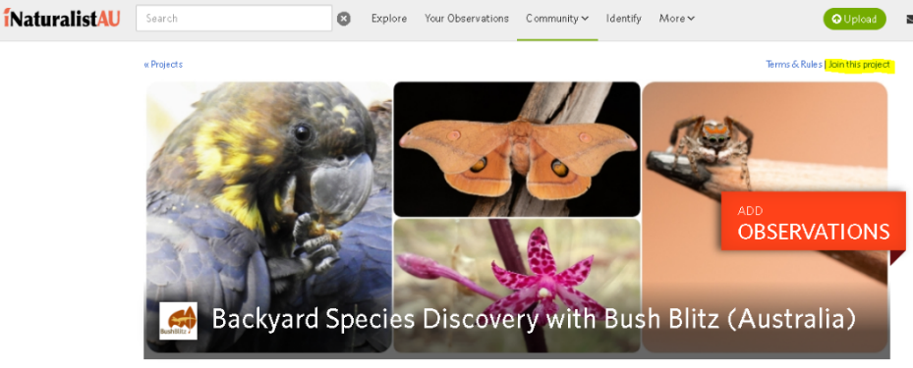- Click on **Join this project,**

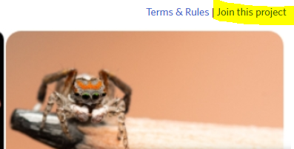

then **Yes, I want to join****.**

## How to add observations to the Backyard Species Discovery project

***If using a computer:***

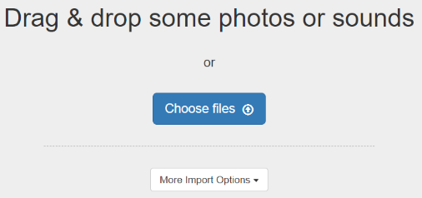Click on

* 1. Choose how you want to upload your photos &/or sounds
  2. If uploading more than one file for an observation (e.g. multiple views of the same plant/animal), tick ‘Select All’ and ‘Combine’ to combine them into one observation.
  3. 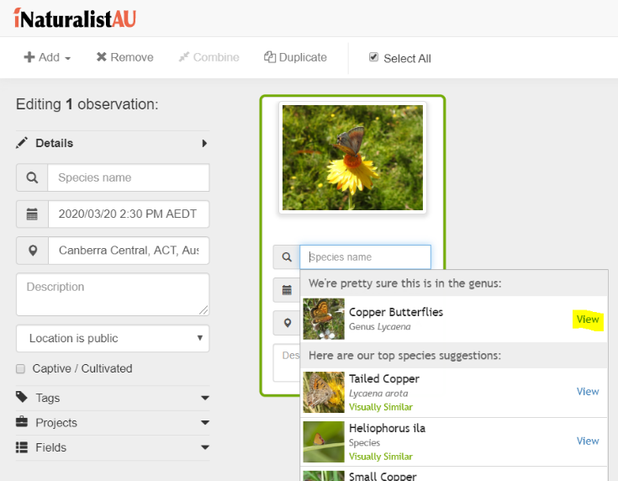Click in the **Species name** space and enter a name or wait for suggestions but only ID to a level you are confident of e.g. if you can only confidently say it’s a spider, just select ‘Spiders’. The image recognition software isn’t always correct and our scientists will do the rest!
  4. Expand Projects, click in the **Add to a Project** space and select **Backyard Species Discovery with Bush Blitz**

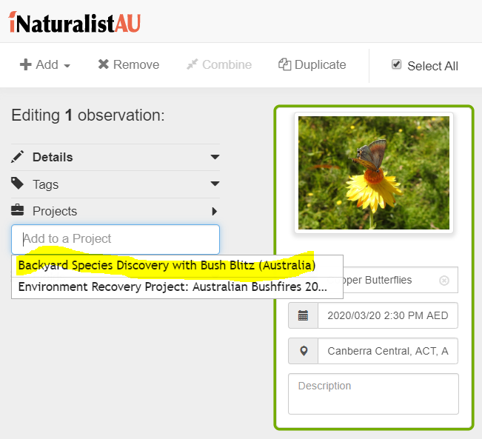

* 1. 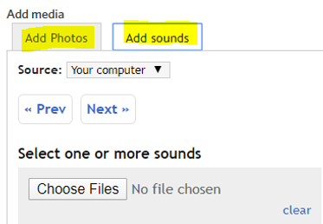If your files don’t contain metadata, enter the date, time and location;
  2. Enter any other details you’d like to contribute and click

**Save observation**.

* 1. To add photos/sounds to an existing observation, open it and click

on the blue **Edit** button. Under Add media, click on **Add Photos** or

**Add sounds** and choose the files you’d like to add.

***If using the iNaturalist app:***

* 1. The iNaturalist app is the easiest way to upload observations directly from your phone—there are links to the different platforms at the bottom of the <https://inaturalist.ala.org.au/> page.
  2. Once you’ve downloaded the app you’ll be prompted to sign-in.
  3. On Android phones, click on the green “**+**” icon, and choose one of the options.
  4. On iPhones, click on the Observe button, then take a photo or choose an image. At this stage the iPhone app can’t record or upload sounds, however you can record sounds with the Voice Memo app, transfer them to your computer and upload them to iNaturalist from there.
  5. 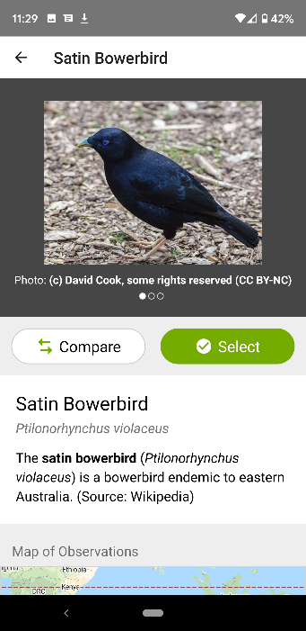Once your photos &/or sounds are uploaded, click on **What did you see?** and enter a name or wait for suggestions but only ID to a level you are confident of, e.g. if you can only confidently say it’s a spider, just select ‘Spiders’. Our scientists will do the rest! Click on the green **Select** button.

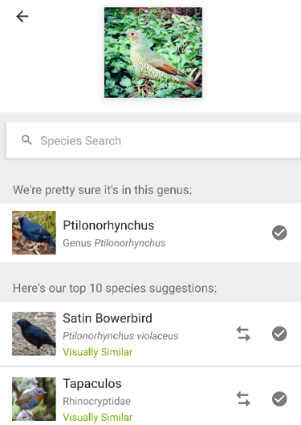

* 1. 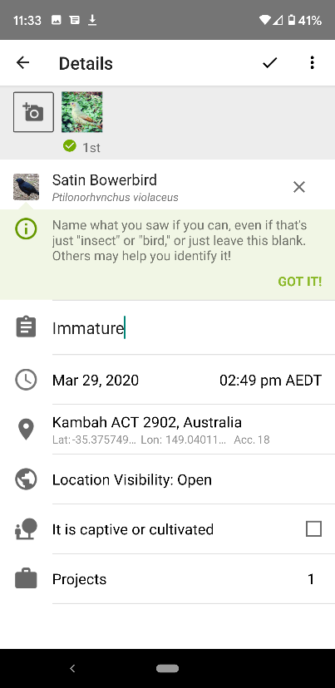If your photo contains metadata, the date, time and location will be automatically added. If not, and for all sound recordings, enter the date, time, location and any other details you’d like to add.

Remember to add the Bush Blitz project.

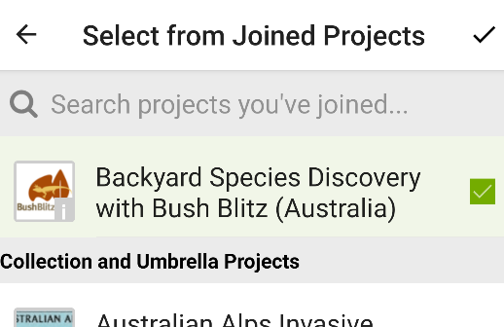

Click on the **✓** symbol to save your record.

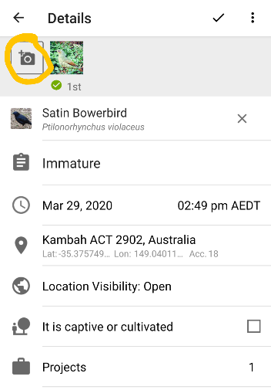

* 1. To add photos/sounds to an existing observation, click on the observation, click on the camera symbol and select an option, then follow the instructions above.

## How to add existing iNaturalist records to the Backyard Species Discovery project

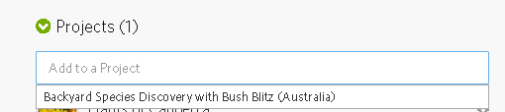To add existing observations to the project, open the record you want to add, scroll down to **Projects**, click in the **Add to a Project** space, and the Bush Blitz project will come up so you can select it. It will save automatically.

## How to share what you have found on Bush Blitz social media

Have you found something you would like to know more about? Do you want to know if it is native or a pest, common or rare? Is it dangerous? Or maybe it’s just really cool! Share your photo/s on Facebook, Instagram or Twitter. Make sure you include the hashtag #speciesdiscovery and tag us @bushblitz (Facebook & Instagram) or @bushblitz2 (Twitter).

Don’t forget to give your location (region or nearest town) to help with your questions. Sometimes a video of an animal moving can assist with identification, especially when the animal is too far away for a decent photo. While you can’t upload videos to iNaturalist you can post them on our social media channels.

Our Bush Blitz online community will try to answer your questions. This is a great way to share what you have found with your friends as well of lots of interested people around the world.

## Stay safe

Protect yourself from the sun and avoid touching any plants or animals. Children should get permission from their parent/carer before taking part in the Backyard Species Discovery project. Make sure your parent/carer knows where you are going to look for plants and animals.

If you have an observation from your home or garden, we recommend you change the geoprivacy setting to ‘obscured’ from the drop-down menu so that general users can’t see exactly where the observation was made. So long as you chose to affiliate with iNaturalistAU when you created your iNaturalist account, the ALA will have access to the true coordinates, so your observations won’t lose their scientific value. To add affiliation, go to your Account Settings, scroll right to the bottom, select iNaturalistAU and Save.

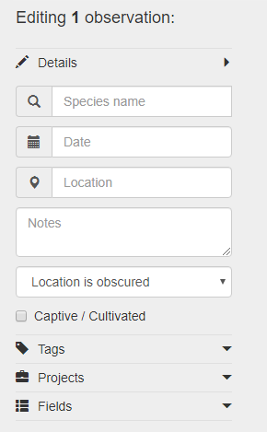 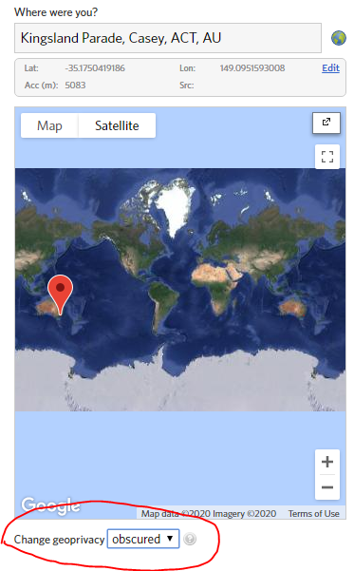 

## Do you need more help?

If you have any questions about Backyard Species Discovery, please contact us through our social media, iNaturalist or by emailing [bushblitz@awe.org.au](mailto:bushblitz@awe.org.au).

Thank you for joining us on this virtual expedition. We can’t wait to see you what you discover!