Approach to Market
Reference ID: DNP-BCK-2122-021
This Approach to Market (ATM) is for the provision of: The publication of new species and resolution of problematic species groups in peer-reviewed journals, and the addition of new species names into the Australian Faunal Directory
The Director of National Parks (the Customer) is seeking submissions for the provision of the services (the Requirement) as described in this Commonwealth Approach to Market.
In submitting a response, Potential Suppliers are required to comply with all requirements set out in the Commonwealth Approach to Market Terms (a copy of which is included in this document), and if successful, agree to enter into a contract which incorporates the Commonwealth Contract Terms available at https://www.finance.gov.au/government/procurement/commonwealth-contracting-suite-ccs (Note: you do not need a CCS user account to view the terms).
Mandatory Conditions for Participation
The Customer will exclude from consideration any Response that does not meet the following Mandatory Conditions for Participation:
- The respondent must be associated or employed by a legal entity. The respondent’s answer must be a Yes or No;
- Responses will only be accepted from Australian institutions or Australian individual researchers;
- Specified Personnel must be affiliated with an institution holding Bush Blitz collections, or have an agreement in writing to gain access to facilities, data and material from collections;
- Specified Personnel must have the relevant scientific qualifications and experience to undertake taxonomic and/or systematics work to publish new species or revise classifications; and
- Institutions and Specified Personnel must have submitted any overdue reports associated with previous ABRS National Taxonomy Research Grant Program (NTRGP) grants, and any other contracts with Bush Blitz.

Statement of Requirement
A.A.1 Key Dates and Times
Event | Details
Industry Briefing#: | Unless otherwise notified by an addendum, there are no industry briefing sessions for this ATM.
Site Inspection*: | Unless otherwise notified by an addendum, there are no site inspections for this ATM.
ATM Closing Date: | Monday, 30 May 2022
ATM Closing Time: | 15:00 ACT local time
Question Closing Date and Time: | Questions will be permitted up until 5pm Friday, 27 May 2022
Expected Contract Execution Date: | Friday, 1 July 2022
Contract Term: | The Contract will remain in force for a period of 18 months from the date the Contract is entered into.
Contract Extension Option: | The Contract will include the following extension option(s): six months.
A.A.2 The Requirement
Bush Blitz requires the submission of manuscripts to peer-reviewed journals that:
- publish new species using specimens and data collected on Bush Blitz expeditions; or
- resolve problematic groups of species using specimens and data collected on Bush Blitz expeditions;
Proposals may target one, or several, taxa.
Suppliers may develop multiple proposals (operating in parallel), each focused on different taxa.
Sharing of knowledge and expertise by established researchers, collaborating and co-applying with early career researchers to support and develop their track records, is encouraged.
Proposals must:
- list the taxa being described or resolved;
- list the Bush Blitz expedition/s where data and specimens were collected or, if collections were made by a researcher not listed as a Specified Personnel, the researcher’s name and institutional affiliation must be provided;
- include a Project Title and a Project Summary which uses plain English and includes the scientific significance of the project;
- describe the methods to be used to undertake the project,
- include details of any field and/or laboratory work to be conducted and the analysis methods to be used.
A copy of all publications resulting from the contract must be submitted to Bush Blitz on publication.
Each contract will be awarded a maximum of $15,000 (GST excl.).
The criteria for evaluation will encompass the:
1. extent to which the potential Supplier’s Response meets the Customer’s Requirement, as set out in this ATM;
2. potential Supplier’s demonstrated capability and capacity to provide the Requirement; and
3. whole of life costs to be incurred by the Customer. Considerations will include both the quoted price and any costs that the Customer will incur as a result of accepting the potential Supplier’s Response.
Unless stated otherwise in the Approach to Market documentation, the above three (3) criteria for evaluation will be of equal importance.
A.A.2(a) Standards
The Supplier must ensure that any goods and services proposed comply with all applicable Australian standards (or in its absence an international standard) including any requirements or standards specified in this Statement of Requirement. Potential Suppliers should note that they may be required to enable the Customer, or an independent assessor, to conduct periodic audits to confirm compliance with all applicable Australian or international standards.
Web Content Accessibility
The Supplier must ensure that any website, associated material and/or online publications (where applicable) complies with the Web Content Accessibility Guidelines available at: https://www.w3.org/WAI/intro/wcag.
A.A.2(b) Security Requirements
None Specified
A.A.2(c) Work Health and Safety
Prior to commencement of the Contract, the Customer’s Contract Manager and the Supplier’s Contract Manager will identify any potential Work Health and Safety issues anticipated to arise during the term of the contract and assign management of each issue identified to the party best able to manage it. The Supplier will provide the Customer with a plan for approval.
Throughout the Contract Term, the Customer and the Supplier will proactively identify and cooperate to manage any Work Health and Safety issues that arise.
The Supplier must ensure that appropriate risk management systems, policies and procedures are in place to avoid or manage foreseeable risks to its Personnel, the Customer’s Personnel, and any third parties present in or near the location where the Contract Requirements will be undertaken or performed.
The Supplier must produce evidence of its systems, policies and procedures referred to above, and their implementation, immediately upon request by the Customer.
The Supplier must, jointly with the Customer, prepare, finalise and implement a detailed risk assessment addressing foreseeable risks to its Personnel, the Customer’s Personnel, and any third parties present in or near the location where the Contract Requirements will be undertaken or performed, prior to commencing performance of the Contract Requirements.
The Supplier must, in carrying out its obligations under this Contract, comply, and use reasonable endeavours to ensure that its Personnel comply, with any of the Customer’s work health and safety policies as notified, referred to, or made available, by the Customer to the Supplier in writing.
The Supplier must, in carrying out its obligations under this Contract, comply, and use reasonable endeavours to ensure that its Personnel comply, with the provisions of all relevant work health and safety laws and requirements of a work health and safety authority administering those laws.
The Supplier and its Personnel must, where the Goods and/or Services being supplied under this Contract require the Service Provider to attend, perform or supply those Goods and/or Services to an area of the Customer’s premises (Supply Location):
a) not attend, or commence performing or supplying those Goods and/or Services, without having first:
i. completed the Customer’s WHS Handbook and Induction pack; and
ii. received a site induction in relation to the Customer’s premises generally, and the Supply Location specifically, from a member of the Customer’s Personnel, and
b) control access to the Supply Location during the supply of the Goods and/or Services so that visitors, and unauthorised Personnel and third parties cannot enter the Supply Location (including, if necessary, through the establishment of barricades and fencing and management of entry and exit points); and
c) during the supply of the Goods and/or Services, conduct regular hazard inspections of, and rectify any unreasonable hazards present in, the Supply Location.
The Supplier and its Personnel must be competent, medically fit, and hold all necessary and appropriate qualifications and licences to carry out its obligations under this Contract.
The Supplier must ensure that its Personnel are supplied all necessary and appropriate safety equipment to carry out the Supplier’s obligations under this Contract in a safe manner.
If the Supplier is required by a work health and safety law to report an incident arising out of the provision of the Contract Requirements to a work health safety authority:
(a) at the same time, or as soon as is possible thereafter, the Supplier must notify the Customer of the incident and provide a copy of any written report submitted to the work health safety authority; and
(b) the Supplier must provide to the Customer, within such time as is specified by the Customer, a report detailing the circumstances of the incident, the results of investigations into its cause, and any recommendations or strategies for prevention in the future.
In this clause, ‘Personnel’ includes a party’s officers, employees, agents and subcontractors.
A.A.2(d) Delivery and Acceptance
The Customer must accept or reject any deliverables under the Contract in accordance with the Commonwealth Contract Terms [Clause C.C.11].
Milestone Description | Delivery Location | Due Date
Execution of Contract | BushBlitz@environment.gov.au | 1/07/2022
Delivery of progress report | BushBlitz@environment.gov.au | 28/04/2023
Acceptance of progress report by the Customer | Supplier’s contact email address | 31/05/2023
Submission of at least one manuscript to a peer-reviewed journal. | BushBlitz@environment.gov.au | 31/12/2023
Acceptance by Customer of submitted journal manuscript | Supplier’s contact email address | 31/01/2024
Reports
During the term of the Contract the Supplier must provide the Customer with reports as set out in the table below:
Report Type | Detailed Description | Due Date
Progress report | The Supplier must provide the Customer with a progress report on the work that has been undertaken towards the journal publication | 5pm 28/04/2023
Final Confirmation Email | The Supplier must provide the Customer with an email forwarding the submission of the manuscript to the journal | 5pm 31/12/2023
A.A.2(e) Meetings
The Supplier is not required to attend meetings.
A.A.2(f) Facilities and Assistance Offered by the Customer
The Customer will not make any facilities or assistance available to the Supplier.
A.A.2(g) Customer Material
The Customer will not provide any material.

A.A.2(h) Public Interest Disclosure
Public officials (including service providers under a Commonwealth contract) who suspect wrongdoing within the Commonwealth public sector can raise their concerns under the Public Interest Disclosure Act 2013 (PID Act). Prior to making a disclosure, refer to information available at: https://www.ombudsman.gov.au/Our-responsibilities/making-a-disclosure/information-for-disclosers.
All Public Interest Disclosure matters (relating to this procurement) should be referred to:
Name/Position: | Chief Financial Officer
Email Address: | helpdesk.parksfinance@awe.gov.au
A.A.2(i) Complaints Handling
In the first instance, complaints relating to this ATM should be directed to the Customer’s Contact Officer or:
Name/Position: | DNP Procurement Manager
Email Address: | DNPprocurement@awe.gov.au
If your issue is not resolved refer https://www.finance.gov.au/business/procurement/complaints-handling-charter-complaints for more information relating to the handling of complaints.

A.A.3 ATM Distribution
Email Distribution
Any questions relating to this ATM must be directed to the Customer Contact Officer at A.A.5. Updates to this ATM will be distributed via email.
A.A.4 Lodgement Method
Email
Responses should be lodged via email to BushBlitz@environment.gov.au quoting reference number DNP-BCK-2122-021 by the closing time specified above.
Response File Format, Naming Convention and Size
The Customer will accept Responses lodged in the following formats:
- Word Doc (.docx)
- Word 97-2003 Doc (.doc)
- PDF (.pdf)
The Response file name/s should:
- incorporate the Potential Supplier’s full legal organisation name; and
- reflect the various parts of the bid they represent (where the Response comprises multiple files).
Response files must not exceed a combined file size of 5 megabytes per email.
Responses must be completely self-contained. No hyperlinked or other material may be incorporated by reference.
A.A.5 Customer’s Contact Officer
For all matters relating to this ATM, the Contact Officer is:
Name/Position: Helen Cross, Bush Blitz Administration Officer
Email Address: BushBlitz@environment.gov.au
Note: Question Closing Date and Time is set out at item A.A.1 [Key Dates and Times].

Additional Contract Terms
An executed contract will incorporate the Commonwealth Contract Terms and also the following Additional Contract Terms:
A.C.1 Intellectual Property
For the purposes of this clause, “Intellectual Property Rights” means all intellectual property rights which may subsist in Australia or elsewhere, whether or not they are current or future or registered or capable of being registered, including without limitation in relation to, copyright, designs, trade marks (including unregistered marks), business and company names, domain names, database, circuit layouts, patents, inventions, discoveries, know-how, trade secrets and confidential information, but excluding Moral Rights.
The Customer owns the Intellectual Property Rights in the Material created under the Contract.
To the extent the Supplier or a third party holds any Intellectual Property Rights in any existing Material, the Supplier hereby agrees to licence the Customer to enable the Customer to exercise full rights and interests in the Intellectual Property Rights in any Material provided under the Contract. The Supplier agrees to create, execute or sign any documents and perform all acts which may be necessary to allow the use of those rights by the Customer for any purpose.
The Customer grants to the Supplier a non-exclusive, non-transferable, irrevocable, royalty-free licence for the Contract Term to exercise the Intellectual Property Rights in the Material for the sole purpose of fulfilling its obligations under the Contract. The licence in this clause is subject to any conditions or limitations of third parties that the Customer notifies to the Supplier.
Intellectual Property Rights in Goods provided under the Contract or pre-existing Intellectual Property of the Supplier, set out below (if any), will not change as a result of the Contract.
A.C.2 Payment
The Customer must pay the amount of a Correctly Rendered Invoice to the Supplier within twenty (20) calendar days after receiving it, or if this day is not a business day, on the next business day.
A.C.3 Insurance
(a) For the purpose of clause C.C.14, the Supplier must effect and maintain, and must ensure that its subcontractors effect and maintain, the minimum insurance coverage types and amounts set out in clause (b), on and from the date of this Contract for the period specified in clause (c).
(b) Minimum insurance requirements:
i. Public liability insurance of at least $20,000,000 per claim and in aggregate;
ii. Product liability insurance of at least $10,000,000 per claim and in aggregate;
iii. Professional indemnity insurance of at least $5,000,000 per claim and in aggregate; and
iv. Workers compensation insurance as required by law.
(c) Any insurance policies held by the Supplier that provide cover on a ‘claims made’ basis must be maintained for no less than seven (7) years after the completion of the Contract Requirements. Any insurance policies that provide cover on an ‘occurrence’ basis must be maintained during the Contract Term.
(d) The Supplier must, on request, promptly provide to the Customer any relevant insurance policies and certificates of currency for inspection.

A.C.4 Compliance with environmental laws
Without limiting clause C.C.21, the Supplier must, in the provision of the Contract Requirements, comply with:
(a) the Environment Protection and Biodiversity Conservation Act 1999 (Cth) (‘EPBC Act’), the Environment Protection and Biodiversity Conservation Regulations 2000 (Cth) (‘EPBC Regulations’), and any Management Plan(s) for the Commonwealth reserve(s) forming part of, or encompassing, the location in which the Contract Requirements are to be provided; and
(b) all State or Territory laws that apply to the provision of the Contract Requirements.
For the purpose of this clause, a ‘Management Plan’ for a Commonwealth reserve means a management plan made and in force under section 388 of the EPBC Act.

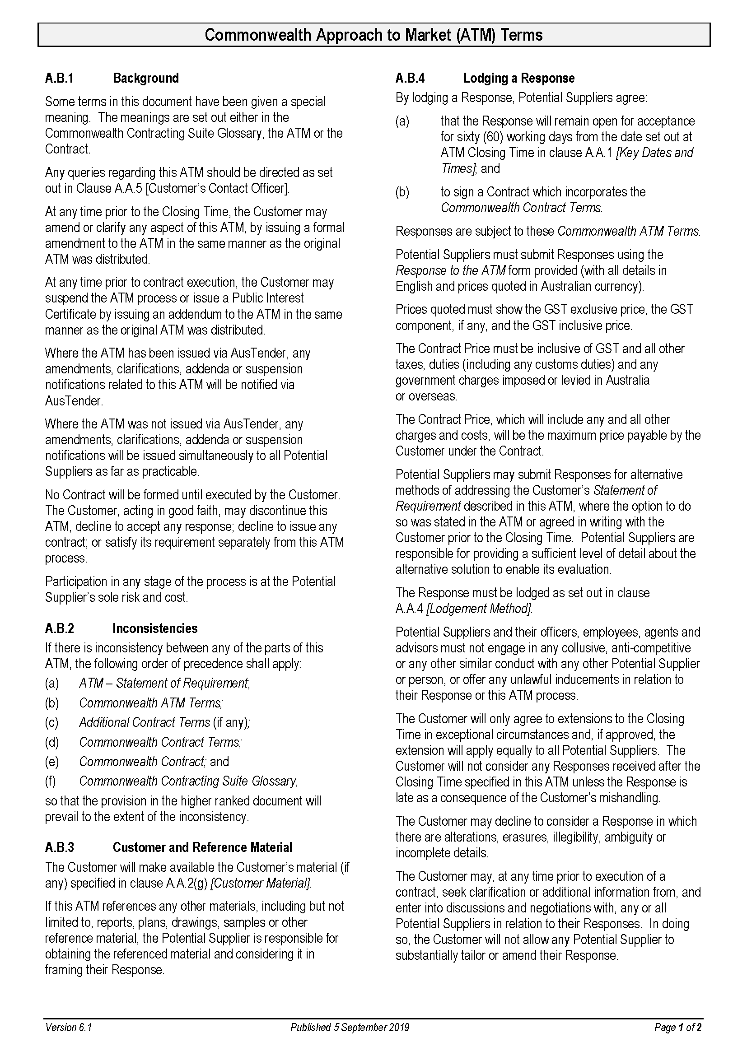
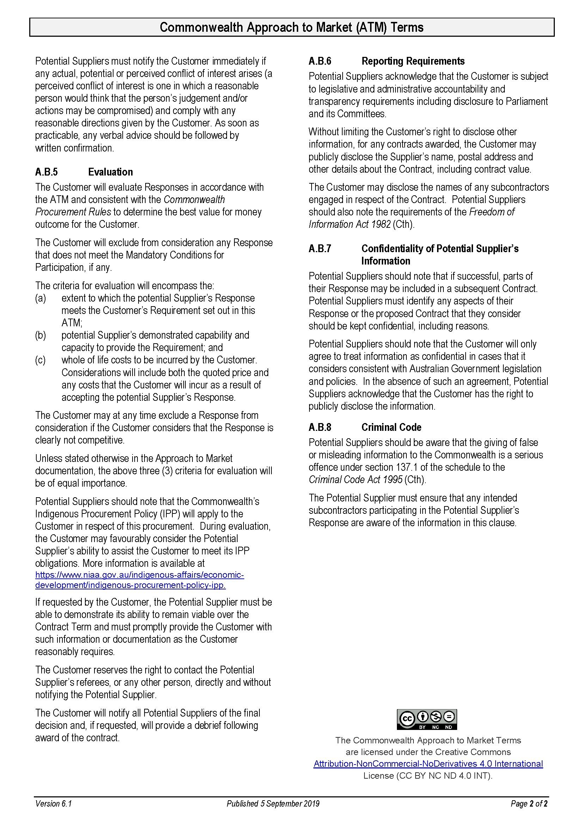
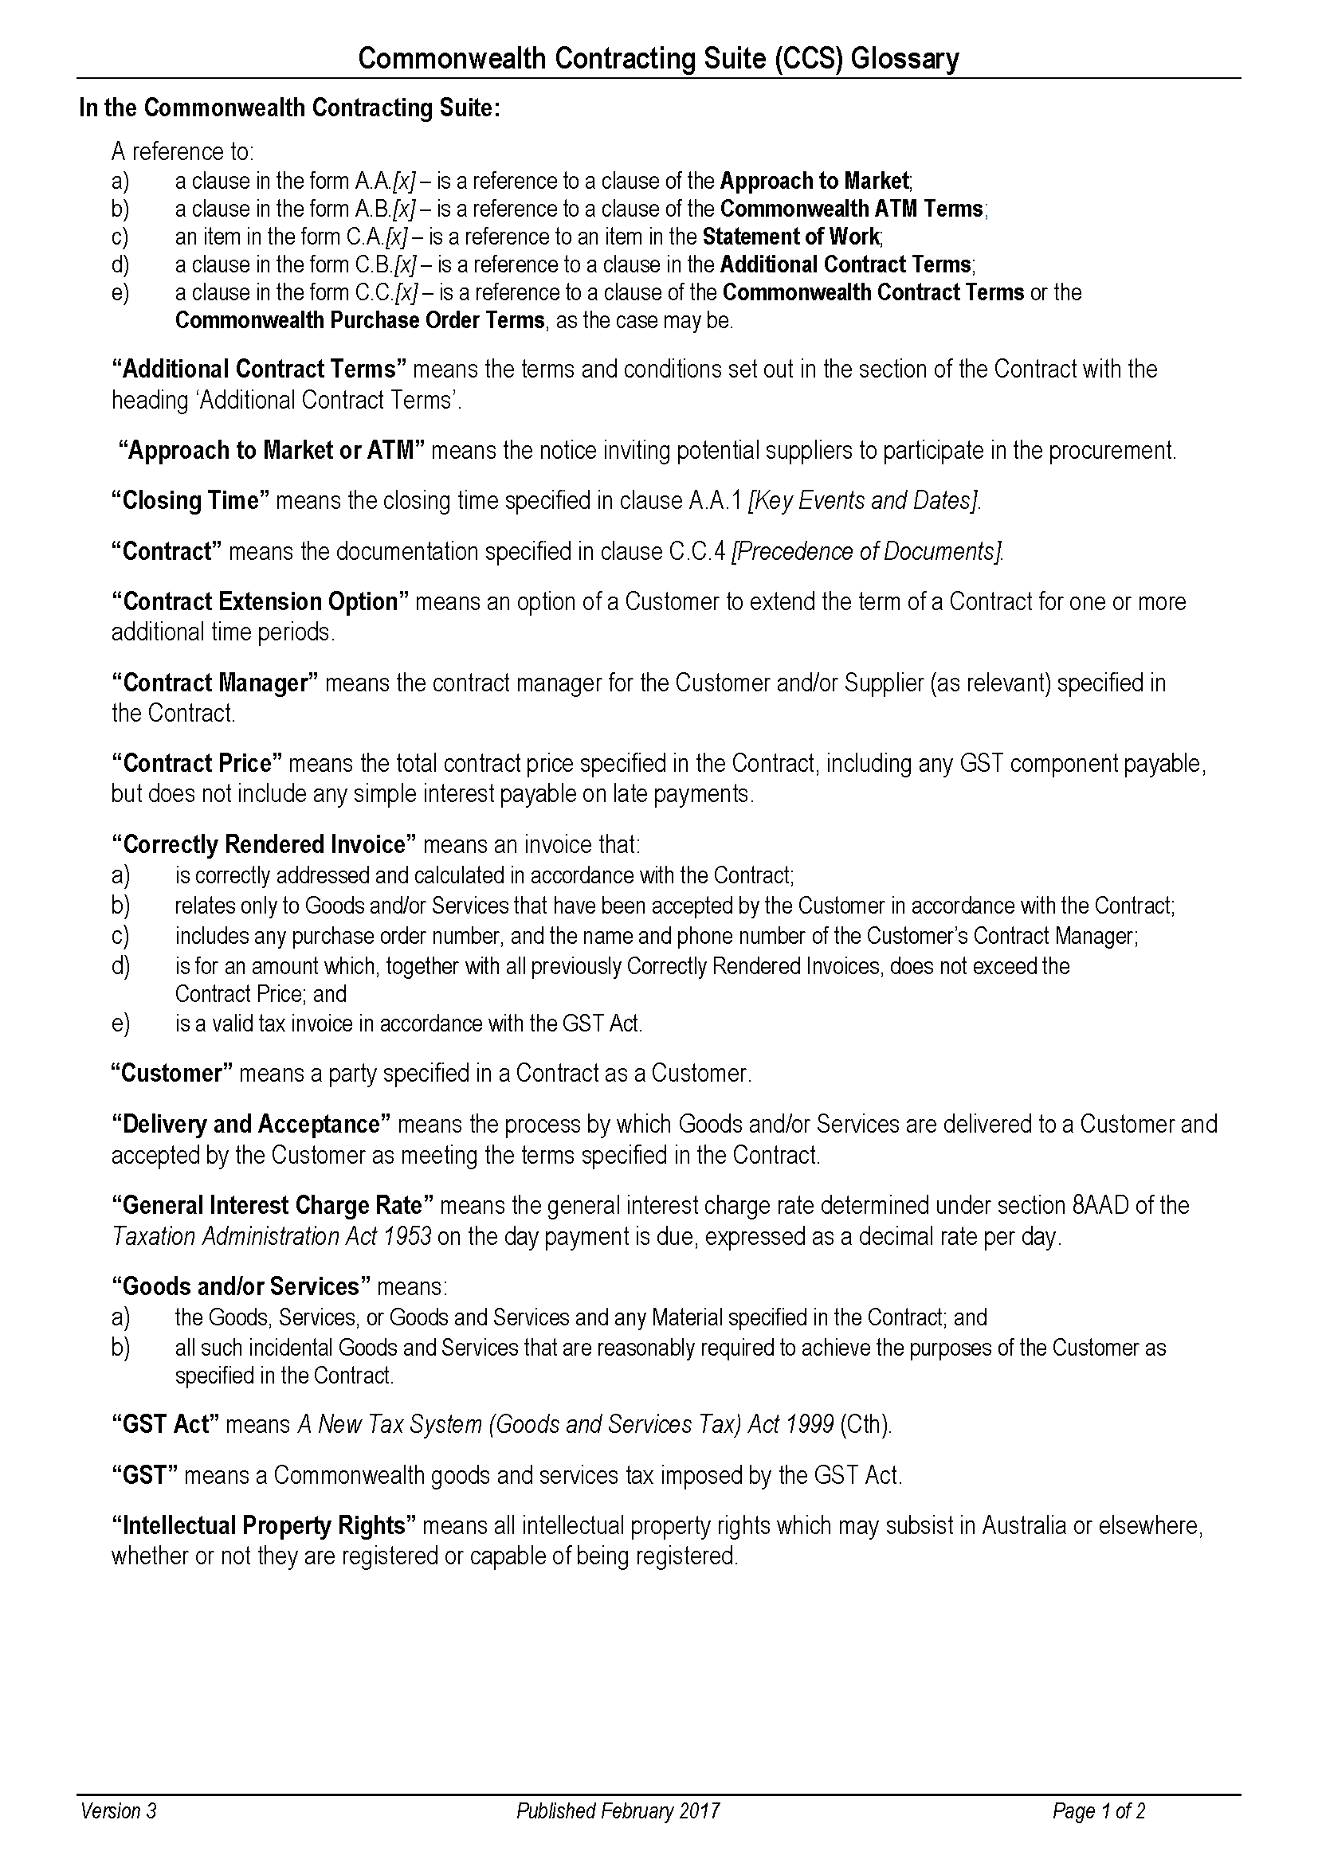
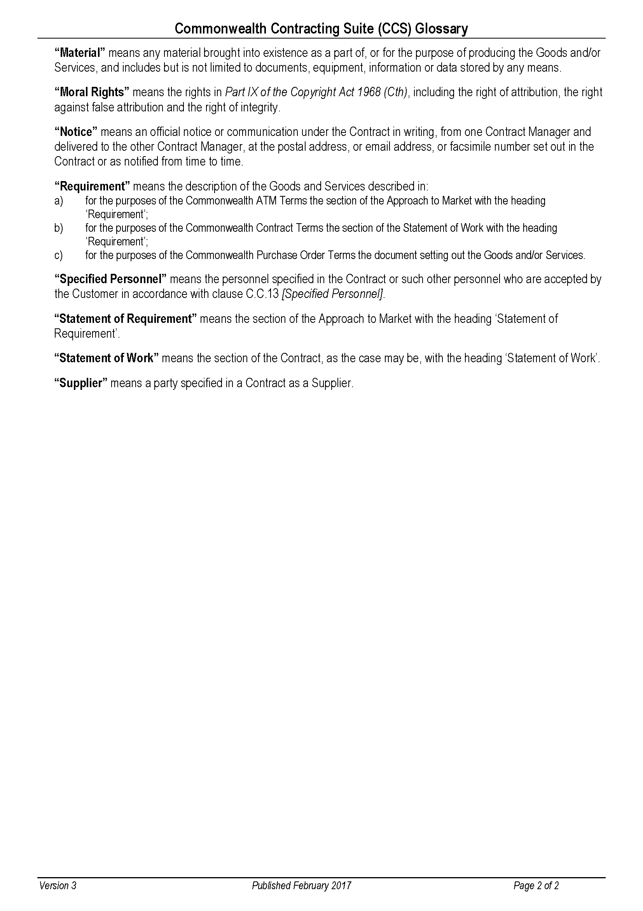
RESPONSE
Remember to remove all drafting note guidance before you finalise and submit your Response.
Specific questions about this ATM should be directed to the Customer’s Contact Officer [Item A.A.5].
If successful your organisation will be offered a contract which includes the Commonwealth Contract Terms, available at: https://www.finance.gov.au/government/procurement/commonwealth-contracting-suite-ccs. These terms are not negotiable. Do not submit a response if you cannot agree to these terms as you cannot be awarded the Contract.
Submit the form as required in Lodgement Method [Item A.A.4].
You MUST use this form to submit your Response, which MUST comply with the Commonwealth ATM Terms, available at: https://www.finance.gov.au/government/procurement/commonwealth-contracting-suite-ccs. The form is set out to facilitate evaluation of responses.
Participation in this ATM is at your sole risk and cost. This is a competitive process, and you should note that your organisation may incur costs in responding, if you are unsuccessful you will be unable to recoup these costs.
Be as concise as possible while including all information that your organisation wants the evaluation team to consider. Do not assume that the evaluation team has any knowledge of your organisation’s abilities or personnel.
Before completing your Response read the Customer’s Approach to Market (ATM) distributed with this Response form and decide whether your organisation has the necessary skills and experience to meet the Customer’s requirement.
You must clearly demonstrate that your organisation meets the Mandatory Conditions for Participation (if any), as failure to do so will mean your response cannot be considered and you cannot be awarded the Contract.
If you are an Individual without an ABN and you do not meet the Australian Taxation Office’s (ATO) definition of an independent contractor, you may be offered a different form of contract OR we may not be able to contract with you. Before completing this Response Form notify the Customer’s Contact Officer to enable them to seek advice. For further information, refer to the ATO website at: https://www.ato.gov.au/business/employee-or-contractor/how-to-work-it-out--employee-or-contractor/.
If you are a Trust where the Trustee is not empowered to sign contracts on behalf of the Trust, we may not be able to contract with you. Before completing this Response Form notify the Customer’s Contact Officer to enable them to seek advice.
The Customer will evaluate all valid Responses received by the Closing Time [Item A.A.1] which meet the Mandatory Conditions for Participation (if any), to determine which Potential Supplier has proposed the best value for money outcome for the Customer.
In making this decision, the Customer will consider the criteria set out at Clause A.B.5 [Evaluation].
In preparation of this Response you should note the Commonwealth Indigenous Procurement Policy (IPP) available at: https://www.niaa.gov.au/indigenous-affairs/economic-development/indigenous-procurement-policy-ipp may apply to the Customer in respect of this procurement. During evaluation of responses, the Customer may consider the Supplier’s ability to assist the Customer to meet its IPP obligations.
The successful Supplier will have demonstrated its ability to provide the best value for the Customer. This will not necessarily be the lowest price.
If your organisation is unsuccessful with this submission, request a debrief to assist with future submissions. The Customer’s Contact Officer [Item A.A.5] can arrange this for you.

Part 1 – Potential Supplier’s Details
DRAFTING NOTE:
The following details will appear in the Contract should your Response be successful. The details you provide should be for the legal organisation that would be the Supplier under the Contract.

Full Legal Organisation Name:
Legal Status: | Individual/Sole Trader  Partnership  Company  Sole Director Company  Trust (see note below)  Educational Institution (see note below)  Other (please state):
NOTE FOR TRUSTS: If the Potential Supplier is trading as a trust, please provide details of the relevant trust (and trustee) including a copy of the relevant trust deed (including any variations to that deed) as an attachment to this Response.
NOTE FOR EDUCATIONAL INSTITUTIONS: If your Response is successful, prior to Contract you will be required to provide details of any enabling legislation as well as details of any delegations or other authorisations that are relevant to the execution of a contract.
Australian Business Number (ABN):
Australian Company Number (ACN):
Australian Registered Body Number (ARBN):
Registered Address:
Web address:
Is your organisation classified as a ‘relevant employer’ under the Workplace Gender Equality Act 2012 (the WGE Act)? |  | Yes, I am a relevant employer  No, I am not a relevant employer
If yes, you are required to provide a current letter of compliance with the WGE Act prior to contract. Have you provided a letter of compliance with this Response? |  | Yes  No, I will provide a current letter of compliance prior to contract
NOTE: Where the Supplier is a relevant employer, the Supplier must provide evidence that it complies with its obligations under the WGE Act before commencement of any Contract and annually thereafter for the duration of the Contract. If the Supplier becomes non-compliant with the WGE Act during the course of the contract, the Supplier must notify the Customer’s Contact Officer. Compliance with the WGE Act does not relieve the Supplier from its responsibilities to comply with its obligations under the Contract.
Is your organisation 50% or more Indigenous owned? |  | Yes, see below.  No
If your organisation is 50% or more Indigenous owned, is your organisation registered on Supply Nation? |  | Yes  No – see note below  Not Applicable
Please provide a certificate or letter from a recognised Indigenous organisation such as Land Council, Indigenous Chamber of Commerce or Office of the Registrar of Indigenous Corporations verifying Indigenous ownership.
Has your organisation ever had a judicial decision about employee entitlements or engaged in practices that have been found to be dishonest, unethical or unsafe? |  | Yes, see below.  No
If yes, what was the date of discharge?  The Supplier acknowledges that the giving of false or misleading information to the Commonwealth is a serious offence under section 137.1 of the schedule to the Criminal Code Act 1995 (Cth). |  | (dd-mm-yyyy)  Note: The Customer cannot enter a contract with a supplier who has an undischarged judicial decision relating to employee entitlements.
Contact Officer
For matters relating to this Response contact:
Name:
Position Title:
Telephone:
Mobile:
Email Address:
Postal Address:
Address for Notices (if different from the Contact Officer)
DRAFTING NOTE:
Complete with “AS ABOVE” if same as Contact Officer.

Name:
Position Title:
Email Address:
Postal Address:
Contract Manager (if different from the Contact Officer)
DRAFTING NOTE:
Provide the requested details of the person you propose will be the Contact Manager if your Response is successful and a contract is awarded.
Complete with “AS ABOVE” if same as Contact Officer.

For matters of a general nature, including acceptance and issuance of written notices contact:
Name:
Position Title:
Telephone:
Mobile:
Email Address:
Postal Address:

Part 2 – Executive Summary
DRAFTING NOTE:
You may find it useful to complete this section after you have completed your response.
Provide a brief (less than one page) summary of your Response highlighting its key features. The Executive Summary should not merely replicate information provided elsewhere in your Response. This section brings together all aspects of your proposal and is your opportunity to “sell” its unique features.
In support of the Indigenous Procurement Policy (https://www.niaa.gov.au/indigenous-affairs/economic-development/indigenous-procurement-policy-ipp), highlight any Indigenous subcontractors you are proposing to use, or any Indigenous staff who will work on the project.

Provide your response here:

Part 3 – Ability to Meet the Requirement
Mandatory Conditions for Participation
IMPORTANT INFORMATION:
Respond to the Mandatory Conditions for Participation here.
Do not proceed further if you cannot meet the Mandatory Conditions for Participation. If you do not meet the Mandatory Conditions for Participation your Response cannot be considered.
If there was a mandatory industry briefing or mandatory site visit include name of the person(s) who attended.
If no Mandatory Conditions for Participation specified, include the words: No Mandatory Conditions for Participation specified.
Provide your response here (confirm that you meet the conditions in the box at the very front of this document):

Detailed Proposal to Meet the Customer’s Requirement
DRAFTING NOTE:
Your response should address each aspect of the Statement of Requirement and explain/demonstrate how your response/solution meets the Requirement.
Provide a detailed description of your proposal to supply the Customer’s requirement, including any delivery methodology. This is your opportunity to convince the evaluation team that your organisation understands the requirement and can deliver it to a high standard. Do not provide general marketing material.
Highlight your competitive advantage as well as special or unique features of your proposal. Depending on the requirement, your response may propose a detailed project plan including project milestones and completion dates, timeframes, quality standards or performance indicators. It may also detail critical issues or key delivery risks of which the Customer should be aware.
If meeting the Customer’s requirement involves reporting, travel or attendance at meetings, you should clearly identify how you will meet these requirements, including details of personnel involved. Do not include any pricing or pricing information in Part 3. You should ensure that you clearly address any costs in your response to Part 5.
Do not rely on your organisation’s reputation. The evaluation team can only consider information you provide in this submission.
Explain how you will:
1. publish new species using specimens and data collected on Bush Blitz expeditions; or
2. resolve problematic groups of species using specimens and data collected on Bush Blitz expeditions;
Include:
1. list the taxa being described or resolved;
2. list the Bush Blitz expedition/s where data and specimens were collected or, if collections were made by a researcher not listed as a Specified Personnel, the researcher’s name and institutional affiliation must be provided;
3. include a Project Title and a Project Summary which uses plain English and includes the scientific significance of the project;
4. describe the methods to be used to undertake the project,
5. include details of any field and/or laboratory work to be conducted and the analysis methods to be used

Standards
DRAFTING NOTE:
Potential Suppliers must provide full details and evidence of compliance with all applicable Australian standards (or in its absence an international standard), and any standards and requirements specified in the Statement of Requirement. Where you do not propose to comply with a standard which has been included in the Statement of Requirement, propose an alternative standard and justify your reasons.
No standard has been specified, however you may list any applicable standards with which you propose to comply.
If you wish to provide standards you will follow, list them here:

Part 4 – Potential Supplier’s Demonstrated Capability and Capacity
Statement of Skills and Experience
DRAFTING NOTE:
The information you enter here will be used to evaluate your organisation’s proven capacity to meet the customer’s requirement.
Provide clear, concise details of your relevant abilities to deliver what you have proposed.
This is your opportunity to highlight any unique capabilities and prove to the evaluation team that you can meet the requirement to a high standard.
Depending on the requirement, this could include a detailed description of recent relevant experience in successfully supplying a similar requirement. It could also include your organisation’s expertise in this field, brief information on relevant personnel (highlighting relevant expertise and experience), details of relevant intellectual property or unique products used.
You may also attach brief supporting information specific to the requirement including tailored CVs for Specified Personnel.
Do not include any pricing or pricing information in this Part. All pricing information should be included in Part 5.
Please attach CVs of all resarchers

Specified Personnel
DRAFTING NOTE:
Only propose Specified Personnel where your proposal has referenced the skills of specific personnel and you reasonably expect them to perform the roles nominated. Include their role, the percentage of the project they will complete, and if relevant, their current Commonwealth Government security clearance. Add extra lines to the table as required.
Where there is a number of staff who could perform a particular role, include details of the position/role and the percentage of project time which this role will perform. In these circumstances it would not be necessary to name the person.
Include details for subcontractor personnel if applicable. You will need to give additional details for subcontractors in the next section.
If no Specified Personnel are proposed, insert “Not Applicable”.

Name | Position/Role | Current Security Clearance Level# | Percentage of  Total Project Time
Total personnel time |  |  | 100%
# if requested at A.A.2(b)

Subcontractors
DRAFTING NOTE:
The Customer is required to publicly disclose information about subcontractors. Provide details for each subcontractor organisation you will use below.
If no subcontractors are proposed insert “Not Applicable”

Full Legal Name:
Postal Address:
ABN / ACN / ARBN:
Is this subcontractor registered on Supply Nation or 50% or more Indigenous owned?

Scope of Works to be Subcontracted
DRAFTING NOTE:
If no subcontractors are proposed insert “Not Applicable”.
Provide details of the roles (or specific parts of the contract) each subcontractor will perform.
The Supplier is solely responsible for all obligations under the contract, including subcontractor performance and management. The Supplier must ensure that any subcontract arrangement that is entered into imposes necessary obligations on the subcontractor.
If you are intending to include subcontractors, read and understand your obligations under the Commonwealth Contract Terms, Subcontracting [Clause C.C.10], Relationship of the Parties [Clause C.C.2], Compliance with the Laws [Clause C.C.21] and Compliance with Commonwealth Laws and Policies [C.C.22] specifically relate to subcontractors.
Provide your response here:

Conflicts of Interest
DRAFTING NOTE:
Public officials have an obligation to disclose conflicts of interest under section 29 of the Public Governance, Performance and Accountability Act 2013 (PGPA Act). Suppliers to Commonwealth entities need to assist the Customer to meet its obligations by complying with the same standard of conduct.
Conflicts can be actual, perceived or potential. The perception of a conflict can be just as damaging to public confidence in public administration as an actual conflict based on objective facts.
It is important that if, after the response has been submitted or during the Contract period, any actual, perceived or potential conflicts arise they are reported to the Customer without delay.
If you are aware of a conflict (real or perceived) that could arise as a result of entering into a contract with the Customer (and Subcontractor where applicable) include full details and strategies to manage below, or for complex issues, attach a Conflict of Interest Management Plan detailing your proposed approach.
If no conflicts of interest were identified, type “Nil”.
Provide your response here:

Curriculum vitae
DRAFTING NOTE:
Provide any additional information to support your response e.g. curriculum vitae and/or publishing history of personnel working on the project, other specimens and/or data being contributed to the project.

Pre-existing Intellectual Property of Potential Supplier
DRAFTING NOTE:
List your pre-existing Intellectual Property (if any) noting that:
The Supplier grants to, or in the case of Third-Party Material, must obtain for, the Customer a non-exclusive, irrevocable, royalty-free, perpetual, world-wide licence (including the right to sub-licence) to exercise the Intellectual Property Rights in all Pre-existing Material and Third- Party Material incorporated into the Material to enable the Customer to receive the full benefit of the Goods and/or Services and the Material and to exercise its rights in relation to the Material.
If no pre-existing Intellectual Property is proposed insert “Not Applicable”.
Provide your response here

Confidentiality of Potential Supplier’s Information
DRAFTING NOTE:
Identify any aspect of the Response, or any aspect of the proposed Contract, that you consider should be kept confidential, with reason.
The Customer will only agree to treat information as confidential in cases that meet the Commonwealth’s guidelines and which the Customer considers appropriate. In the absence of the Customer’s agreement, the Customer has the right to disclose any information contained in the Contract.
Add extra lines to the table as required.
Information to assist you to assess whether the Customer is able to treat particular information as confidential is available at: https://www.finance.gov.au/publications/resource-management-guides/procurement-publishing-reporting-obligations-rmg-423.
If none, type “Not Applicable”.

Information to be kept Confidential | Reasons for Confidentiality Request

Regulatory and Sustainability Considerations
DRAFTING NOTE:
The Australian Government has a commitment to sustainable procurement practices. Sustainable procurement aims to reduce adverse social, environmental and economic impacts of purchased goods and services throughout their life. This includes considerations such as waste disposal and the cost of operations and maintenance over the life of the goods and services.
Provide a brief statement of how your organisation intends to comply with relevant regulations or provide sustainable procurement benefits.
You may wish to include information, where relevant to the Customer’s Requirement, of your commitment to or targets for the following:
- human rights and ethical employment practices such as fair pay and avoiding slavery in the supply chain, preventing discrimination, support for worker’s rights, supporting socially inclusive practices, work health and safety and fair work conditions
- protection of the environment such as recycling, sustainable resource use, prevention of pollution, climate change mitigation and environmental conservation
- fair operating practices such as including prevention/detection of fraud, payment of fair share of tax (including in supply chain), fair competition, fair contractual practices for subcontractors/consumers
- consumers such as fair marketing and consumer data protection and privacy
- community involvement and development such as involvement in community activities, education and culture, employment creation and skills development – including with vulnerable sectors of the community.
Provide your response here

Additional Information
DRAFTING NOTE:
Any information included here should be relevant to this proposal and should be as concise as possible.
The Commonwealth’s Fraud Control Framework requires the Customer to manage risk of fraud and corruption as part of contracting and procurement activities. You should include details of controls (if any) you will have in place to prevent fraud and corruption against the Commonwealth.
This section should NOT be used to include generic marketing information that is not specific to the Requirement.
Provide your response here:

Part 5 – Total Costs to be incurred by the Customer
DRAFTING NOTE:
The information you provide in this section will be used to assess the total costs the Customer will incur under your proposal.
Pricing
Fixed Price (including all expenses)
DRAFTING NOTE:
Complete the following table including fixed prices for each item. Fixed prices must include taxes, duties and other government charges which may be imposed or levied in Australia and overseas, and all other costs associated with providing the services, including delivery fees where applicable.
Make sure you include, costs of any reporting and attending necessary meeting as well as any travel, accommodation and associated costs.
Add additional lines to the table as required.

Description  (e.g. Personnel, field costs, materials) | Total Price  GST Exclusive | GST Component | Total Price  GST Inclusive
Total Fixed Price for Services

Non-Compliance
DRAFTING NOTE:
If your response is successful, you will be offered a Contract which incorporates the Commonwealth Contract Terms available at https://www.finance.gov.au/government/procurement/commonwealth-contracting-suite-ccs. The Terms have been designed to enable Commonwealth officials to comply with their legislated responsibilities and are therefore NOT negotiable.
If you have reasons why any of the Additional Contract Terms should be changed, complete the following table, as these additional terms may be negotiable.
Any costs the Customer would incur in obtaining legal advice (including in-house legal advice) or negotiating the Customer’s Additional Contract Terms will be included in the Customer’s total costs assessment.

Clause | Reason for Non-Compliance | Proposed New Wording

